Table S1 List of 153 genes associated with epilepsy in the MyGenostics panel

ADSL | CHD2 | DHFR | GLB1 | MAGI2 | PNPO | SLC9A6
ALDH7A1 | CHRNA2 | DIAPH3 | GLRA1 | MAPK10 | POLG | SPTAN1
ALG13 | CHRNA4 | DNAJC6 | GPR56 | MBD5 | PPT1 | SRPX2
ARG1 | CHRNA7 | DNM1 | GPR98 | MDGA2 | PROC | ST3GAL2
ARHGEF15 | CHRNB2 | DOCK7 | GRIN1 | ME2 | PRRT2 | ST3GAL5
ARHGEF9 | CLCN2 | EEF1A2 | GRIN2A | MECP2 | RBFOX1 | STRADA
ARX | CLCN4 | EFHC1 | GRIN2B | MEF2C | RBFOX2 | STXBP1
ASAH1 | CLN3 | ELP4 | HAX1 | MFSD8 | RBFOX3 | SYNGAP1
ATP13A4 | CLN5 | EPHB2 | HDAC4 | MTHFR | RELN | SYNJ1
ATP1A2 | CLN6 | ErbB4 | HEXA | MTOR | RYR3 | SZT2
ATP1A3 | CLN8 | FASN | HEXB | NDE1 | SCN1A | TBC1D24
ATP6AP2 | CNTN5 | FLNA | HNRNPH1 | NEDD4L | SCN1B | TCF4
ATP7A | CNTNAP2 | FOLR1 | HNRNPU | NID2 | SCN2A | TNK2
BRAF | COX6B1 | FOXG1 | IQSEC2 | NRXN1 | SCN8A | TPP1
BSN | CSTB | FOXP2 | KCNB1 | PAFAH1B1 | SHANK3 | TSC1
CACNA1A | CTNNA3 | GABBR2 | KCNH5 | PCDH19 | SLC13A5 | TSC2
CACNA1H | CTSD | GABRA1 | KCNMA1 | PDHA1 | SLC19A3 | TUBA1A
CACNB4 | CYB5R3 | GABRA6 | KCNQ2 | PIGA | SLC1A3 | UBE3A
CASK | DBH | GABRB2 | KCNQ3 | PIGV | SLC25A22 | VRK2
CDH13 | DCX | GABRB3 | KCNT1 | PLCB1 | SLC2A1 | WDR45
CDH9 | DEPDC5 | GABRD | LGI1 | PNKD | SLC35A2 | ZEB2
CDKL5 | DGKD | GABRG2 | LIAS | PNKP | SLC46A1

Table S2 The ddPCR results in 20 PCDH19-related epileptic families

Subject No. | Sample | Drop count |  |  | Mutant allelic fraction |  |  | PCDH19 Mutation
 |  | Total No. | Mutant No. | Wild No. | Mean | 95%L | 95%U
001 | blood | 9445727 | 11516 | 11470 | 50.10% | 49.45% | 50.75% | c.488T>G
001F | blood | 8468678 | 3328 | 21036 | 13.66% | 13.23% | 14.10% | c.488T>G
001F | hair | 9710907 | 141 | 3251 | 4.16% | 3.51% | 4.88% | c.488T>G
001F | buccal | 9838316 | 4736 | 21175 | 18.28% | 17.81% | 18.75% | c.488T>G
001F | nail | 10029597 | 10320 | 17287 | 37.38% | 36.81% | 37.96% | c.488T>G
001F | saliva | 10808241 | 4202 | 30479 | 12.12% | 11.77% | 12.46% | c.488T>G
001F | urine | 10106162 | 31 | 68 | 31.31% | 22.36% | 41.41% | c.488T>G
001F | semen | 10347332 | 4441 | 23743 | 15.76% | 15.33% | 16.19% | c.488T>G
001M | blood | 9724717 | 0 | 20173 | 0.00% | 0.00% | 0.02% | c.488T>G
002 | blood | 9158314 | 23284 | 25850 | 47.39% | 46.95% | 47.83% | c.1347_1348insAAC
002F | blood | 9138940 | 2 | 18254 | 0.01% | 0.00% | 0.04% | c.1347_1348insAAC
002M | blood | 8523214 | 9 | 63371 | 0.01% | 0.01% | 0.03% | c.1347_1348insAAC
003 | blood | 9858580 | 41321 | 40570 | 50.46% | 50.12% | 50.80% | c.1019A>G
003F | blood | 8885706 | 0 | 17052 | 0.00% | 0.00% | 0.02% | c.1019A>G
003M | blood | 8842757 | 0 | 34161 | 0.00% | 0.00% | 0.01% | c.1019A>G
004 | blood | 8641995 | 14543 | 14228 | 50.55% | 49.97% | 51.13% | c.1019A>G
004M | blood | 8198298 | 11157 | 10494 | 51.53% | 50.86% | 52.20% | c.1019A>G
004MGF | blood | 7747185 | 0 | 13836 | 0.00% | 0.00% | 0.03% | c.1019A>G
004MGM | blood | 8792515 | 0 | 35666 | 0.00% | 0.00% | 0.01% | c.1019A>G
006 | blood | 8412186 | 25686 | 25305 | 50.37% | 49.94% | 50.81% | c.1017delC
006F | blood | 8863596 | 0 | 13617 | 0.00% | 0.00% | 0.03% | c.1017delC
006M | blood | 8578199 | 16667 | 17153 | 49.28% | 48.75% | 49.82% | c.1017delC
007 | blood | 8940039 | 12775 | 12691 | 50.16% | 49.55% | 50.78% | C.790G>C

007F | blood | 9442598 | 14888 | 47 | 99.69% | 99.58% | 99.77% | C.790G>C
007M | blood | 8805498 | 1 | 29913 | 0.00% | 0.00% | 0.02% | C.790G>C
008 | blood | 9261374 | 8546 | 8496 | 50.15% | 49.39% | 50.90% | c.1184G>C
008F | blood | 9578248 | 1 | 18543 | 0.01% | 0.00% | 0.03% | c.1184G>C
008M | blood | 8661868 | 0 | 25828 | 0.00% | 0.00% | 0.01% | c.1184G>C
011 | blood | 9244373 | 5944 | 5847 | 50.41% | 49.50% | 51.32% | c.1375C>T
011F | blood | 9286472 | 0 | 16650 | 0.00% | 0.00% | 0.02% | c.1375C>T
011M | blood | 8979903 | 0 | 33654 | 0.00% | 0.00% | 0.01% | c.1375C>T
013 | blood | 9499990 | 330 | 314 | 51.24% | 47.31% | 55.17% | c.370G>A
013S | blood | 9609107 | 832 | 943 | 46.87% | 44.53% | 49.23% | c.370G>A
013F | blood | 9961261 | 340 | 1649 | 17.09% | 15.46% | 18.82% | c.370G>A
013F | buccal | 8705715 | 2056 | 22440 | 8.39% | 8.05% | 8.75% | c.370G>A
013F | nail | 10558801 | 160 | 12407 | 1.27% | 1.08% | 1.48% | c.370G>A
013F | saliva | 10420060 | 1555 | 9231 | 14.42% | 13.76% | 15.09% | c.370G>A
013F | urine | 10562064 | 9 | 260 | 3.35% | 1.54% | 6.26% | c.370G>A
013F | semen | 9111565 | 492 | 2080 | 19.13% | 17.63% | 20.70% | c.370G>A
013M | blood | 10548038 | 1 | 2267 | 0.04% | 0.00% | 0.25% | c.370G>A
014 | blood | 6801232 | 10830 | 10586 | 50.57% | 49.90% | 54.54% | c.1240G>A
014F | blood | 8364969 | 1 | 12649 | 0.01% | 0.00% | 49.38% | c.1240G>A
014M | blood | 8629970 | 10850 | 11104 | 49.42% | 48.76% | 48.44% | c.1240G>A
014M | hair | 9748038 | 208 | 211 | 49.64% | 44.75% | 53.17% | c.1240G>A
014M | saliva | 8362733 | 12550 | 13688 | 47.83% | 47.23% | 48.44% | c.1240G>A
014M | urine | 9674086 | 135 | 151 | 47.20% | 41.30% | 53.17% | c.1240G>A
014MGM | blood | 7816940 | 6 | 32882 | 0.02% | 0.01% | 0.04% | c.1240G>A
014FGF | blood | 9566760 | 6 | 32882 | 0.01% | 0.00% | 0.03% | c.1240G>A
014FGM | blood | 8802810 | 3 | 31787 | 0.01% | 0.00% | 0.02% | c.1240G>A
016 | blood | 10025222 | 12628 | 13140 | 49.01% | 48.39% | 49.62% | c.1019A>G
016F | blood | 9402591 | 0 | 4637 | 0.00% | 0.00% | 0.08% | c.1019A>G
016M | blood | 7887228 | 0 | 20172 | 0.00% | 0.00% | 0.02% | c.1019A>G
017 | blood | 9704797 | 14538 | 14478 | 50.10% | 49.53% | 50.68% | c.695A>G
017F | blood | 9846025 | 0 | 6111 | 0.00% | 0.00% | 0.06% | c.695A>G
017M | blood | 10715290 | 0 | 17850 | 0.00% | 0.00% | 0.02% | c.695A>G
020 | blood | 9854513 | 1955 | 1974 | 49.76% | 48.18% | 51.33% | c.471C>A
020F | blood | 10589917 | 0 | 1297 | 0.00% | 0.00% | 0.28% | c.471C>A
020M | blood | 9810489 | 0 | 1292 | 0.00% | 0.00% | 0.29% | c.471C>A
021 | blood | 9772903 | 27982 | 28081 | 49.91% | 49.50% | 50.33% | c.964G>C
021F | blood | 10926262 | 0 | 16607 | 0.00% | 0.00% | 0.02% | c.964G>C
021M | blood | 9881127 | 0 | 55599 | 0.00% | 0.00% | 0.01% | c.964G>C
025 | blood | 9833568 | 11990 | 2780 | 81.18% | 80.54% | 81.81% | c.317T>A
025 | hair | 9903094 | 3893 | 61 | 98.46% | 98.02% | 98.82% | c.317T>A
025 | buccal | 10103157 | 16261 | 4182 | 79.54% | 78.98% | 80.09% | c.317T>A
025 | nail | 9648471 | 354 | 171 | 67.43% | 63.23% | 71.42% | c.317T>A
025 | saliva | 10328252 | 685 | 159 | 81.16% | 78.36% | 83.75% | c.317T>A
025 | urine | 10205476 | 59 | 16 | 78.67% | 67.68% | 87.29% | c.317T>A
025F | blood | 10559849 | 0 | 5369 | 0.00% | 0.00% | 0.07% | c.317T>A
025F | hair | 10875091 | 0 | 3021 | 0.00% | 0.00% | 0.12% | c.317T>A
025F | buccal | 9284060 | 1 | 25299 | 0.00% | 0.00% | 0.02% | c.317T>A
025F | nail | 9911513 | 11 | 20824 | 0.05% | 0.03% | 0.09% | c.317T>A
025F | saliva | 9278855 | 2 | 13583 | 0.01% | 0.00% | 0.05% | c.317T>A
025F | urine | 10377045 | 0 | 429 | 0.00% | 0.00% | 0.86% | c.317T>A
025F | semen | 8810601 | 0 | 30987 | 0.00% | 0.00% | 0.01% | c.317T>A
025M | blood | 9444803 | 0 | 18906 | 0.00% | 0.00% | 0.02% | c.317T>A
025M | hair | 8973370 | 0 | 1466 | 0.00% | 0.00% | 0.25% | c.317T>A
025M | buccal | 9814500 | 0 | 41247 | 0.00% | 0.00% | 0.01% | c.317T>A
025M | nail | 9970224 | 7 | 872 | 0.80% | 0.32% | 1.63% | c.317T>A
025M | saliva | 10213711 | 1 | 12680 | 0.01% | 0.00% | 0.04% | c.317T>A
025M | urine | 10080266 | 0 | 31412 | 0.00% | 0.00% | 0.01% | c.317T>A
026 | blood | 9361738 | 8218 | 13945 | 37.08% | 36.44% | 37.72% | c158_159insT
026F | blood | 10060282 | 0 | 14739 | 0.00% | 0.00% | 0.03% | c158_159insT
026M | blood | 9400294 | 0 | 15980 | 0.00% | 0.00% | 0.02% | c158_159insT
027 | blood | 9296126 | 9327 | 9540 | 49.44% | 48.72% | 50.15% | c.262G>T
027F | blood | 10523650 | 0 | 948 | 0.00% | 0.00% | 0.39% | c.262G>T
027M | blood | 8907582 | 1 | 13684 | 0.01% | 0.00% | 0.04% | c.262G>T
029 | blood | 10209863 | 1238 | 3396 | 26.72% | 25.45% | 28.01% | c.2341delA
029F | blood | 10304373 | 0 | 5737 | 0.00% | 0.00% | 0.06% | c.2341delA
029M | blood | 8634163 | 0 | 5401 | 0.00% | 0.00% | 0.07% | c.2341delA
030 | blood | 10320964 | 4670 | 4694 | 49.87% | 48.85% | 50.89% | c.964G>C
030F | blood | 9924059 | 0 | 3235 | 0.00% | 0.00% | 0.11% | c.964G>C
030M | blood | 10050223 | 0 | 1772 | 0.00% | 0.00% | 0.21% | c.964G>C
031 | blood | 10360456 | 2003 | 2006 | 49.96% | 48.40% | 51.52% | c.2113C>T
031F | blood | 10058477 | 8549 | 4 | 99.95% | 99.88% | 99.99% | c.2113C>T
031M | blood | 10659987 | 1 | 12452 | 0.01% | 0.00% | 0.04% | c.2113C>T

Table S3. Males and females with a mosaic PCDH19 variant
Mosaic (Sex) | Analysis | PCDH19 variantmutation | Phenotype | Mutant allelic frequency
A (male) | NGS, ddPCR | c.317T>A, p.M106R | PCDH19-related epilepsy | 81.18% (blood), 98.46% (hair), 79.54% (buccal), 67.43% (nail), 81.16% (saliva), 78.67% (urine)
B (male) | NGS, ddPCR | c.158dupT, p.D54GfsX35 | PCDH19-related epilepsy | 37.08% (blood)
C (male) | Sanger sequencing, ddPCR | c.370G>A, p.D124N | Asymptomatic | 17.09% (blood), 8.39% (buccal), 1.27% (nail), 14.42% (saliva), 3.35% (urine), 19.13% (sperm)
D (male) | Sanger sequencing, ddPCR | c.488T>G, p.V163G | Asymptomatic | 13.23% (blood), 3.51% (hair), 17.81% (buccal), 36.81% (nail), 11.77% (saliva), 22.36% (urine), 15.33% (sperm)
E (female) | ddPCR | c.2341delA, p.I781SfsX19 | PCDH19-related epilepsy | 26.72% (blood)
F (male) | NGS | c.1864G > C, p.Gly622Arg | PCDH19-related epilepsy | 60% (blood)
G (male) | NGS | c.840C > G, p.Tyr280X | PCDH19-related epilepsy | 22% (blood)
H (male) | NGS | c.462C > G, p.Tyr154X | PCDH19-related epilepsy | 65% (blood)
I (male) | NGS | c.1682C > G, p.Pro561Arg | PCDH19-related epilepsy | 78% (blood)
J (male) | NGS | c.799G > T, p.Glu267X | PCDH19-related epilepsy | 20% (blood)
K (male) | Microarray | del PCDH19 | PCDH19-related epilepsy | 100% (lymphocytes), 47% (fibroblasts)
L (male) | Exome sequencing | c.605C > A, p.Ser202X | PCDH19-related epilepsy | 50% (blood), 70% (buccal cells), 100% (urine sediment)
M (male) | NGS | c.918C > G, p.Tyr306X | PCDH19-related epilepsy | 10% (lymphocytes, saliva, hair)
N (male) | NGS | c.1352 C > T, p.Pro451Leu | PCDH19-related epilepsy | 90%(lymphocytes, urine)
O (male) | unknown | c.2147+2T>C | PCDH19-related epilepsy | unknown
P (female) | Restriction enzyme analysis | c.74T>C, p.L25P | Asymptomatic | unknown
Q (female) | Sanger sequencing | c.1019A>G, p.N340S | PCDH19-related epilepsy | unknown
L (female) | qPCR | c.1019A>G, p.N340S | Asymptomatic | 35-60% (blood, saliva), 0 (urine)？

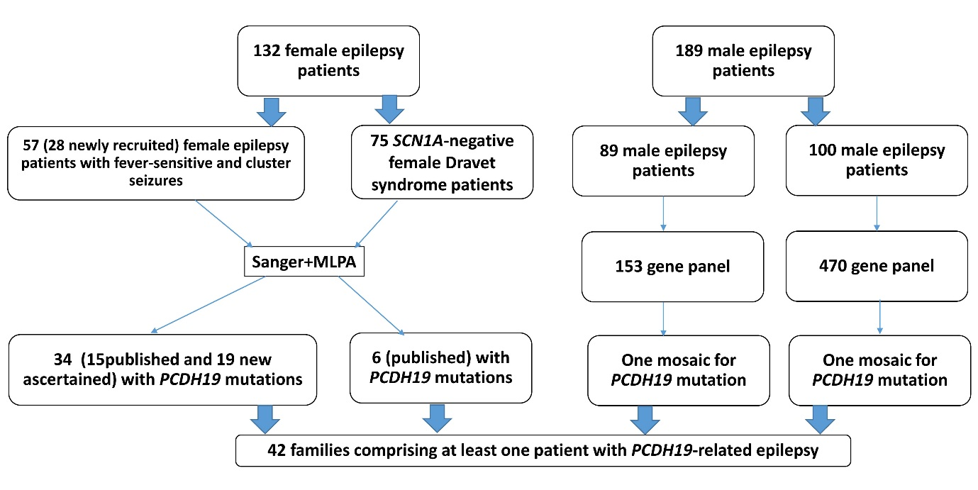
Disclosure of the ascertainment of 42 patients with PCDH19 variants in a Chinese population
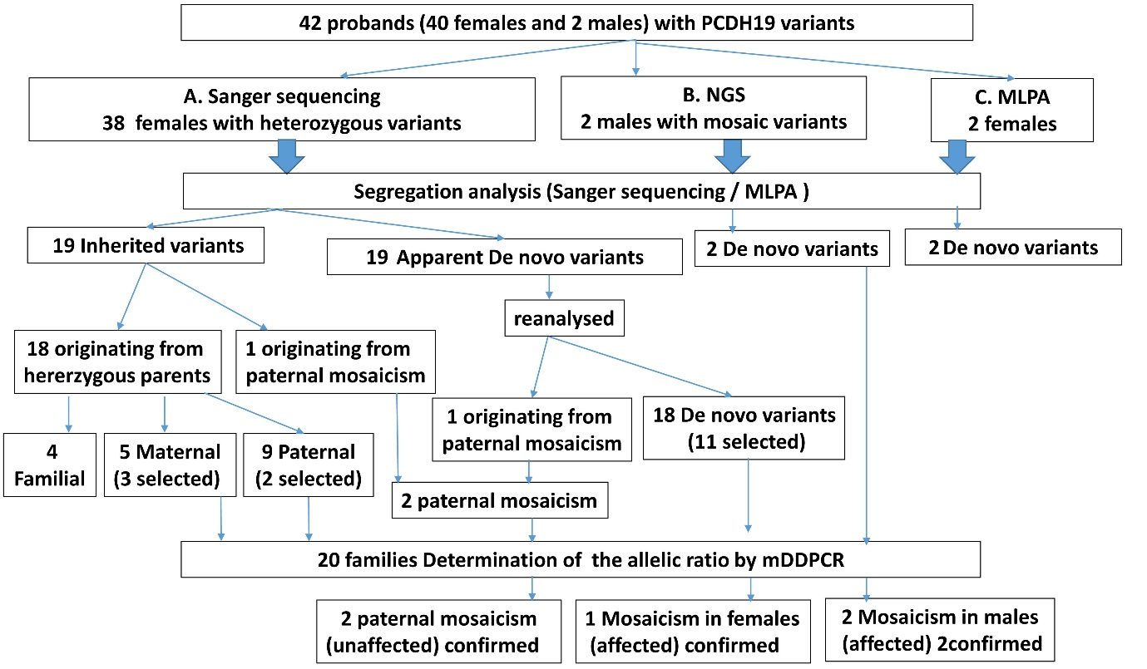
Workflow for the detection of Mosaic Mutations in 42 families

