Table S1: Primers and PCR conditions of the present study.
Gene/Exon： | Forward (5’-3') | Reverse (5’-3') | Product size | Anealing temperature
Human XRCC2-EXON1 | AGGCCCGCACACCCTATT | GGCCTTGTTCCCATCTCC | 249 bp | 63℃
Human XRCC2-EXON2 | ACAGCACCCAGCCTAAAGTT | TTGTCTGACACCGATGAGGA | 378 bp | 63℃
Human XRCC2-EXON3-1 | TGCATTTTGTAACCTACCCTTG | TCTCTAAGCACTGAGAACATTTCC | 485 bp | 61℃
Human XRCC2-EXON3-2 | tgttttgtagtcacccatctctctg | cacacataggaggatcccttgag | 575 bp | 60℃
Mouse  XRCC2-EXON2 | GCCTCAGTCGCCTCTGTACACAT | CATGGCTATGCAGGAGATCAAGTAAC | 364 bp | 59℃
Mouse 5'UTR -3'UTR | TGCTGGCGGGTAGGTTGA | ATCCAGTAAAAAGACGACAGGC | 509 bp | 60℃
Human 5'UTR -3'UTR | GGCGGGAAAGTTGAGTCTCT | CTTTCTCCTCCATTGACGCG | 536 bp | 59℃
β-actin | CCAGCCTTCCTTCTTGGGTAT | GTTGGCATAGAGGTCTTTACGG | 103bp | 60℃

Figure s1: The XRCC2 antibody affinity assay. The mice XRCC2 cDNA sequence was amplified and linked to the pDoubleEx-EGFP-flag-N plasmid, the predicted molecular size of the fusion protein is 33 Kda (a). The plasmid purified and then transfect to COS-7 cells. Transfection efficiency was assessed by cellular immunofluorescence. After the cell cultured for 48 hours, the cell was harvested and subject to Western blot assay (b).
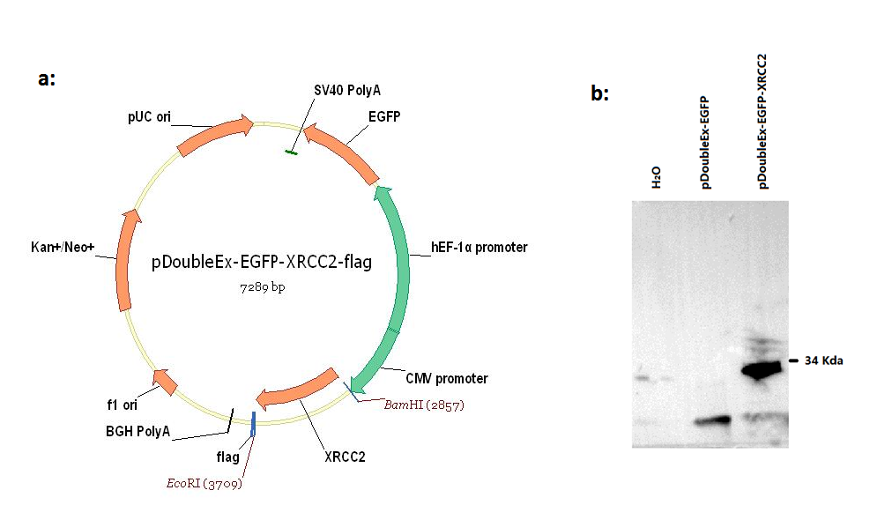

Table S2. Recent semen analyses for two infertile brothers.
 | sperm volume（ml） | PR  (Forward motion) | NP  (Non forward motion) | IM  (Inactive sperm) | PR+NP  (Total vitality) | Sperm concentration  （Million/ml）
Control case | 2.2 | 47.6 | 1.5 | 50.9 | 49.1 | 91.8
IV:2 | 2.8 | 0 | 0 | 0 | 0 | 0
IV:3 | 2.6 | 0 | 0 | 0 | 0 | 0
Normal range | ≧1.5 | ≧32 | \ | \ | ≧40 | ≧15

Table S3. General clinical data for two infertile men.
Intelligence Quotient(IQ) is based on the Wechsler Adult Intelligence Scale in Chinese.
Birth weight, weight, height and other clinical scores are based on a local Hospital Standard
Subjects | IV:2 | IV:3 | REFERENCE
Age (years) | 31.5 | 29 | -
Weight(Kg) | 68.5 | 68.5 | ～50 centile
Height(cm) | 169 | 171 | ～50 centile
Birth Weight (g) | 3050 | 2900 | ～50 centile
IQ | 100 | 110 | -
Karyotype | 46,XY | 46,XY | -
AZF(a,b,c region) | (+) | (+) | (+)
Follicle-stimulating hormone(mIU/ml) | 8.23 | 9.12 | 1.5-12.5
Luteotropic hormone (mIU/ml) | 7.9 | 8.6 | 1.7-8.6
Estradiol (pg/ml) | 38 | 35 | 25.8-60.7
Progesterone (pg/ml) | 1.1 | 0.4 | 0.2-1.4
Prolactin (pg/ml) | 12 | 7.91 | 1.6-21.4
Testosterone (pg/ml) | 7.4 | 8.25 | 2.49-8.36

Figure S2. Histology of IV:2. H&E staining revealed no sperm in the seminiferous tubules. Magnification: AB=200×. 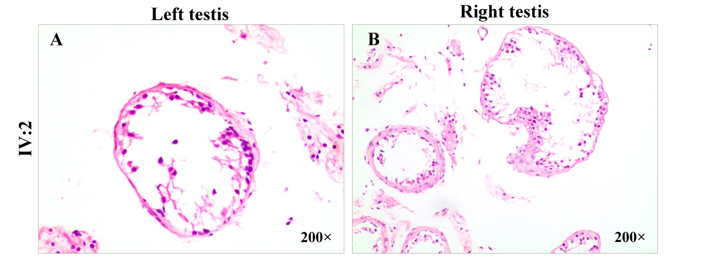

Figure S3. Details of homozygositymapping for two patients in the family. Homozygous intervals for IV:2 and IV:3 were labeled with blue and red frames, respectively. Note: All homo-intervals are more than 3Mb. 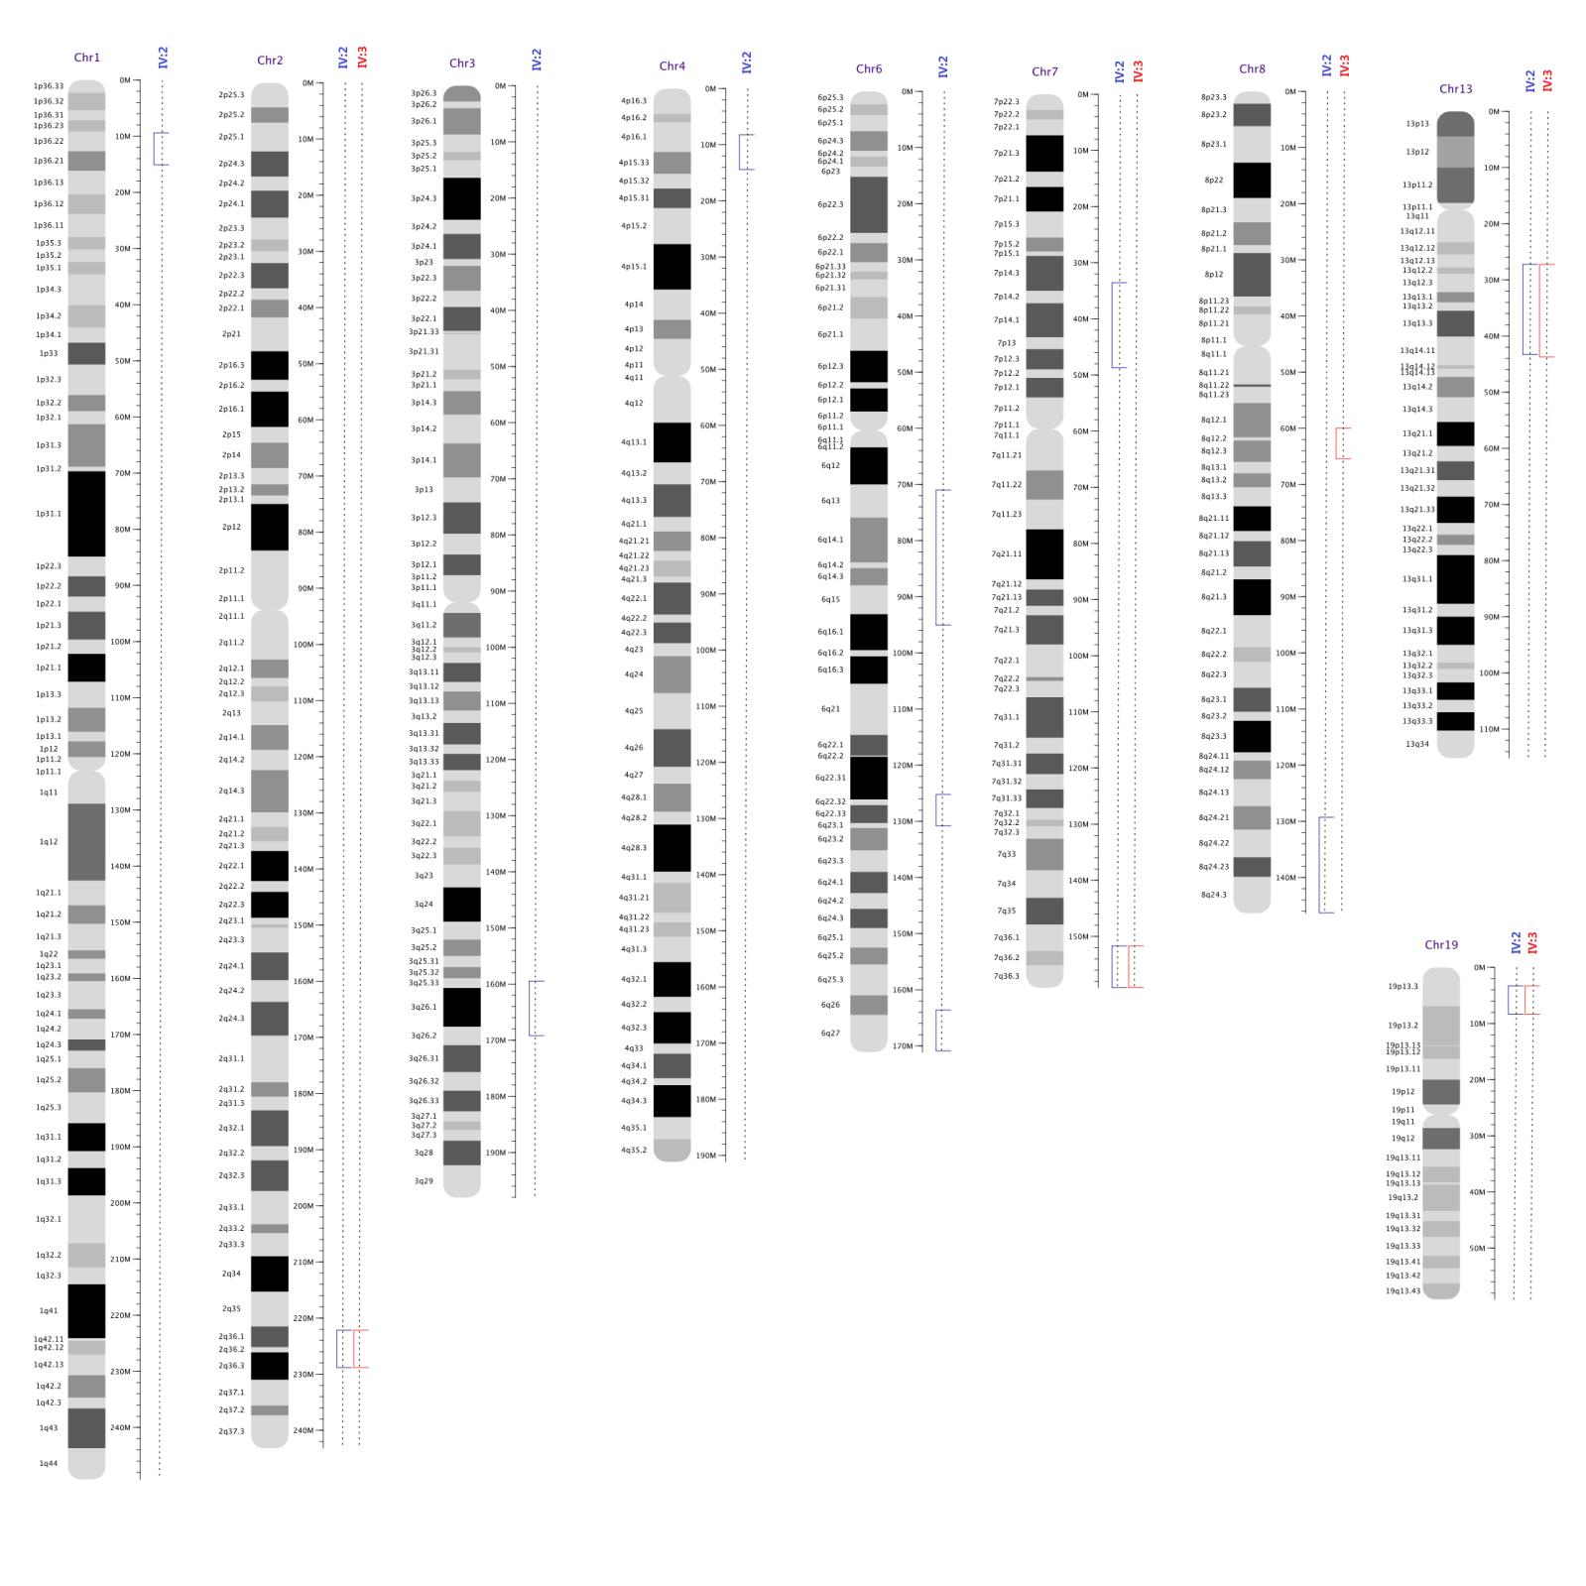

Table S4: Quality control data of whole exome sequencing for the investigated family.
Sample | IV:2 | III:5 | M0951 | IV:3
Clean reads (Read Count) | 44675216 | 40787158 | 60051812 | 55648360
Mapped reads (Read Count) | 39880494 (89.27%) | 36445660 (89.36%) | 53272753 (88.71%) | 49425059 (88.82%)
Fraction of effective bases on target | 61.75% | 60.61% | 62.82% | 62.50%
Fraction of effective bases on or near target | 92.35% | 92.28% | 92.27% | 92.26%
Average sequencing depth on target | 55.91x | 45.67x | 78.06x | 72.1x
Average sequencing depth near target | 14.94x | 12.86x | 19.73x | 18.51x
Coverage of target region | 97.90% | 97.65% | 97.90% | 97.93%
Fraction of target covered at least 4x | 97.52% | 97.09% | 97.52% | 97.56%
Fraction of target covered at least 10x | 96.60% | 95.83% | 96.76% | 96.74%
Fraction of target covered at least 20x | 92.92% | 91.03% | 94.23% | 93.76%
Fraction of target covered at least 50x | 54.86% | 38.25% | 73.47% | 69.68%

Table S5: The candidate homozygous variants identified in the family.
Chr | Position | Ref | Alt | Gene | Func. | ExonicFunc.refGene | IV:2 | IV:3 | III:4 | III:5
1 | 24296088 | G | T | SRSF10 | UTR3 | . | 1/1 | 1/1 | 1/1 | 1/1
17 | 72889676 | - | GGC… | FADS6 | exonic | nonframeshift insert | 1/1 | 1/1 | 1/1 | 1/1
21 | 14982886 | G | A | POTED | exonic | nonsynonymous SNV | 1/1 | 1/1 | 0/1 | 1/1
21 | 14982952 | A | G | POTED | exonic | nonsynonymous SNV | 1/1 | 1/1 | 1/1 | 1/1
21 | 15013735 | A | G | POTED | exonic | nonsynonymous SNV | 1/1 | 1/1 | 1/1 | 1/1
3 | 75787726 | G | A | ZNF717 | exonic | nonsynonymous SNV | 1/1 | 1/1 | 1/1 | 1/1
3 | 100170600 | - | TCC… | LNP1 | exonic | nonframeshift insert | 1/1 | 1/1 | 1/1 | 1/1
6 | 32796456 | - | ACC… | TAP2 | UTR3 | . | 1/1 | 1/1 | 1/1 | 0/1
7 | 152357866 | A | G | XRCC2 | exonic | nonsynonymous SNV | 1/1 | 1/1 | 0/1 | 0/1

Table S6: Candidate pathogenic gene (MAF<0.01).
Gene | Variant | Chr | Coord  inate | Variant  Type | Allelic  Depths | Geno  type | Transcript | CDS | Amine  Acid | Consequ  ence | MAF
XRCC2 | A>G/G | 7 | 15235  7866 | snv | 16/16 | homoz  ygous | NM_0054  31.1 | c.41T>C | p.Leu1  4Pro | missense  variant,  splice  region  variant | 0%

Figure S4: Filtering strategy for variants obtained from the whole exome sequencing.
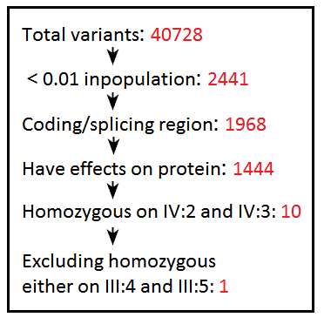

Table S7: Frequencies of chromosomal breaks induced by DNA-breaking agents mitomycin C (MMC) or cisplatin (DDP).
Samples: C1384, lymphocytes of a healthy 35-year-old man; FA, lymphocytes of a 7.5-year-old girl affected by Fanconi anemia and recessive FANCA mutations; IV:2 and IV:3, lymphocytes of two infertile brothers with the XRCC2 c.41 T>C/p.Leu14Pro mutation of this study.
Break agents (dose) | Sample | Mean breaks/cell | Analyzed cells
PBS | C1384 | 0 | 100
 | FA | 0.07 | 100
 | IV:2 | 0.01 | 100
 | IV:3 | 0 | 100
MMC （50ng/ml） | C1384 | 0.26 | 86
 | FA | 1.72 | 40
 | IV:2 | 0.23 | 78
 | IV:3 | 0.19 | 84
MMC （100ng/ml） | C1384 | 0.61 | 46
 | FA | 3.74 | 23
 | IV:2 | 0.66 | 53
 | IV:3 | 0.69 | 61
DDP（3.75ug/ml） | C1384 | 1.22 | 27
 | FA | 7.4 | 5
 | IV:2 | 1.19 | 21
 | IV:3 | 1.27 | 19

Figure S5: Representative of chromosomal breaks (arrow) in XRCC2-mutated cells (IV:3) and FANCA-mutated cells (FA). Note: Chromosomal double-strand breaks were induced by 3.75 µg/ml cisplatin. Magnification: 1000×.
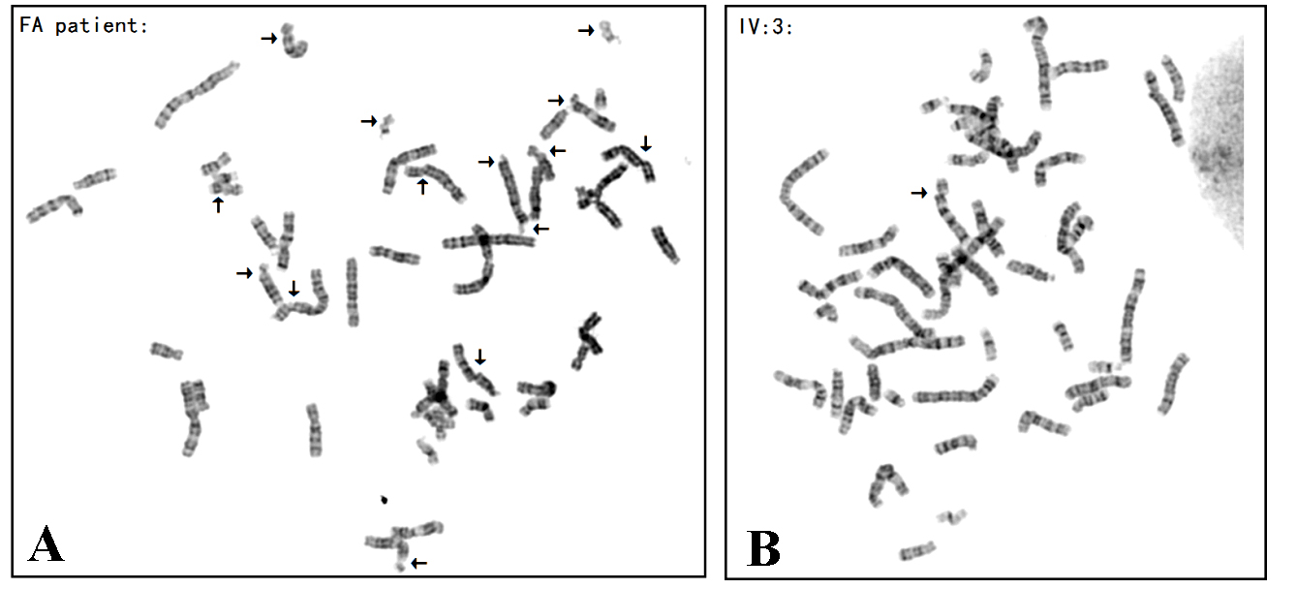

Table S8. Data of 21 litters transmitted from heterozygote (Xrcc2^{WT/L14P}) intercrosses and the data of body weight of the offspring. Total offspring=171, ♀=78,♂=93; WT=42, Heterozygote=90, Homozygote=39.
Litters | ID | Sex | Genotype | Weight(7 days) (g) | Weight (30 days) (g) | Weight (60 days) (g)
1 | F1 | ♂ | het | 5.91 | 15.67 | 26.05
 | F2 | ♂ | hom | 5.06 | 15.09 | 23.83
 | F3 | ♂ | hom | 5.64 | 15.41 | 23.56
 | F4 | ♂ | het | 5.53 | 16.28 | 24.05
 | F5 | ♂ | wt | 5.39 | 15.86 | 23.16
 | F6 | ♂ | wt | 5.16 | 13.69 | 22.69
 | F7 | ♀ | hom | 5.26 | 12.21 | 17.5
 | F8 | ♂ | het | 4.49 | 12.22 | 23.91
 | F9 | ♀ | het | 5.38 | 14.1 | 21.15
 | F10 | ♂ | het | 5.75 | 15.54 | 25.15
 | F11 | ♀ | het | 5.66 | 13.39 | 17.65
 | F12 | ♂ | wt | 5.67 | 14.99 | 24.99
2 | G1 | ♀ | het | 4.98 | 12.58 | 20.42
 | G2 | ♀ | wt | 5.04 | 12.88 | 19.83
 | G3 | ♀ | wt | 4.99 | 13.88 | 18.87
 | G4 | ♂ | wt | 4.98 | 15.63 | 25.02
 | G5 | ♂ | het | 5.24 | 14.38 | 23.87
 | G6 | ♀ | het | 3.74 | 9.68 | 17.51
 | G7 | ♂ | hom | 5.38 | 13.92 | 23.5
 | G8 | ♂ | hom | 3.8 | 8.17 | 23.18
3 | L1 | ♂ | hom | 3.78 | 12.42 | 22.77
 | L2 | ♂ | wt | 4.5 | 12.39 | 24.72
 | L3 | ♂ | hom | 3.95 | 12.57 | 23.56
 | L4 | ♀ | hom | 4.33 | 10.85 | 17.7
 | L5 | ♂ | hom | 3.67 | 11.36 | 23.74
 | L6 | ♀ | hom | 4.06 | 10.37 | 17
4 | O1 | ♂ | het | 7.96 | 17.05 | 24.85
 | O2 | ♂ | het | 7.67 | 15.77 | 24.64
 | O3 | ♀ | het | 7.22 | 14.32 | 18.16
 | O4 | ♀ | hom | 6.86 | 13.93 | 18.66
 | O5 | ♂ | hom | 6.88 | 13.18 | 21.92
 | O6 | ♂ | het | 7.52 | 15.69 | 24.88
 | O7 | ♀ | het | 4.45 | 13.96 | 18.24
5 | P1 | ♀ | het | 3.12 | 13.72 | 18.26
 | P2 | ♂ | het | 3.9 | 17.96 | 27.35
 | P3 | ♀ | wt | 3.54 | 15.75 | 19.37
 | P4 | ♂ | het | 3.66 | 16.5 | 27.98
 | P5 | ♀ | wt | 3.74 | 15.75 | 19.08
 | P6 | ♂ | wt | 2.72 | 12.41 | 23.06
6 | Q1 | ♀ | het | 2.17 | 11.68 | 17.8
 | Q2 | ♀ | het | 2.6 | 11.43 | 16.89
 | Q3 | ♀ | het | 2.61 | 11.78 | 18.02
 | Q4 | ♂ | wt | 2.56 | 12.46 | 23.31
 | Q5 | ♂ | het | 2.58 | 10.83 | 21.6
 | Q6 | ♀ | wt | 2.78 | 11.64 | 18.67
 | Q7 | ♂ | het | 2.51 | 10.25 | 11.33
 | Q8 | ♂ | het | 2.71 | 12.03 | 18.39
 | Q9 | ♂ | hom | 2.75 | 13.51 | 23.28
 | Q10 | ♀ | het | 2.54 | 11.94 | 18.35
 | Q11 | ♀ | wt | 1.61 | 8.58 | 17.79
7 | R1 | ♂ | hom | 2.53 | 15.75 | 23.62
 | R2 | ♀ | het | 2.68 | 16.22 | 20.15
 | R3 | ♂ | het | 2.96 | 8.94 | 23.22
 | R4 | ♀ | wt | 2.86 | 14.28 | 21.6
 | R5 | ♂ | wt | 2.16 | 15.76 | 26.48
 | R6 | ♂ | hom | 2.81 | 12.32 | 22.18
 | R7 | ♀ | wt | 2.12 | 12.89 | 19.08
 | R8 | ♂ | het | 3.56 | 11.56 | 28.78
8 | T1 | ♀ | hom | 5.32 | 9.97 | 17.2
 | T2 | ♂ | wt | 5.37 | 11.2 | 22.3
 | T3 | ♀ | het | 5.55 | 10.67 | 18.22
 | T4 | ♂ | het | 5.51 | 11.51 | 23.83
 | T5 | ♂ | wt | 4.88 | 8.99 | 19.57
 | T6 | ♀ | het | 5.65 | 11.29 | 18.54
9 | U1 | ♂ | het | 4.6 | 14.82 | 26.05
 | U2 | ♂ | het | 4.96 | 15.22 | 22.69
 | U3 | ♂ | wt | 4.19 | 15.47 | 25.77
 | U4 | ♂ | het | 4.6 | 12.86 | 23.34
 | U5 | ♂ | het | 4.78 | 17.37 | 22.86
 | U6 | ♀ | wt | 4.37 | 12.21 | 20.63
10 | V1 | ♀ | wt | 6.12 | 9.82 | 18.49
 | V2 | ♀ | het | 6.35 | 12.6 | 17.17
 | V3 | ♂ | wt | 7.25 | 15.23 | 26.77
 | V4 | ♀ | hom | 6.57 | 13.43 | 17.75
 | V5 | ♀ | het | 6.57 | 12.99 | 18.62
 | V6 | ♀ | wt | 6.5 | 12.67 | 16.21
 | V7 | ♂ | hom | 6.81 | 14.23 | 24.99
 | V8 | ♀ | hom | 6.25 | 12.6 | 18.98
 | V9 | ♂ | het | 6.36 | 12.83 | 21.84
 | V10 | ♂ | wt | 6.94 | 15.01 | 26.15
11 | W1 | ♂ | het | 4.92 | 11.5 | 23.66
 | W2 | ♀ | het | 5.8 | 12.53 | 21
 | W3 | ♂ | wt | 5.58 | 13.13 | 21.42
 | W4 | ♂ | hom | 5.62 | 12.62 | 26.08
 | W5 | ♂ | wt | 5.66 | 13.86 | 28.65
 | W6 | ♂ | wt | 4.52 | 11.53 | 25.02
 | W7 | ♂ | het | 5.27 | 11.69 | 26.7
 | W8 | ♀ | het | 4.93 | 10.98 | 20.06
12 | Z1 | ♂ | het | 3.53 | 13.86 | 23.14
 | Z2 | ♀ | het | 3.55 | 14.31 | 18.18
 | Z3 | ♀ | wt | 3.72 | 14.23 | 17.8
 | Z4 | ♀ | het | 4 | 14.52 | 17.44
 | Z5 | ♀ | wt | 3.66 | 12.04 | 17.12
 | Z6 | ♂ | het | 4.02 | 13.47 | 23.52
 | Z7 | ♂ | het | 3.99 | 13.7 | 21.06
 | Z8 | ♀ | wt | 3.54 | 12.6 | 17.02
 | Z9 | ♀ | wt | 3.76 | 13.37 | 19.29
13 | AA1 | ♀ | het | 6.14 | 12.93 | 17.86
 | AA2 | ♀ | het | 5.93 | 15.18 | 18.14
 | AA3 | ♂ | het | 6.11 | 18.77 | 24.33
 | AA4 | ♀ | hom | 6.26 | 13.16 | 18.33
 | AA5 | ♀ | het | 5.98 | 13.21 | 16.36
 | AA6 | ♂ | het | 6.21 | 15.16 | 25.14
 | AA7 | ♂ | het | 5.98 | 18.23 | 25.22
14 | AB1 | ♂ | het | 3.93 | 14.64 | 22.12
 | AB2 | ♂ | het | 3.49 | 11.61 | 18.93
 | AB3 | ♀ | wt | 4.1 | 13.27 | 19.62
 | AB4 | ♂ | het | 4.4 | 14.79 | 23.44
 | AB5 | ♀ | het | 3.73 | 13.01 | 20.32
 | AB6 | ♂ | hom | 4.06 | 14.9 | 22.86
 | AB7 | ♀ | het | 3.91 | 11.72 | 18.37
 | AB8 | ♂ | het | 3.01 | 12.81 | 23.36
 | AB9 | ♂ | het | 4.4 | 15.1 | 23.3
 | AB10 | ♂ | het | 3.66 | 16.8 | 22.82
 | AB11 | ♂ | het | 4.3 | 15.62 | 23.45
 | AB12 | ♀ | het | 4.12 | 12.44 | 18.42
15 | AC1 | ♀ | wt | 4.45 | 11.31 | 16.41
 | AC2 | ♀ | hom | 4.83 | 11.36 | 16.8
 | AC3 | ♀ | het | 3.82 | 11.01 | 17.92
 | AC4 | ♂ | hom | 3.67 | 12.08 | 23.07
 | AC5 | ♂ | hom | 4.8 | 12.79 | 22.55
 | AC6 | ♀ | hom | 4.59 | 14.52 | 18.56
 | AC7 | ♂ | wt | 5 | 15.02 | 21.79
 | AC8 | ♂ | wt | 4.9 | 14.27 | 22.46
 | AC9 | ♂ | hom | 5.08 | 15.28 | 21.88
 | AC10 | ♀ | het | 4.73 | 13.51 | 19.95
 | AC11 | ♀ | het | 4.64 | 12.51 | 18.79
 | AC12 | ♂ | het | 4.98 | 15.04 | 23.62
16 | AD1 | ♂ | hom | 4.94 | 13.57 | 21.8
 | AD2 | ♂ | hom | 6.18 | 14.65 | 25.44
 | AD3 | ♂ | het | 5.22 | 13.46 | 22.22
 | AD4 | ♀ | het | 5.9 | 14.43 | 18.5
 | AD5 | ♂ | het | 4.61 | 15.41 | 23.48
 | AD6 | ♂ | het | 5.98 | 15.15 | 24.49
17 | AE1 | ♀ | het | 4.38 | 16.02 | 19.69
 | AE2 | ♀ | hom | 4.29 | 15.8 | 17.56
 | AE3 | ♀ | het | 4.26 | 11.18 | 18.23
 | AE4 | ♂ | hom | 3.83 | 15.37 | 22.69
 | AE5 | ♀ | wt | 4.38 | 15.22 | 18.97
18 | AF1 | ♀ | hom | 4.16 | 13.26 | 19.1
 | AF2 | ♂ | het | 3.89 | 15.55 | 22.74
 | AF3 | ♂ | het | 4.16 | 15.98 | 23.5
 | AF4 | ♀ | hom | 4.24 | 14.57 | 20.06
 | AF5 | ♀ | het | 4.01 | 11.85 | 16.75
 | AF6 | ♂ | hom | 4.34 | 16.06 | 25.13
 | AF7 | ♂ | wt | 4.34 | 14.9 | 25.12
 | AF8 | ♂ | het | 4.33 | 14.19 | 24.31
 | AF9 | ♀ | het | 3.38 | 10.36 | 18.67
19 | AG1 | ♂ | het | 5.96 | 16.01 | 24.94
 | AG2 | ♂ | het | 5.7 | 13.75 | 22.88
 | AG3 | ♀ | hom | 5.82 | 13.76 | 19.17
 | AG4 | ♂ | hom | 6.25 | 15.95 | 22.1
 | AG5 | ♀ | het | 5.73 | 14.12 | 18.85
20 | AH1 | ♂ | hom | 4.64 | 16.3 | 21.25
 | AH2 | ♀ | wt | 5.41 | 13.69 | 19.67
 | AH3 | ♀ | hom | 5.33 | 13.78 | 18.11
 | AH4 | ♀ | wt | 5.67 | 15.02 | 18.58
 | AH5 | ♂ | het | 5.7 | 17.52 | 23.19
 | AH6 | ♀ | het | 4.9 | 13.19 | 16.62
 | AH7 | ♀ | het | 4.61 | 13.22 | 16.61
21 | AI1 | ♀ | het | 4.25 | 10.7 | 18.66
 | AI2 | ♀ | hom | 4.2 | 11.26 | 17.98
 | AI3 | ♀ | wt | 3.91 | 11.58 | 17.65
 | AI4 | ♂ | het | 4.55 | 12.1 | 24.21
 | AI5 | ♂ | wt | 4.39 | 12.94 | 23.98
 | AI6 | ♂ | het | 4.19 | 13.35 | 21.65
 | AI7 | ♀ | het | 4.04 | 12.26 | 17.85
 | AI8 | ♀ | wt | 4.27 | 12.66 | 16.92
 | AI9 | ♀ | het | 4.03 | 12.65 | 17.23
 | AI10 | ♂ | het | 4.38 | 11.61 | 23.8
 | AI11 | ♂ | het | 3.83 | 11.86 | 24.31

Table S9.Statistics in body weight between the Xrcc2^{WT/WT} and Xrcc2^{WT/L14P} male mice.
Groups | 7d | 30d | 60d
Het♂（n=46） | 4.79±1.29 | 14.46±2.23 | 23.77±3.20
WT♂（n=19） | 4.83±1.30 | 13.78±1.88 | 24.32±2.28
t | -0.10 | 1.17 | -0.60
p | 0.92 | 0.25 | 0.55

Table S10:Statistics in body weight between the Xrcc2^{WT/WT} and Xrcc2^{L14P/L14P} male mice.
Groups | 7d | 30d | 60d
Hom♂（n=23） | 4.63±1.24 | 13.80±1.91 | 23.55±1.08
WT♂（n=19） | 4.83±1.30 | 13.78±1.88 | 24.32±2.28
t | -0.51 | 0.04 | -1.11
p | 0.61 | 0.97 | 0.28

Table S11:Statistics in body weight between the Xrcc2^{WT/WT} and Xrcc2^{WT/L14P} female mice.
Groups | 7d | 30d | 60d
Het♀（n=44） | 4.52±1.18 | 12.71±1.46 | 18.44±1.27
WT♀（n=25） | 4.22±1.19 | 12.94±1.71 | 18.72±1.41
t | 1.01 | -0.59 | -0.64
p | 0.32 | 0.56 | 0.53

Table S12.Statistics in body weight between the Xrcc2^{WT/WT} and Xrcc2^{L14P/L14P} female mice at 30 and 60 days.
Groups | 30d | 60d
Hom（n=14） | 12.84±1.72 | 17.89±0.70
WT（n=25） | 12.94±1.71 | 18.72±1.41
t | -0.17 | -1.56
p | 0.86 | 0.13

Figure S6: Physical characteristics of three males with different genotypes at 28 days post-partum.
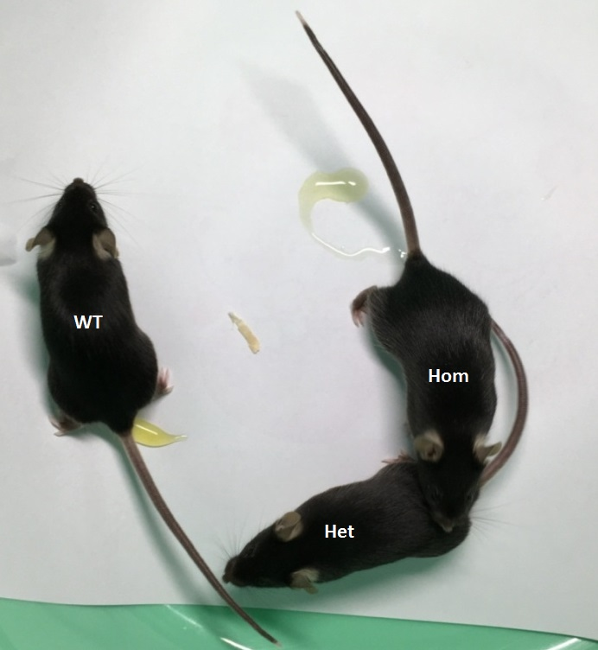

Figure S7: Testis characteristics of homozygotes or WT mice from 7 days to 180 days post-partum (dpp). A: Testis size; BCDEF: H&E staining ofseminiferous tubule, magnification=1000×.
Note: In 28 dpp tubules, multiple layers of spermatocytes were arrested at the zygotene stage of prophase I for homozygotes; in 180 dpp tubules, cells were arrested in the zygotene (arrow head) or pachytene stage (arrow).
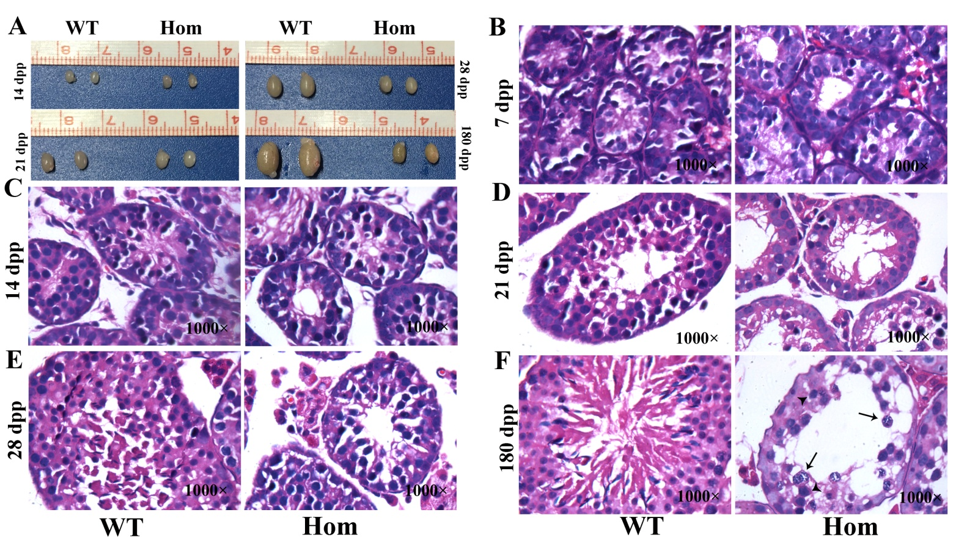

Table S13: Fertility of male homozygous mice. Data of 17 (8-week old) Xrcc2^{L14P/L14P} males mated with wild-type or heterozygousfemales for 60–90 days.
Male ID | Female ID | Mating days | Giving birth status
♂ 0721 25（hom) (L1） | ♀ 0714 11(het) (L3) | 90 days | no birth
♂ 0714 13（hom) (L2） | ♀ 0721 21(wt)(L2) | 90 days | no birth
♂ 0714 13(hom) (L3) | ♀ 160917 B3(wt) (F3) | 90 days | no birth
♂ 161101 C2(hom) (L2) | ♀ 160907 A5(wt) (R1) | 90 days | no birth
♂ 161107 D1(hom) (L1) | ♀ 161101 C4(het) (L4) | 90 days | no birth
♂ 161107 D7(hom) (R3) | ♀ 161101 C6(het) (R2) | 60 days | no birth
♂ 161127 F2(hom) (L2) | ♀ 161127 G2(wt) (L2) | 60 days | no birth
♂ 161127 F3(hom) (L3) | ♀ 161127 G3(wt) (L3) | 60 days | no birth
♂ 161127 G8(hom) (R4) | ♀ 161127 F9(het) (FL1) | 60 days | no birth
♂ 161201 H3(hom) (L3) | ♀ 161204 I1(wt) (L1) | 60 days | no birth
♂ 161229 K5(hom) (R1) | ♀ 161204 R4(wt) (L4) | 60 days | no birth
♂ 170110 L4(hom) (L4) | ♀ 161204 I5(wt) (R1) | 60 days | no birth
♂ 170111 M6(hom) (R2) | ♀ 161204 I2(wt) (L2) | 60 days | no birth
♂ 170111 M7(hom) (R3) | ♀ 161127 G2(wt) (L2) | 60 days | no birth
♂ 170110 L5(hom) (R1) | ♀ 170111 M4(wt) (R4) | 60 days | no birth
♂ 170110 L1(hom) (L1) | ♀ 170111 M8(wt) (R4) | 60 days | no birth
♂ 170110 L3(hom) (L3) | ♀ 170111 M1(wt) (L1) | 60 days | no birth

Table S14.Fertility of female homozygote mice. Data of 17 (8-week old) Xrcc2^{L14P/L14P} females continually mated with WT or heterozygote males for 60 days.
Male ID | Female ID | Mating days | Fertility | Litter size
♂ 0410 25(het) | ♀ 0714 10(hom) | 41 days | yes | 7
♂ 071414 L1(wt) | ♀ 0721 20(hom) | 45 days | yes | 5
♂ 161107 D4(het)(L4) | ♀ 161101 C5(hom)(R1) | 24 days | yes | 5
♂ 161127 F12(wt)(FL4) | ♀ 170110 L6(hom)(R2) | 52 days | yes | 4
♂ 161127 F6(wt)(R2) | ♀ 170111 M3(hom)(L3) | 46 days | yes | 4
♂ 161204 I5(wt)(R1) | ♀ 170110 L4(hom)(L4) | 46 days | yes | 5
♂ 160907 A7 (wt)(R3) | ♀ 161101 C8(hom)(R4) | 53 days | yes | 2
♂ 161107 D4(het)(L4) | ♀ 161101 C5(hom)(R1) | 47 days | yes | 1
♂ 170121 P6(wt)(R2) | ♀ 170120 O4(hom)(L4) | 46 days | yes | 8
♂ 0405 22(het) | ♀ 160907 A1(hom)(F1) | 60 days | no birth | -
♂ 161107 D4(het)(L4) | ♀ 161101 C7(hom)(R1) | 60 days | no birth | -
♂ 161127 G4(het)(L4) | ♀ 161127 F7(hom)(R3) | 60 days | no birth | -
♂ 160907 A6(het)(R2) | ♀ 161201 H1(hom)(L1) | 60 days | no birth | -
♂ 161204 I6(wt)(R2) | ♀ 161201 H5(hom)(R1) | 60 days | no birth | -
♂ 170111 M2 (wt)(L2) | ♀ 170213 T1(hom)(L1) | 60 days | no birth | -
♂ 170205 S2 (wt)(L2) | ♀ 170214 V4(hom)(L4) | 60 days | no birth | -
♂ 170213 T5 (wt)(R1) | ♀ 170222 X4(hom)(L4) | 60 days | no birth | -

Table S15. Statistics of litter size and mating time between fertile Xrcc2^{L14P/L14P} and Xrcc2^{L14P/WT} females.

Groups | Mating time to give birth | Litter size
XRCC2^{L14P/L14P} females（n=9） | 44.44±8.47 | 4.56±2.19
XRCC2^{L14P/WT}females（n=27） | 23.41±4.24 | 7.85±2.28
t | 9.87 | -3.79
p | ＜0.0001 | ＜0.001

Table S16. Results of histology of Xrcc2^{L14P/L14P} mice ovaries from 7 days to 180 days post-partum (dpp).

Mice age | 7 dpp | 14 dpp | 21 dpp | 28 dpp | 90 dpp | 180 dpp
Number of ovaries | 10 | 10 | 10 | 10 | 10 | 10
Follicle visiable | 10 | 10 | 8 | 7 | 5 | 2
Follicle invisiable | 0 | 0 | 2 | 3 | 5 | 8

Figure S8: Representative H&E staining figures of Xrcc2-mutated mice ovaries from 7 days to 180 days post-partum.
Magnification=100. Box: ovary.
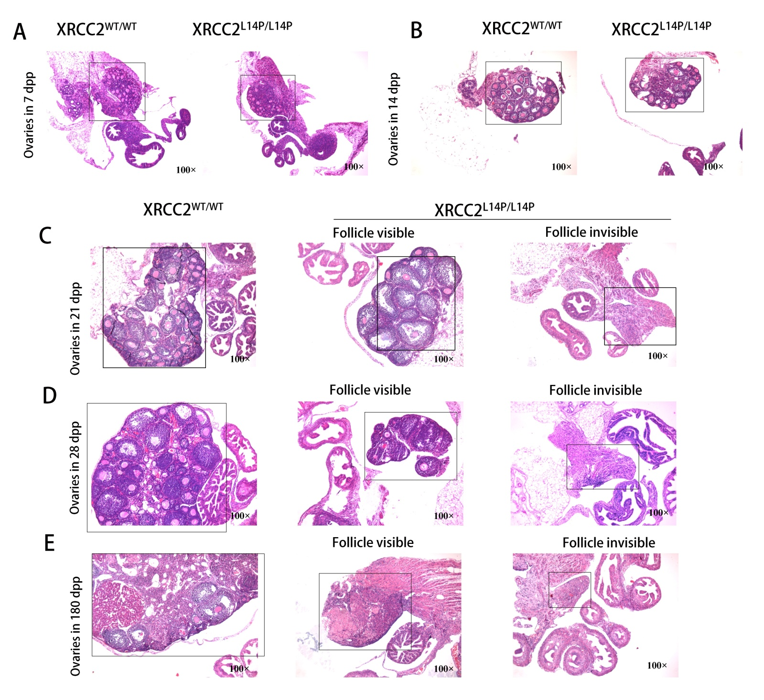

Figure S9: Diagram of models of XRCC2 and other RAD51 paralogs.
(A) Functional regions are shown for five RAD51 paralogs. Note: XRCC2 shows a special structure, and the asterisk indicates the position of the p.L14P mutation.
(B) Ribbon diagram of XRCC2. Arrow: residue 14-leucine is substituted by proline. The linker regions are encircled. This diagram was created by SWISS-MODEL (https://www.swissmodel.expasy.org) using the template 5h1c.1.

