Cheng et al Supplementary Information

Table of contents
Figure S1. The cyclization products of 019-CAR and eGFP.
Figure S2. Target fragments amplified with 96 pairs of primers produced minicircle molecule more efficiently.
Figure S3. The transgene expression level and duration of mini-GFP in K562 Cells.
Figure S4. 019-CAR minicircle vector (Kit-minicircle-019) produced with a commercially available kit.
Table S1. List of 96 pairs of primers for transgene amplification.

Supplemental figure legends
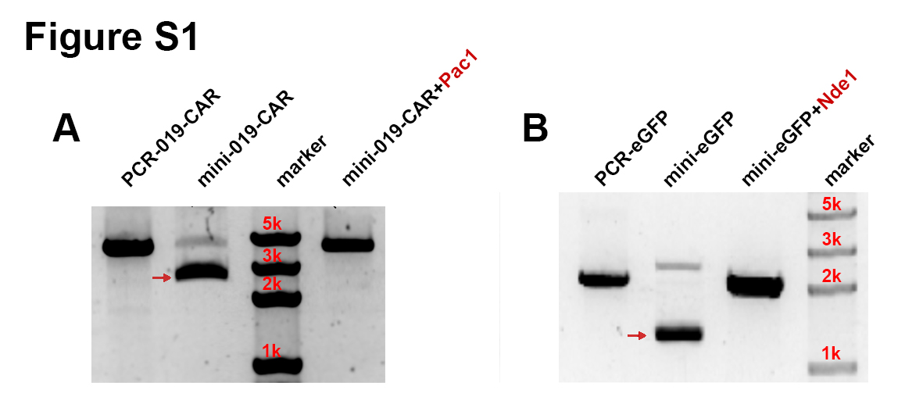
Figure S1. The cyclization products of 019-CAR and eGFP. (A) mini-019-CAR was digested by PacI and (B) mini-eGFP was digested by NdeI. The minicircle molecule was indicated by the red arrow.

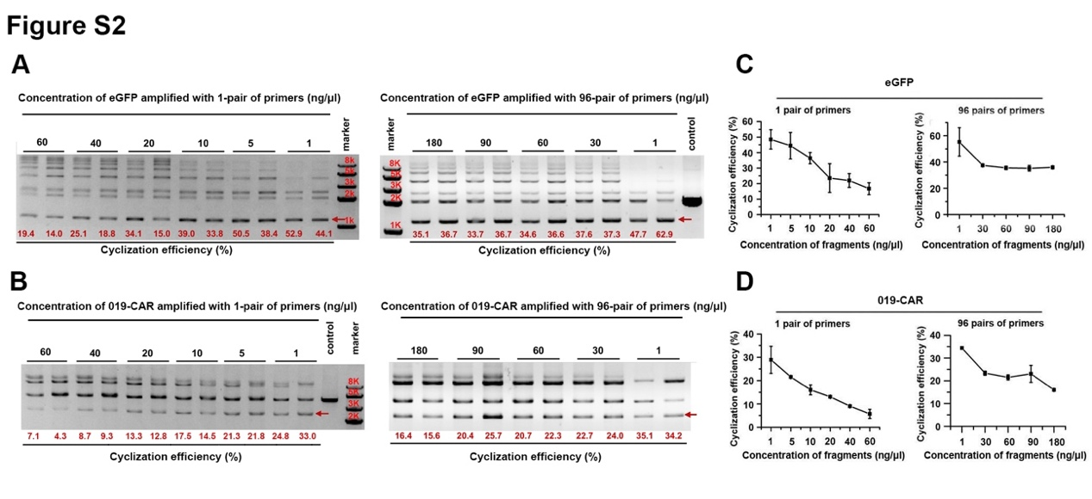
Figure S2. Target fragments amplified with 96 pairs of primers produced minicircle molecule more efficiently. Agarose gel electrophoresis of ligation products from (A) eGFP fragments or (B) 019-CAR fragments amplified with 1 pair of primers in the concentration of 1, 5 10, 20, 40 and 60 ng/μl (left panel). Ligation products amplified with 96 pairs of primers in the concentration of 1, 30, 60, 90 and 180 ng/μl (right panel). The target minicircle molecule was indicated by the red arrow. The cyclization efficiency was quantified based on bend intensity and the numeric value was marked in red font. (C) Quantification of cyclization efficiency of eGFP minicircle. (D) Quantification of cyclization efficiency of 019-CAR minicircle.

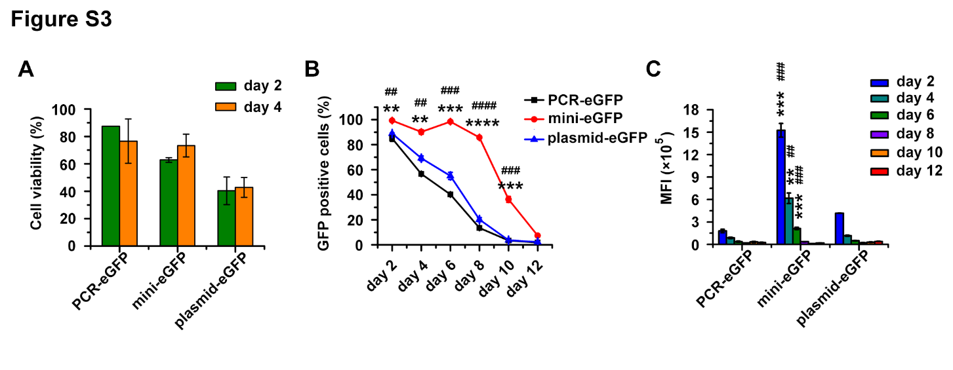
Figure S3. The transgene expression level and duration of mini-eGFP in K562 cells. (A) Cell viability of K562 transfected with linear PCR product, BF minicircle vector and plasmid encoding eGFP 2 days and 4 days after electroporation. (B) The proportion of eGFP positive cells at different time points in K562 cells transfected with linear PCR product, BF minicircle vector, and plasmid encoding eGFP. (C) The Mean Fluorescence Intensity (MFI) of eGFP positive cells at different time points. Unpaired multiple two-tailed t test, **, *** and **** indicated the significant differences between mini-eGFP group and plasmid-eGFP group. **P<0.01; ***P<0.001; ****P<0.0001; ##, ### and #### indicated the significant differences between mini-eGFP group and PCR-eGFP group. ## P<0.01; ### P<0.001; #### P<0.0001.

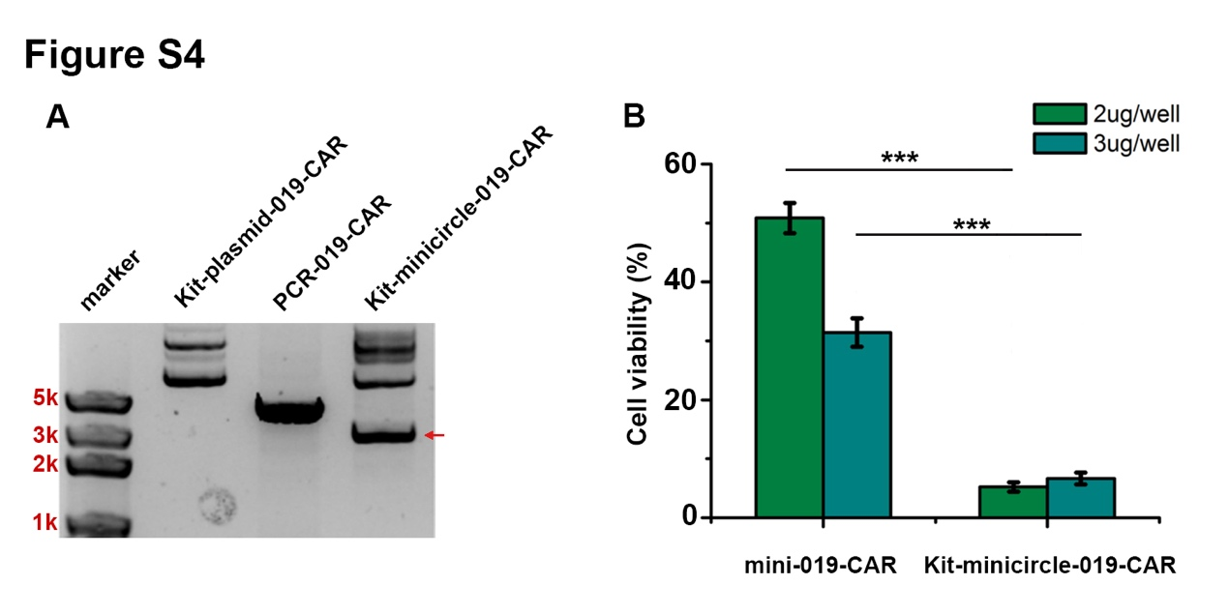
Figure S4. 019-CAR minicircle vector (Kit-minicircle-019-CAR) produced with a commercially available kit. (A) Agarose gel electrophoresis of Kit-plasmid-019-CAR, fragment of PCR-019-CAR and Kit-minicircle-019-CAR. To generate minicircle using commercially available kit, gene fragment (PCR-019-CAR) needs to be first cloned into parental plasmid, which is named as Kit-plasmid-019-CAR. The minicircle product generated using this kit is shown as Kit-minicircle-019-CAR, indicated by red arrow. (B) Cell viability of T cells electroporated with Kit-minicircle-019-CAR and mini-019-CAR. T cells were electroporated with 2 μg or
3 μg Kit-minicircle-019-CAR and mini-019-CAR respectively. Live cells were counted 48 hours after electroporation. *** indicated the significant differences between mini-019-CAR group and Kit-minicircle-019-CAR group. ***P<0.001.

Table S1: List of 96 pairs of primers for transgene amplification

No. | Sequences (5’—3’)
F.1 | ATCGTA GAAGAC AG AACC GTCCACTTCAGGACAGCATG
R.1 | ATCGTA GAAGAC AG GGTTT TCTGTCACCAATCCTGTCC
F.2 | ATCGTA GAAGAC AG AACG GTCCACTTCAGGACAGCATG
R.2 | ATCGTA GAAGAC AG CGTTT TCTGTCACCAATCCTGTCC
F.3 | ATCGTA GAAGAC AG AAGC GTCCACTTCAGGACAGCATG
R.3 | ATCGTA GAAGAC AG GCTTT TCTGTCACCAATCCTGTCC
F.4 | ATCGTA GAAGAC AG AAGG GTCCACTTCAGGACAGCATG
R.4 | ATCGTA GAAGAC AG CCTTT TCTGTCACCAATCCTGTCC
F.5 | ATCGTA GAAGAC AG ATCA GTCCACTTCAGGACAGCATG
R.5 | ATCGTA GAAGAC AG TGATT TCTGTCACCAATCCTGTCC
F.6 | ATCGTA GAAGAC AG ATCT GTCCACTTCAGGACAGCATG
R.6 | ATCGTA GAAGAC AG AGATT TCTGTCACCAATCCTGTCC
F.7 | ATCGTA GAAGAC AG ATCC GTCCACTTCAGGACAGCATG
R.7 | ATCGTA GAAGAC AG GGATT TCTGTCACCAATCCTGTCC
F.8 | ATCGTA GAAGAC AG ATCG GTCCACTTCAGGACAGCATG
R.8 | ATCGTA GAAGAC AG CGATT TCTGTCACCAATCCTGTCC
F.9 | ATCGTA GAAGAC AG ATGA GTCCACTTCAGGACAGCATG
R.9 | ATCGTA GAAGAC AG TCATT TCTGTCACCAATCCTGTCC
F.10 | ATCGTA GAAGAC AG ATGT GTCCACTTCAGGACAGCATG
R.10 | ATCGTA GAAGAC AG ACATT TCTGTCACCAATCCTGTCC
F.11 | ATCGTA GAAGAC AG ATGC GTCCACTTCAGGACAGCATG
R.11 | ATCGTA GAAGAC AG GCATT TCTGTCACCAATCCTGTCC
F.12 | ATCGTA GAAGAC AG ATGG GTCCACTTCAGGACAGCATG
R.12 | ATCGTA GAAGAC AG CCATT TCTGTCACCAATCCTGTCC
F.13 | ATCGTA GAAGAC AG ACAA GTCCACTTCAGGACAGCATG
R.13 | ATCGTA GAAGAC AG TTGTT TCTGTCACCAATCCTGTCC
F.14 | ATCGTA GAAGAC AG ACAC GTCCACTTCAGGACAGCATG
R.14 | ATCGTA GAAGAC AG GTGTT TCTGTCACCAATCCTGTCC
F.15 | ATCGTA GAAGAC AG ACAG GTCCACTTCAGGACAGCATG
R.15 | ATCGTA GAAGAC AG CTGTT TCTGTCACCAATCCTGTCC
F.16 | ATCGTA GAAGAC AG ACTA GTCCACTTCAGGACAGCATG
R.16 | ATCGTA GAAGAC AG TAGTT TCTGTCACCAATCCTGTCC
F.17 | ATCGTA GAAGAC AG ACTC GTCCACTTCAGGACAGCATG
R.17 | ATCGTA GAAGAC AG GAGTT TCTGTCACCAATCCTGTCC
F.18 | ATCGTA GAAGAC AG ACTG GTCCACTTCAGGACAGCATG
R.18 | ATCGTA GAAGAC AG CAGTT TCTGTCACCAATCCTGTCC
F.19 | ATCGTA GAAGAC AG ACCA GTCCACTTCAGGACAGCATG
R.19 | ATCGTA GAAGAC AG TGGTT TCTGTCACCAATCCTGTCC
F.20 | ATCGTA GAAGAC AG ACCT GTCCACTTCAGGACAGCATG
R.20 | ATCGTA GAAGAC AG AGGTT TCTGTCACCAATCCTGTCC
F.21 | ATCGTA GAAGAC AG ACCC GTCCACTTCAGGACAGCATG
R.21 | ATCGTA GAAGAC AG GGGTT TCTGTCACCAATCCTGTCC
F.22 | ATCGTA GAAGAC AG ACCG GTCCACTTCAGGACAGCATG
R.22 | ATCGTA GAAGAC AG CGGTT TCTGTCACCAATCCTGTCC
F.23 | ATCGTA GAAGAC AG ACGA GTCCACTTCAGGACAGCATG
R.23 | ATCGTA GAAGAC AG TCGTT TCTGTCACCAATCCTGTCC
F.24 | ATCGTA GAAGAC AG ACGC GTCCACTTCAGGACAGCATG
R.24 | ATCGTA GAAGAC AG GCGTT TCTGTCACCAATCCTGTCC
F.25 | ATCGTA GAAGAC AG ACGG GTCCACTTCAGGACAGCATG
R.25 | ATCGTA GAAGAC AG CCGTT TCTGTCACCAATCCTGTCC
F.26 | ATCGTA GAAGAC AG AGAA GTCCACTTCAGGACAGCATG
R.26 | ATCGTA GAAGAC AG TTCTT TCTGTCACCAATCCTGTCC
F.27 | ATCGTA GAAGAC AG AGAC GTCCACTTCAGGACAGCATG
R.27 | ATCGTA GAAGAC AG GTCTT TCTGTCACCAATCCTGTCC
F.28 | ATCGTA GAAGAC AG AGAG GTCCACTTCAGGACAGCATG
R.28 | ATCGTA GAAGAC AG CTCTT TCTGTCACCAATCCTGTCC
F.29 | ATCGTA GAAGAC AG AGTA GTCCACTTCAGGACAGCATG
R.29 | ATCGTA GAAGAC AG TACTT TCTGTCACCAATCCTGTCC
F.30 | ATCGTA GAAGAC AG AGTC GTCCACTTCAGGACAGCATG
R.30 | ATCGTA GAAGAC AG GACTT TCTGTCACCAATCCTGTCC
F.31 | ATCGTA GAAGAC AG AGTG GTCCACTTCAGGACAGCATG
R.31 | ATCGTA GAAGAC AG CACTT TCTGTCACCAATCCTGTCC
F.32 | ATCGTA GAAGAC AG AGCA GTCCACTTCAGGACAGCATG
R.32 | ATCGTA GAAGAC AG TGCTT TCTGTCACCAATCCTGTCC
F.33 | ATCGTA GAAGAC AG AGCC GTCCACTTCAGGACAGCATG
R.33 | ATCGTA GAAGAC AG GGCTT TCTGTCACCAATCCTGTCC
F.34 | ATCGTA GAAGAC AG AGCG GTCCACTTCAGGACAGCATG
R.34 | ATCGTA GAAGAC AG CGCTT TCTGTCACCAATCCTGTCC
F.35 | ATCGTA GAAGAC AG AGGA GTCCACTTCAGGACAGCATG
R.35 | ATCGTA GAAGAC AG TCCTT TCTGTCACCAATCCTGTCC
F.36 | ATCGTA GAAGAC AG AGGC GTCCACTTCAGGACAGCATG
R.36 | ATCGTA GAAGAC AG GCCTT TCTGTCACCAATCCTGTCC
F.37 | ATCGTA GAAGAC AG AGGG GTCCACTTCAGGACAGCATG
R.37 | ATCGTA GAAGAC AG CCCTT TCTGTCACCAATCCTGTCC
F.38 | ATCGTA GAAGAC AG TACA GTCCACTTCAGGACAGCATG
R.38 | ATCGTA GAAGAC AG TGTAT TCTGTCACCAATCCTGTCC
F.39 | ATCGTA GAAGAC AG TACC GTCCACTTCAGGACAGCATG
R.39 | ATCGTA GAAGAC AG GGTAT TCTGTCACCAATCCTGTCC
F.40 | ATCGTA GAAGAC AG TACG GTCCACTTCAGGACAGCATG
R.40 | ATCGTA GAAGAC AG CGTAT TCTGTCACCAATCCTGTCC
F.41 | ATCGTA GAAGAC AG TAGA GTCCACTTCAGGACAGCATG
R.41 | ATCGTA GAAGAC AG TCTAT TCTGTCACCAATCCTGTCC
F.42 | ATCGTA GAAGAC AG TAGC GTCCACTTCAGGACAGCATG
R.42 | ATCGTA GAAGAC AG GCTAT TCTGTCACCAATCCTGTCC
F.43 | ATCGTA GAAGAC AG TAGG GTCCACTTCAGGACAGCATG
R.43 | ATCGTA GAAGAC AG CCTAT TCTGTCACCAATCCTGTCC
F.44 | ATCGTA GAAGAC AG TTAC GTCCACTTCAGGACAGCATG
R.44 | ATCGTA GAAGAC AG GTAAT TCTGTCACCAATCCTGTCC
F.45 | ATCGTA GAAGAC AG TTAG GTCCACTTCAGGACAGCATG
R.45 | ATCGTA GAAGAC AG CTAAT TCTGTCACCAATCCTGTCC
F.46 | ATCGTA GAAGAC AG TTCA GTCCACTTCAGGACAGCATG
R.46 | ATCGTA GAAGAC AG TGAAT TCTGTCACCAATCCTGTCC
F.47 | ATCGTA GAAGAC AG TTCC GTCCACTTCAGGACAGCATG
R.47 | ATCGTA GAAGAC AG GGAAT TCTGTCACCAATCCTGTCC
F.48 | ATCGTA GAAGAC AG TTCG GTCCACTTCAGGACAGCATG
R.48 | ATCGTA GAAGAC AG CGAAT TCTGTCACCAATCCTGTCC
F.49 | ATCGTA GAAGAC AG TTGA GTCCACTTCAGGACAGCATG
R.49 | ATCGTA GAAGAC AG TCAAT TCTGTCACCAATCCTGTCC
F.50 | ATCGTA GAAGAC AG TTGC GTCCACTTCAGGACAGCATG
R.50 | ATCGTA GAAGAC AG GCAAT TCTGTCACCAATCCTGTCC
F.51 | ATCGTA GAAGAC AG TTGG GTCCACTTCAGGACAGCATG
R.51 | ATCGTA GAAGAC AG CCAAT TCTGTCACCAATCCTGTCC
F.52 | ATCGTA GAAGAC AG TCAC GTCCACTTCAGGACAGCATG
R.52 | ATCGTA GAAGAC AG GTGAT TCTGTCACCAATCCTGTCC
F.53 | ATCGTA GAAGAC AG TCAG GTCCACTTCAGGACAGCATG
R.53 | ATCGTA GAAGAC AG CTGAT TCTGTCACCAATCCTGTCC
F.54 | ATCGTA GAAGAC AG TCTC GTCCACTTCAGGACAGCATG
R.54 | ATCGTA GAAGAC AG GAGAT TCTGTCACCAATCCTGTCC
F.55 | ATCGTA GAAGAC AG TCTG GTCCACTTCAGGACAGCATG
R.55 | ATCGTA GAAGAC AG CAGAT TCTGTCACCAATCCTGTCC
F.56 | ATCGTA GAAGAC AG TCCA GTCCACTTCAGGACAGCATG
R.56 | ATCGTA GAAGAC AG TGGAT TCTGTCACCAATCCTGTCC
F.57 | ATCGTA GAAGAC AG TCCC GTCCACTTCAGGACAGCATG
R.57 | ATCGTA GAAGAC AG GGGAT TCTGTCACCAATCCTGTCC
F.58 | ATCGTA GAAGAC AG TCCG GTCCACTTCAGGACAGCATG
R.58 | ATCGTA GAAGAC AG CGGAT TCTGTCACCAATCCTGTCC
F.59 | ATCGTA GAAGAC AG TCGC GTCCACTTCAGGACAGCATG
R.59 | ATCGTA GAAGAC AG GCGAT TCTGTCACCAATCCTGTCC
F.60 | ATCGTA GAAGAC AG TCGG GTCCACTTCAGGACAGCATG
R.60 | ATCGTA GAAGAC AG CCGAT TCTGTCACCAATCCTGTCC
F.61 | ATCGTA GAAGAC AG TGAC GTCCACTTCAGGACAGCATG
R.61 | ATCGTA GAAGAC AG GTCAT TCTGTCACCAATCCTGTCC
F.62 | ATCGTA GAAGAC AG TGAG GTCCACTTCAGGACAGCATG
R.62 | ATCGTA GAAGAC AG CTCAT TCTGTCACCAATCCTGTCC
F.63 | ATCGTA GAAGAC AG TGTC GTCCACTTCAGGACAGCATG
R.63 | ATCGTA GAAGAC AG GACAT TCTGTCACCAATCCTGTCC
F.64 | ATCGTA GAAGAC AG TGTG GTCCACTTCAGGACAGCATG
R.64 | ATCGTA GAAGAC AG CACAT TCTGTCACCAATCCTGTCC
F.65 | ATCGTA GAAGAC AG TGCC GTCCACTTCAGGACAGCATG
R.65 | ATCGTA GAAGAC AG GGCAT TCTGTCACCAATCCTGTCC
F.66 | ATCGTA GAAGAC AG TGCG GTCCACTTCAGGACAGCATG
R.66 | ATCGTA GAAGAC AG CGCAT TCTGTCACCAATCCTGTCC
F.67 | ATCGTA GAAGAC AG TGGC GTCCACTTCAGGACAGCATG
R.67 | ATCGTA GAAGAC AG GCCAT TCTGTCACCAATCCTGTCC
F.68 | ATCGTA GAAGAC AG TGGG GTCCACTTCAGGACAGCATG
R.68 | ATCGTA GAAGAC AG CCCAT TCTGTCACCAATCCTGTCC
F.69 | ATCGTA GAAGAC AG CAAC GTCCACTTCAGGACAGCATG
R.69 | ATCGTA GAAGAC AG GTTGT TCTGTCACCAATCCTGTCC
F.70 | ATCGTA GAAGAC AG CAAG GTCCACTTCAGGACAGCATG
R.70 | ATCGTA GAAGAC AG CTTGT TCTGTCACCAATCCTGTCC
F.71 | ATCGTA GAAGAC AG CATC GTCCACTTCAGGACAGCATG
R.71 | ATCGTA GAAGAC AG GATGT TCTGTCACCAATCCTGTCC
F.72 | ATCGTA GAAGAC AG CACC GTCCACTTCAGGACAGCATG
R.72 | ATCGTA GAAGAC AG GGTGT TCTGTCACCAATCCTGTCC
F.73 | ATCGTA GAAGAC AG CACG GTCCACTTCAGGACAGCATG
R.73 | ATCGTA GAAGAC AG CGTGT TCTGTCACCAATCCTGTCC
F.74 | ATCGTA GAAGAC AG CAGC GTCCACTTCAGGACAGCATG
R.74 | ATCGTA GAAGAC AG GCTGT TCTGTCACCAATCCTGTCC
F.75 | ATCGTA GAAGAC AG CAGG GTCCACTTCAGGACAGCATG
R.75 | ATCGTA GAAGAC AG CCTGT TCTGTCACCAATCCTGTCC
F.76 | ATCGTA GAAGAC AG CTAC GTCCACTTCAGGACAGCATG
R.76 | ATCGTA GAAGAC AG GTAGT TCTGTCACCAATCCTGTCC
F.77 | ATCGTA GAAGAC AG CTTC GTCCACTTCAGGACAGCATG
R.77 | ATCGTA GAAGAC AG GAAGT TCTGTCACCAATCCTGTCC
F.78 | ATCGTA GAAGAC AG CTCC GTCCACTTCAGGACAGCATG
R.78 | ATCGTA GAAGAC AG GGAGT TCTGTCACCAATCCTGTCC
F.79 | ATCGTA GAAGAC AG CTCG GTCCACTTCAGGACAGCATG
R.79 | ATCGTA GAAGAC AG CGAGT TCTGTCACCAATCCTGTCC
F.80 | ATCGTA GAAGAC AG CTGC GTCCACTTCAGGACAGCATG
R.80 | ATCGTA GAAGAC AG GCAGT TCTGTCACCAATCCTGTCC
F.81 | ATCGTA GAAGAC AG CTGG GTCCACTTCAGGACAGCATG
R.81 | ATCGTA GAAGAC AG CCAGT TCTGTCACCAATCCTGTCC
F.82 | ATCGTA GAAGAC AG CCAC GTCCACTTCAGGACAGCATG
R.82 | ATCGTA GAAGAC AG GTGGT TCTGTCACCAATCCTGTCC
F.83 | ATCGTA GAAGAC AG CCTC GTCCACTTCAGGACAGCATG
R.83 | ATCGTA GAAGAC AG GAGGT TCTGTCACCAATCCTGTCC
F.84 | ATCGTA GAAGAC AG CCCC GTCCACTTCAGGACAGCATG
R.84 | ATCGTA GAAGAC AG GGGGT TCTGTCACCAATCCTGTCC
F.85 | ATCGTA GAAGAC AG CCCG GTCCACTTCAGGACAGCATG
R.85 | ATCGTA GAAGAC AG CGGGT TCTGTCACCAATCCTGTCC
F.86 | ATCGTA GAAGAC AG CCGC GTCCACTTCAGGACAGCATG
R.86 | ATCGTA GAAGAC AG GCGGT TCTGTCACCAATCCTGTCC
F.87 | ATCGTA GAAGAC AG CGAC GTCCACTTCAGGACAGCATG
R.87 | ATCGTA GAAGAC AG GTCGT TCTGTCACCAATCCTGTCC
F.88 | ATCGTA GAAGAC AG CGTC GTCCACTTCAGGACAGCATG
R.88 | ATCGTA GAAGAC AG GACGT TCTGTCACCAATCCTGTCC
F.89 | ATCGTA GAAGAC AG CGCC GTCCACTTCAGGACAGCATG
R.89 | ATCGTA GAAGAC AG GGCGT TCTGTCACCAATCCTGTCC
F.90 | ATCGTA GAAGAC AG CGGC GTCCACTTCAGGACAGCATG
R.90 | ATCGTA GAAGAC AG GCCGT TCTGTCACCAATCCTGTCC
F.91 | ATCGTA GAAGAC AG GAAC GTCCACTTCAGGACAGCATG
R.91 | ATCGTA GAAGAC AG GTTCT TCTGTCACCAATCCTGTCC
F.92 | ATCGTA GAAGAC AG GACC GTCCACTTCAGGACAGCATG
R.92 | ATCGTA GAAGAC AG GGTCT TCTGTCACCAATCCTGTCC
F.93 | ATCGTA GAAGAC AG GAGC GTCCACTTCAGGACAGCATG
R.93 | ATCGTA GAAGAC AG GCTCT TCTGTCACCAATCCTGTCC
F.94 | ATCGTA GAAGAC AG GTCC GTCCACTTCAGGACAGCATG
R.94 | ATCGTA GAAGAC AG GGACT TCTGTCACCAATCCTGTCC
F.95 | ATCGTA GAAGAC AG GTGC GTCCACTTCAGGACAGCATG
R.95 | ATCGTA GAAGAC AG GCACT TCTGTCACCAATCCTGTCC
F.96 | ATCGTA GAAGAC AG GCCC GTCCACTTCAGGACAGCATG
R.96 | ATCGTA GAAGAC AG GGGCT TCTGTCACCAATCCTGTCC

