Supplemental Results
Informatics strategies to reduce false positives
In total, ExomeDepth identified 187 potential CNVs, with ≥1 CNV identified in 121 individuals. In order to reduce the number of false positive events analysed in a clinical context, we used three distinct strategies for CNV filtering. In combination, these analyses identified 56 CNV events from 52 individuals for further confirmation and clinical analysis (Figure 1).
Overlap with other copy number variant detection algorithms
CNV calling was performed using two other publically available CNV detection software tools (CoNVex and CoNVaDING), using the same 4 groups of reference sets matched by gender and enrichment kit that were parsed to ExomeDepth. We found that 105 CNV events (56% of original 187; 77 deletions, 28 duplications) identified by ExomeDepth were overlapped by calls from CoNVex (n=12, 7 deletions, 5 duplications), CoNVaDING (n=54, 34 deletions, 20 duplications) or both (n=39, 36 deletions, 3 duplications). In comparison to ExomeDepth, CoNVex identified more potential CNV events (Figure S1, n=921), and more individuals with at least 1 CNV (Figure S1, n=293). In contrast, CONVaDING identified more potential CNV events (Figure S1, n=518), but less individuals had at least 1 CNV than observed with ExomeDepth (Figure S1, n=72). CONVaDING had the additional limitation that apparently continuous CNV events were fragmented into 2 or more events in 22 samples. On average, ExomeDepth identified 0.21 deletions and 0.13 duplications per individual, whereas CoNVex and CONVaDING identified 0.97 and 0.71 deletions, and 0.71 and 0.36 duplications, respectively.
Overlap between mutually exclusive reference sets
We also performed CNV calling for tested samples using ExomeDepth with 3 mutually exclusive reference sets, each comprised of 30 unrelated individuals referred for diagnostic genomic testing. We found 118 CNV events (63% of original 187; 84 deletions and 34 duplications) that were identified in comparison to all 3 reference sets. This included 80 CNV events (63 deletions and 17 duplications) that were also identified by CoNVex, CONVaDING, or both, five of which encapsulated the complete enriched region of chrX and were discarded as gender mismatches. Eight of the CNV events identified through this consensus approach to running ExomeDepth were not present in the original 187 events. None of these events overlapped with CNV events from other algorithms, and all were disregarded before visual inspection.

Visual inspection
All 75 CNV events that shared an overlap between the ExomeDepth consensus approach and other algorithms were visualized using a graphical tool. Each event was assessed for the consistency of calculated read ratios across all exons within implicated genes, the extent of variation within the selected reference samples for each exon, the nature of the exon CNV status across the cohort, and the continuity of abnormal CNV exons within the gene. As a result of these analyses, 19 events were excluded from further analysis and 56 events were selected for confirmation through orthogonal techniques (Figure 1).
Copy number variant confirmations
Of the 44 confirmed events, 11 were confirmed through MLPA techniques, using kits available from MRC-Holland (http://www.mrc-holland.com/). These included three USH2A events (MLPA kits: SALSA MLPA P361 USH2A mix-1 probemix, SALSA MLPA P362 USH2A mix-1 probemix), five EYS events (MLPA kit: SALSA MLPA P328 EYS probemix), a CRB1 deletion (MLPA kit: SALSA MLPA P221 LCA mix-1 probemix), a RPE65 deletion (MLPA kit: SALSA MLPA P221 LCA mix-1 probemix) and a PRPF31 duplication (MLPA kit: SALSA MLPA P235 Retinitis probemix). The remaining events were confirmed through quantitative fluorescence PCR or droplet digital PCR approaches. These full methodologies have been reported previously.¹⁴ Briefly, both techniques allow a quantitative assessment, through optical sensing, of the relative level of amplification for an investigated region (targeted through customized PCR primers) in comparison to defined control regions in the same sample. Primer sequences used for variant confirmation will be made available upon request.
Thirteen events that were excluded from consideration through comparison to CoNVex and CoNVaDING were also investigated through a droplet digital PCR technique. One of the thirteen events was confirmed as a single likely benign duplication in NPHP1 (14016366; NM_000272.3:c.(?_-1)_(*1_?)dup), but the remaining 12 events were determined to have no deviation from the copy number status of control samples. This analysis was restricted to 13 CNV events that were selected from those present in the overlap between mutually exclusive reference sets (n=32, 13 duplications, 19 deletions). Of these 32 events, 21 (65%) are accounted for by 2 reoccurring CNV events (13 heterozygous deletions in BBS9 and 9 duplications in RP9, 10 of which were investigated through ddPCR) and 5 (16%) are present in a single sample which consistently matches poorly to presented reference sets.

Supplemental Tables

Table S1. Specified transcripts for genes causing inherited retinal disease that were enriched and analysed through gene panel NGS.
HGNC | Transcript | HGNC | Transcript | HGNC | Transcript
ABCA4 | NM_000350.2 | PRPF31 | NM_015629.3 | IMPG2 | NM_016247.3
ADAM9 | NM_003816.2 | PRPF6 | NM_012469.3 | KCNV2 | NM_133497.3
AIPL1 | NM_014336.3 | PRPF8 | NM_006445.3 | KLHL7 | NM_001031710.2
ARL6 | NM_032146.3 | PRPH2 | NM_000322.4 | IMPG2 | NM_016247.3
BBS1 | NM_024649.4 | RAX2 | NM_032753.3 | KCNV2 | NM_133497.3
BBS10 | NM_024685.3 | RBP3 | NM_002900.2 | KLHL7 | NM_001031710.2
BBS12 | NM_001178007.1 | RD3 | NM_183059.2 | LCA5 | NM_181714.3
BBS2 | NM_031885.3 | RDH12 | NM_152443.2 | LRAT | NM_004744.3
BBS4 | NM_033028.3 | RDH5 | NM_001199771.1 | LRP5 | NM_002335.2
BBS5 | NM_152384.2 | RGR | NM_002921.3 | MERTK | NM_006343.2
BBS7 | NM_176824.2 | RGS9 | NM_001165933.1 | MKKS | NM_018848.2
BBS7 | NM_018190.3 | RGS9 | NM_003835.3 | MKS1 | NM_001165927.1
BBS9 | NM_198428.2 | RHO | NM_000539.3 | MKS1 | NM_017777.3
BEST1 | NM_004183.3 | RIMS1 | NM_014989.4 | MYO7A | NM_000260.3
C1QTNF5 | NM_015645.3 | RIMS1 | NM_001168407.1 | NDP | NM_000266.3
C2orf71 | NM_001029883.1 | CRB1 | NM_201253.2 | RIMS1 | NM_001168410.1
CA4 | NM_000717.3 | CRX | NM_000554.4 | RLBP1 | NM_000326.4
CACNA2D4 | NM_172364.4 | DFNB31 | NM_015404.3 | ROM1 | NM_000327.3
CDH23 | NM_022124.5 | DHDDS | NM_024887.2 | RP1 | NM_006269.1
CDHR1 | NM_001171971.1 | EFEMP1 | NM_001039348.2 | RP1L1** | NM_178857.5
CDHR1 | NM_033100.2 | ELOVL4 | NM_022726.3 | RP2 | NM_006915.2
CEP290* | NM_025114.3 | EYS | NM_001142800.1 | RP9 | NM_203288.1
CERKL | NM_001030311.2 | FAM161A | NM_001201543.1 | RPE65 | NM_000329.2
CHM | NM_000390.2 | FSCN2 | NM_001077182.2 | RPGR*** | NM_001034853.1
CLRN1 | NM_052995.2 | FZD4 | NM_012193.3 | RPGRIP1 | NM_020366.3
CLRN1 | NM_001195794.1 | GNAT2 | NM_005272.3 | RS1 | NM_000330.3
CNGA1 | NM_001142564.1 | GPR98 | NM_032119.3 | SAG | NM_000541.4
CNGA3 | NM_001298.2 | GUCA1A | NM_000409.3 | SEMA4A | NM_022367.3
CNGB1 | NM_001297.4 | GUCA1B | NM_002098.5 | SNRNP200 | NM_014014.4
CNGB3 | NM_019098.4 | GUCY2D | NM_000180.3 | SPATA7 | NM_018418.4
NR2E3 | NM_014249.2 | IDH3B | NM_006899.2 | TEAD1 | NM_021961.5
NRL | NM_006177.3 | IDH3B | NM_174855.1 | TIMP3 | NM_000362.4
OTX2 | NM_021728.2 | IMPDH1 | NM_000883.3 | TOPORS | NM_005802.4
PCDH15 | NM_001142763.1 | IMPG2 | NM_016247.3 | TRIM32 | NM_012210.3
PCDH15 | NM_001142769.1 | KCNV2 | NM_133497.3 | TTC8 | NM_144596.2
PCDH15 | NM_001142771.1 | KLHL7 | NM_001031710.2 | TULP1 | NM_003322.3
PCDH15 | NM_001142770.1 | LCA5 | NM_181714.3 | UNC119 | NM_005148.3
PDE6A | NM_000440.2 | LRAT | NM_004744.3 | UNC119 | NM_054035.2
PDE6B | NM_000283.3 | LRP5 | NM_002335.2 | USH1C | NM_005709.3
PDE6C | NM_006204.3 | MERTK | NM_006343.2 | USH1C | NM_153676.3
PDE6G | NM_002602.3 | MKKS | NM_018848.2 | USH1G | NM_173477.2
PITPNM3 | NM_031220.3 | MKS1 | NM_001165927.1 | USH2A | NM_206933.2
PRCD | NM_001077620.2 | MKS1 | NM_017777.3 | ZNF513 | NM_144631.5
PROM1 | NM_006017.2 | MYO7A | NM_000260.3
PRPF3 | NM_004698.2 | NDP | NM_000266.3
- RDv2 – 105 genes
Testing of the common intron 26 mutation c.2991+1655A>G in CEP290 is included in this analysis. ** Analysis of the coding region of exon 4 of the RP1L1 gene is not included. *** Analysis of the coding region of the final exon (orf15) of RPGR it is not included.
- RDv3 – 180 genes

HGNC | Transcript | HGNC | Transcript | HGNC | Transcript
ABCA4 | NM_000350 | GNAT1 | NM_000172 | PEX7 | NM_000288
ABHD12 | NM_001042472 | GNAT2 | NM_005272 | PHYH | NM_006214
ACBD5 | NM_145698 | GNPTG | NM_032520 | PITPNM3 | NM_031220
ADAM9 | NM_003816 | GPR125 | NM_145290 | PLA2G5 | NM_000929
ADAMTS18 | NM_199355 | GPR179 | NM_001004334 | PRCD | NM_001077620
AHI1 | NM_001134832; NM_017651 | GPR98 | NM_032119 | PROM1 | NM_006017
AIPL1 | NM_014336 | GRK1 | NM_002929 | PRPF3 | NM_004698
ALMS1 | NM_015120 | GRM6 | NM_000843 | PRPF31 | NM_015629
ARL2BP | NM_012106 | GUCA1A | NM_000409 | PRPF4 | NM_004697
ARL6 | NM_032146 | GUCA1B | NM_002098 | PRPF6 | NM_012469
BBIP1 | NM_001195306 | GUCY2D | NM_000180 | PRPF8 | NM_006445
BBS1 | NM_024649 | HARS | NM_002109 | PRPH2 | NM_000322
BBS10 | NM_024685 | HMX1 | NM_018942 | RAB28 | NM_001017979
BBS12 | NM_001178007 | IDH3B | NM_006899; NM_174855 | RAX2 | NM_032753
BBS2 | NM_031885 | IFT140 | NM_014714 | RBP3 | NM_002900
BBS4 | NM_033028 | IMPDH1 | NM_000883 | RBP4 | NM_006744
BBS5 | NM_152384 | IMPG1 | NM_001563 | RD3 | NM_183059
BBS7 | NM_176824 | IMPG2 | NM_016247 | RDH12 | NM_152443
BBS9 | NM_198428 | INPP5E | NM_019892 | RDH5 | NM_001199771
BEST1 | NM_004183 | INVS | NM_014425 | RGR | NM_002921
C1QTNF5 | NM_015645 | IQCB1 | NM_001023570 | RGS9 | NM_001165933; NM_003835
C21orf2 | NM_004928 | ITM2B | NM_021999 | RHO | NM_000539
C2orf71 | NM_001029883 | KCNJ13 | NM_002242 | RIMS1 | NM_001168407; NM_001168410; NM_014989
C8orf37 | NM_177965 | KCNV2 | NM_133497 | RLBP1 | NM_000326
CA4 | NM_000717 | KIAA1549 | NM_001164665; NM_020910 | ROM1 | NM_000327
CABP4 | NM_145200 | KIF11 | NM_004523 | RP1 | NM_006269
CACNA1F | NM_005183 | KLHL7 | NM_001031710 | RP1L1 | NM_178857
CACNA2D4 | NM_172364 | LCA5 | NM_181714 | RP2 | NM_006915
CAPN5 | NM_004055 | LRAT | NM_004744 | RP9 | NM_203288
CC2D2A | NM_001080522 | LRIT3 | NM_198506 | RPE65 | NM_000329
CDH23 | NM_022124 | LRP5 | NM_002335 | RPGR | NM_001034853
CDH3 | NM_001793 | LZTFL1 | NM_020347 | RPGRIP1 | NM_020366
CDHR1 | NM_001171971; NM_033100 | MAK | NM_001242957 | RPGRIP1L | NM_015272
CEP164 | NM_014956 | MERTK | NM_006343 | RS1 | NM_000330
CEP290 | NM_025114 | MFRP | NM_031433 | SAG | NM_000541
CERKL | NM_001030311 | MKKS | NM_018848 | SDCCAG8 | NM_006642
CHM | NM_000390 | MKS1 | NM_001165927; NM_017777 | SEMA4A | NM_022367
CIB2 | NM_006383 | MVK | NM_000431 | SLC24A1 | NM_001254740; NM_004727
CLN3 | NM_000086 | MYO7A | NM_000260 | SNRNP200 | NM_014014
CLRN1 | NM_001195794; NM_052995 | NDP | NM_000266 | SPATA7 | NM_018418
CNGA1 | NM_001142564 | NEK2 | NM_002497 | TEAD1 | NM_021961
CNGA3 | NM_001298 | NMNAT1 | NM_022787 | TIMP3 | NM_000362
CNGB1 | NM_001297 | NPHP1 | NM_000272 | TMEM237 | NM_001044385
CNGB3 | NM_019098 | NPHP3 | NM_153240 | TOPORS | NM_005802
CNNM4 | NM_020184 | NPHP4 | NM_015102 | TRIM32 | NM_012210
CRB1 | NM_201253 | NR2E3 | NM_014249 | TRPM1 | NM_002420
CRX | NM_000554 | NRL | NM_006177 | TSPAN12 | NM_012338
CSPP1 | NM_024790 | NYX | NM_022567 | TTC8 | NM_144596
CYP4V2 | NM_207352 | OAT | NM_000274 | TUB | NM_177972
DFNB31 | NM_015404 | OFD1 | NM_003611 | TULP1 | NM_003322
DHDDS | NM_024887 | OTX2 | NM_021728 | UNC119 | NM_005148; NM_054035
DTHD1 | NM_001136536; NM_001170700 | PANK2 | NM_153638 | USH1C | NM_005709; NM_153676
EFEMP1 | NM_001039348 | PCDH15 | NM_001142763; NM_001142769; NM_001142770; NM_001142771 | USH1G | NM_173477
ELOVL4 | NM_022726 | PCYT1A | NM_005017 | USH2A | NM_206933
EMC1 | NM_015047 | PDE6A | NM_000440 | VCAN | NM_004385
EYS | NM_001142800 | PDE6B | NM_000283 | VPS13B | NM_017890
FAM161A | NM_001201543 | PDE6C | NM_006204 | WDPCP | NM_015910
FLVCR1 | NM_014053 | PDE6G | NM_002602 | WDR19 | NM_025132
FSCN2 | NM_001077182 | PEX1 | NM_000466 | ZNF423 | NM_015069
FZD4 | NM_012193 | PEX2 | NM_000318 | ZNF513 | NM_144631
Testing of the following intronic mutations are also included in the RDv3 analysis: ABCA4 c.4539+2001G>A, c.4539+2028C>T, c.5196+1056A>G, c.5196+1137G>A, c.5196+1216C>A, c.5461-10T>C; CEP290 c.2991+1655A>G; OFD1 c.935+706A>G; USH2A c.7595-2144A>G

Table S2. Sample numbers matched by gender and enrichment kit. Numbers of individuals reflect the numbers of BAM files presented to CNV detection algorithms using a standalone approach.
 | RDv2 (105 genes) | RDv3 (180 genes)
Total | 197 | 353
Females | 93 | 168
Males | 104 | 185

 | Total | Males (n=289) | Females (n=261)
Total | 187 (0.34) | 114 (0.39) | 73 (0.28)
del | 117 (0.21) | 77 (0.27) | 40 (0.15)
dup | 70 (0.13) | 37 (0.13) | 33 (0.13)
RDv2 (105 genes) | 55 (0.27) | 31 (0.30) | 24 (0.26)
del | 35 (0.17) | 23 (0.22) | 12 (0.13)
dup | 20 (0.10) | 8 (0.08) | 12 (0.13)
RDv3 (176 genes) | 132 (0.37) | 83 (0.45) | 49 (0.29)
del | 82 (0.23) | 54 (0.29) | 28 (0.17)
dup | 50 (0.14) | 29 (0.16) | 21 (0.13)
Table S3. Numbers of copy number variants identified through ExomeDepth for 550 individuals with inherited retinal disease.

The average number of copy number variants identified per individual are indicated in parentheses. The numbers of individuals used for each gene panel to calculate these statistics are indicated in Table S2.

Table S4. The number of exons determined to have poor coverage through gene panel next-generation sequencing.
panel | % of individuals in cohort with poor coverage
 | >40% | 20-40% | 5-20% | 0.01-5% | 0%
low coverage (<50x)
v2 (105 genes) | 8 | 0 | 10 | 29 | 1543
v3 (180 genes) | 0 | 0 | 0 | 45 | 2659
no coverage
v2 (105 genes) | 2 | 2 | 1 | 4 | 1581
v3 (180 genes) | 0 | 0 | 0 | 1 | 2703

Patient ID | Expected inheritance pattern | Referred clinical indication of IRD | Gene | Allele 1 | Allele 2
14017566* | ar | RCD/RP | CERKL | c.238+2T>C | exon 1 del
15005668 | ar | RCD/RP | CERKL | c.1381C>T p.(Arg461Ter) | exon 2 del
12014502 | ar | RD | CNGB1 | exons 25-27 del | exons 25-27 del
14010419 | ar | RD | CNGB1 | exons 25-27 del | exons 25-27 del
15010867** | ar | BCM | CNGB3 | c.990+1G>T | exon 9 del
14015843 | ar | RD | CRB1 | c.3121A>G p.(Met1041Val) | exons 6-7 del
13011434 | ar | RCD/RP | EYS | exon 34 del | exon 34 del
13018538 | ar | RCD/RP | EYS | exon 30 dup | exon 30 dup
13001147 | ar | RCD/RP | EYS | c.9061G>C p.(Ala3021Pro) | exon 32 del
15005265 | ar | RCD/RP | EYS | c.8054G>A p.(Gly2685Glu) | exons 15-18 del
15012122 | ad | RD | KIF11 | 11 exon del | -
13006640 | ad | FEVR | LRP5 | 1 exon del | -
14020104 | ar | RCD/RP | MAK | exon 2 del | exon 2 del
15000307 | ar | severe RCD/RP | MERTK | c.263C>T p.(Ser88Leu) | exons 3-19 del
15006709* | ar | severe RCD/RP | MERTK | c.263C>T p.(Ser88Leu) | exon 7 del
15005008** | ar | eoRD/LCA | NMNAT1 | c.634G>A p.(Val212Met) | exon 3 del
15010972 | ar | Usher | PCDH15 | c.2639C>T p.(Ser880Leu) | exon 2 del
14016924* | ar | RCD/RP | PDE6B | c.1697C>T p.(Ala566Val) | whole gene del
084929** | ar | RD | RPE65 | c.1102T>C p.(Tyr368His) | exons 1-14 del
15004859** | ar | eoRD/LCA | RPGRIP1 | c.2079C>G p.(Tyr693Ter) | exon 19 del
15010656* | ar | CSNB | TRPM1 | c.3004A>T p.(Ile1002Phe) | exons 2-27 del
12008422* | ar | Usher | USH2A | c.6446C>A p.(Pro2146Gln) | exons 33-34 del
10003406 | ar | Usher | USH2A | c.5776+1G>A | exons 57-60 dup
15001263 | ar | RCD/RP | USH2A | c.2802T>G p.(Cys934Trp) | exon 47 del
15005941** | ar | RCD/RP | USH2A | c.9974G>A p.(Gly3325Glu) | exons 10-14 del
Table S5. Disease-causing alleles identified through routine gene panel NGS testing and CNV surveillance.
RCD/RP, rod-cone dystrophy or retinitis pigmentosa; RD, retinal dystrophy; BCM, blue cone monochromatism; FEVR, familial exudative vitreo-retinopathy; eoRD/LCA, early onset retinal dystrophy or Leber congenital amaurosis; Usher, Usher syndrome; CSNB, congenital stationary night blindness. *originally identified as hom, deletion encapsulates it. **proven in-trans through segregation testing.

Table S6. Microhomology detected for CNV breakpoints identified at single nucleotide resolution for three individuals with whole genome sequencing.
CNV event | Breakpoints (hg19) | Microhomology
USH2A ex47 del | chr1:216,009,683-216,011,948 | TTGTTC
USH2A ex33-34 del | chr1:216,177,486-216,167,537 | TGTCT
EYS ex34 del | chr6:64,708,420-64,712,049 | A

Table S7. Quality assurance parameters for ABCA4 exons surveyed for copy number variants.

Reported statistics: mean(min-max; SD). *17 samples were excluded from the analysis of inter-sample variation due to the selection of only a single reference sample through ExomeDepth.
metric | n exons surveyed | observation
insufficient coverage  (n exons with nucleotides <50x) | 29,618 | 0 (0-0; 0)
inter-sample variation  (rpkmCV, %) | 28,690* | 5.29 (0.01-37.19; 2.45)

Supplemental Figures

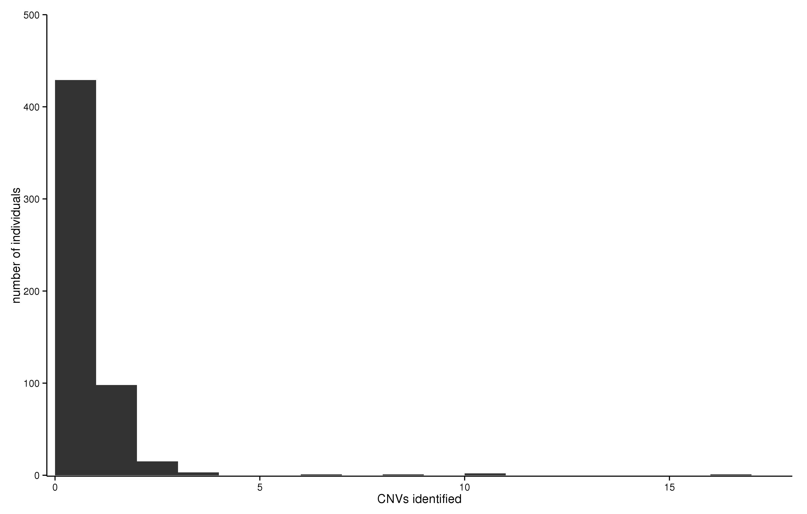
ExomeDepth

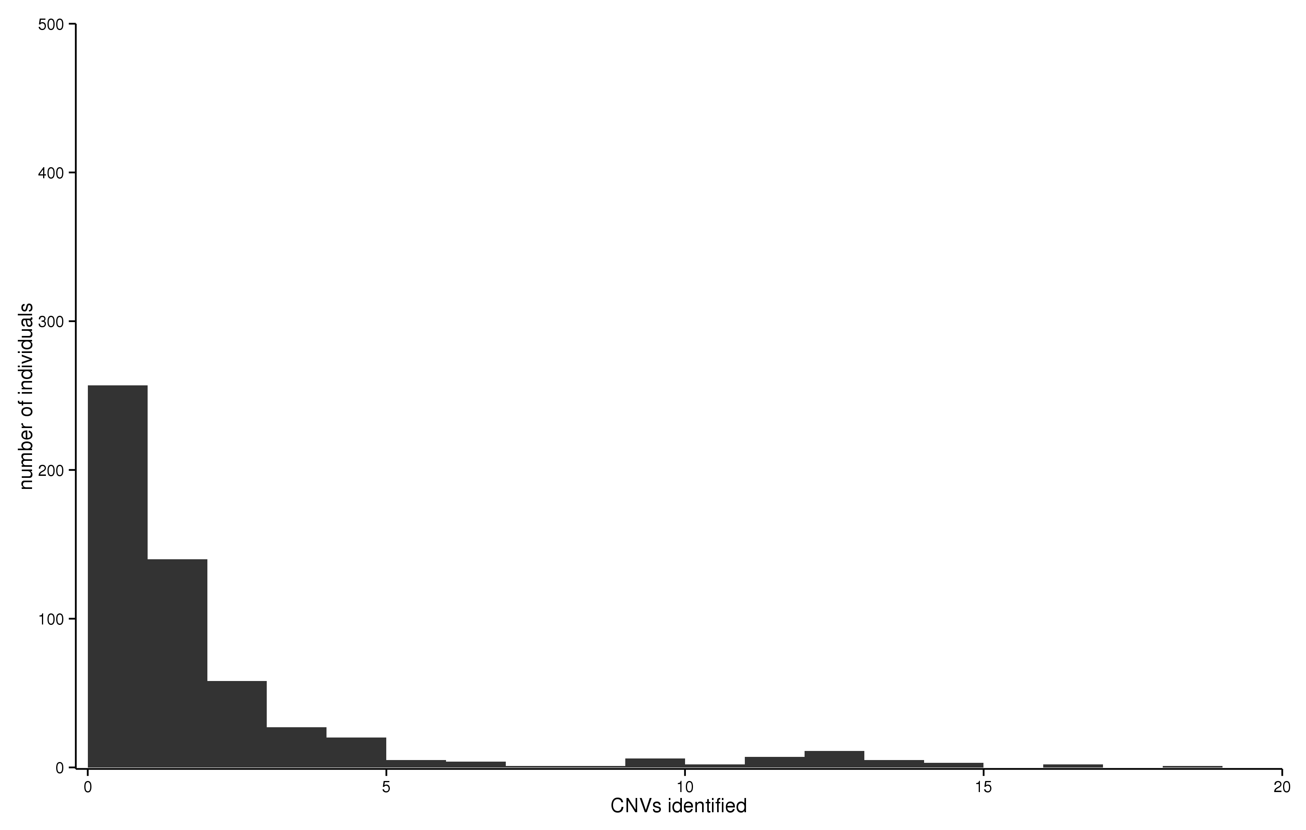
number of individuals
CoNVex

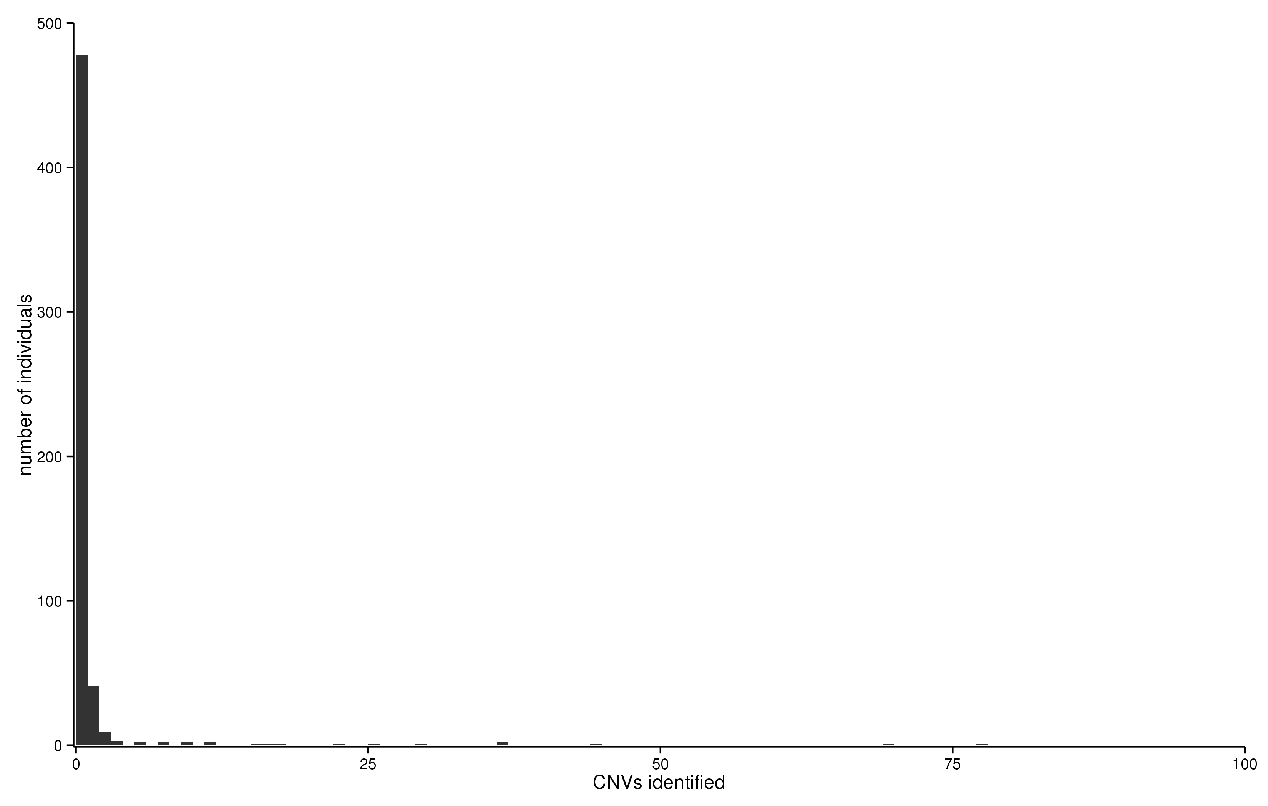
CoNVaDING

number of CNVs identified

Figure S1. Histogram showing the number of copy number variants identified by each of the CNV detection algorithms for 550 individuals with inherited retinal disease.
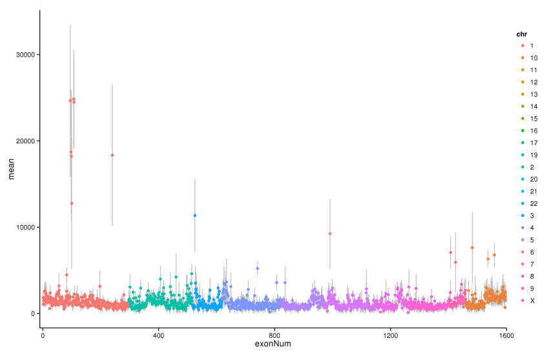
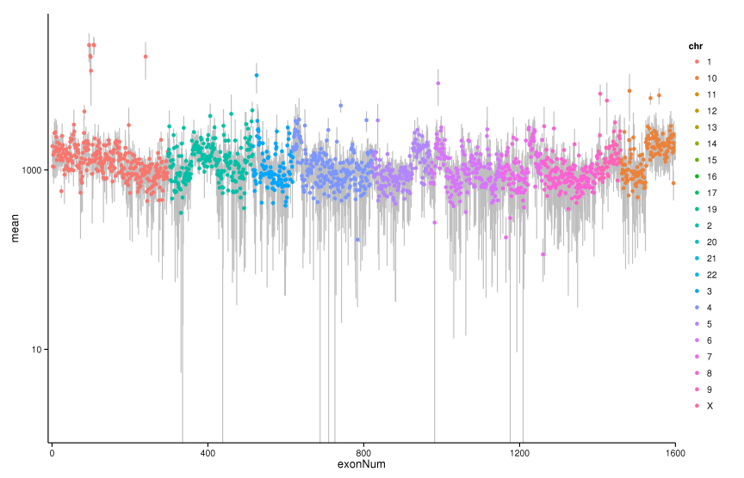
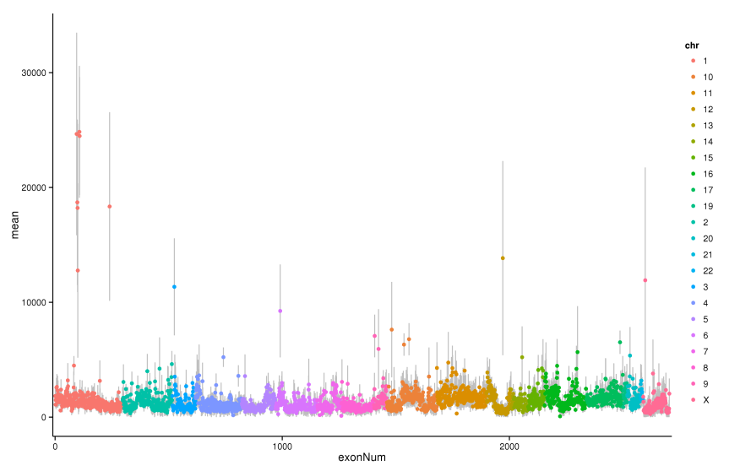
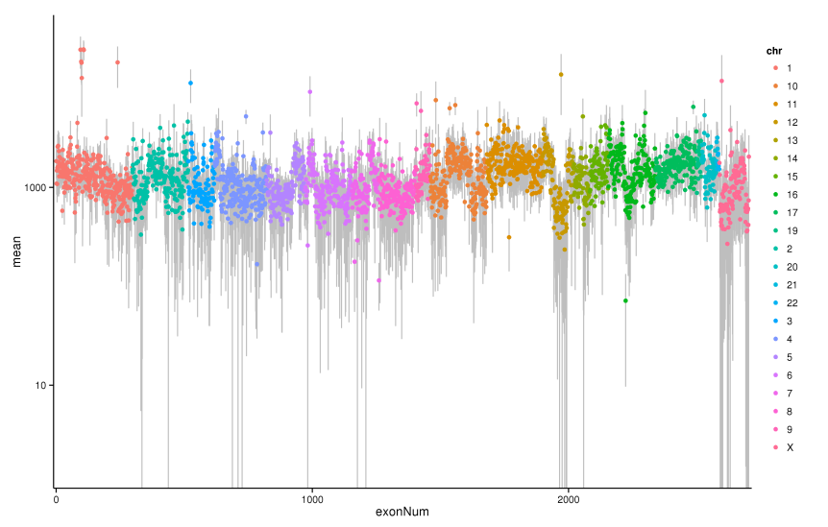
rpkm
Exon Number (ordered by hg19 coordinate)
RDv2 (105 genes)
RDv3 (180 genes)

Figure S2. Average coverage profile for individuals analysed on each next-generation sequencing gene panel. rpkm (reads-per-kilobase-per-million) values were calculated from properly paired reads with a quality value for alignment > 30. The upper and lower panels are plotted on a continuous and log10 scale, respectively. The change in dot colour indicates a transition to a new chromosome. 95% confidence intervals for the average rpkm are plotted as grey bars.

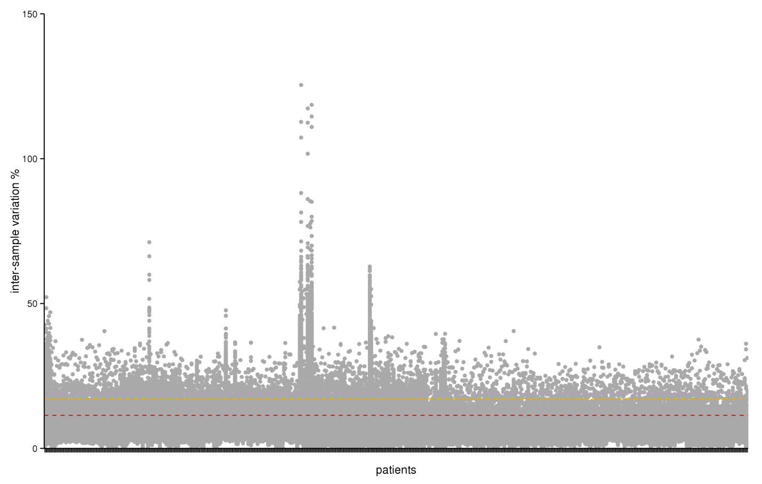
Figure S3. Inter-sample variation observed for 550 patients for exons surveyed using gene panel NGS. Solid circles represent the inter-sample variation calculated for each tested individual, defined as the coefficient of variation across reference samples selected by the ExomeDepth algorithm. We observe an average inter-sample variation of 5.83% (n Exons=1,224,686, median=5.25%, sd=3.28%). 95% of the exons surveyed demonstrate an inter-sample variation below 11.4% (red horizontal line) and this is consistent with an accuracy of 98.7% (n simulations=878). 99% of the exons surveyed demonstrate an inter-sample variation below 17.2% (orange horizontal line) and this is consistent with an accuracy of 98.2% (n simulations=954).

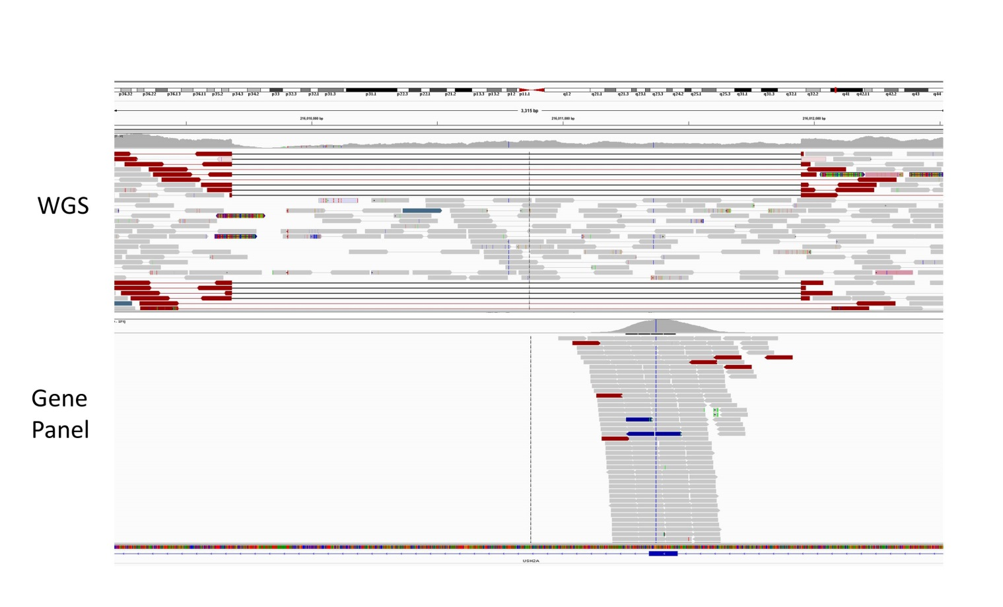
Figure S4. USH2A single exon deletion. A deletion encompassing exon 47 of USH2A (NM_206933.2) was identified through ExomeDepth applied to gene panel next-generation sequencing datasets and through Manta applied to whole genome sequencing datasets generated through Illumina sequencing chemistry. The Integrative Genomics Viewer screenshots demonstrate the clear advantage of whole genome sequencing techniques to characterize large deletions encompassing exons with intronic breakpoints, with split-reads encompassing the identified deletion permitting detection at a single nucleotide resolution (chr1:216,009,683-216,011,948).

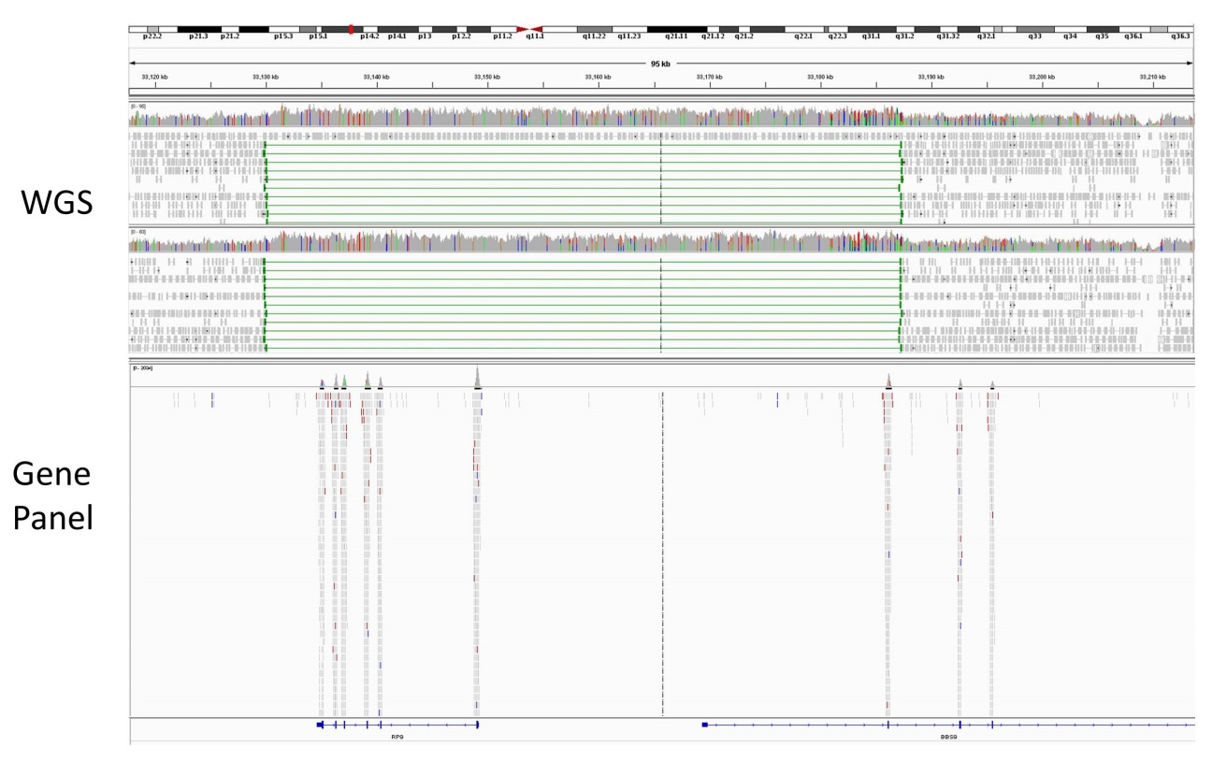

Figure S5. Duplication event impacting RP9 and BBS9 identified in five unrelated individuals. The duplication encompasses the complete coding region of RP9 and the first coding exon of BBS9. The duplication was identified through ExomeDepth applied to gene panel next-generation sequencing datasets, and through Canvas applied to whole genome sequencing datasets generated through Illumina sequencing chemistry. The Integrative Genomics Viewer screenshots demonstrate the clear advantage of whole genome sequencing techniques to characterize large duplications encompassing exons with intronic insertion points. The top panel (WGS) shows reads generated for two individuals, with large insert sizes and everted read direction (green) in respect to the reference genome.

Supplemental Case Study
A 15 year old boy was referred for genetic testing with a clinical indication of rod-cone dystrophy. The parents are consanguineous and there is no family history of inherited retinal disease. Surveillance of 176 genes identified two apparently homozygous variants. Paternal DNA was assessed for variant presence and zygosity. Maternal DNA was not available for familial segregation studies.

- PRPF31: NM_015629.3: c.(?_-1)_(855+1_856-1)dup [4 copies confirmed]
Genomic rearrangements of PRPF31 have been described previously as a cause of autosomal dominant retinitis pigmentosa.¹ Duplications that partially impact the coding regions of PRPF31 have been described as a cause of autosomal dominant retinitis pigmentosa.² Mutations in PRPF31 are known to display incomplete penetrance within families. The identified duplication is predicted to impact 7 coding exons of PRPF31 (NM_015629.3). Droplet digital PCR confirmed that 4 copies of PRPF31 exon 4 (NM_015629.3) are present in the affected individual’s DNA and that 3 copies of PRPF31 exon 4 are present in the unaffected father’s DNA.

Conclusion: It is highly likely that the PRPF31 duplication is present in a homozygous state in the boy clinically presenting with rod-cone dystrophy, although this has not been confirmed. This variant is currently considered to be of unknown significance. Future investigations to determine the location, phase and effect of this duplication on the expression of PRPF31 will assist clinical interpretation.

- TULP1: NM_003322.5 c.1047T>G p.(Asn349Lys) [homozygosity confirmed]

TULP1 c.1047T>G p.(Asn349Lys) has previously been reported in a homozygous state in patients with retinitis pigmentosa.^{3,4} The Asn349 residue is located within the conserved C-terminal tubby domain and is highly conserved in several species.⁴ Segregation analysis through bidirectional Sanger sequencing determined that TULP1 c.1047T>G was in a heterozygous state in the DNA of the unaffected father.

Conclusion: The presence of TULP1 c.1047T>G in a homozygous state is consistent with a clinical diagnosis of autosomal recessive rod-cone dystrophy.

1. Sullivan LS, Bowne SJ, Seaman CR, et al. Genomic rearrangements of the PRPF31 gene account for 2.5% of autosomal dominant retinitis pigmentosa. Investigative Ophthalmology & Visual Science. Oct 2006;47(10):4579-4588.
2. Martin-Merida I, Sanchez-Alcudia R, Fernandez-San Jose P, et al. Analysis of the PRPF31 Gene in Spanish Autosomal Dominant Retinitis Pigmentosa Patients: A Novel Genomic Rearrangement. Invest Ophthalmol Vis Sci. Feb 01 2017;58(2):1045-1053.
3. Eisenberger T, Neuhaus C, Khan AO, et al. Increasing the Yield in Targeted Next-Generation Sequencing by Implicating CNV Analysis, Non-Coding Exons and the Overall Variant Load: The Example of Retinal Dystrophies. PLoS One. Nov 2013;8(11):18.
4. Kannabiran C, Singh H, Sahini N, Jalali S, Mohan G. Mutations in TULP1, NR2E3, and MFRP genes in Indian families with autosomal recessive retinitis pigmentosa. Mol Vis. 2012;18:1165-1174.

