Figure S1. Partial 2-DE comparison images of plasma samples from FD males before and after ERT. The two proteins found to be differentially expressed greater than two-fold, Beta actin and Complement C3, are indicated by numbered arrows.
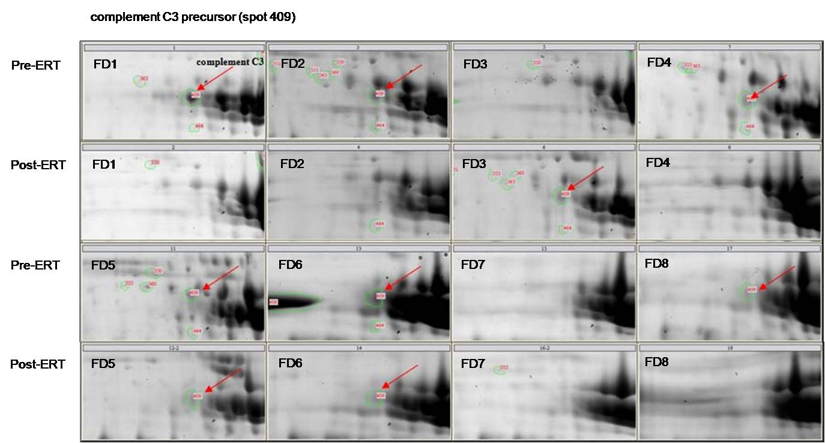
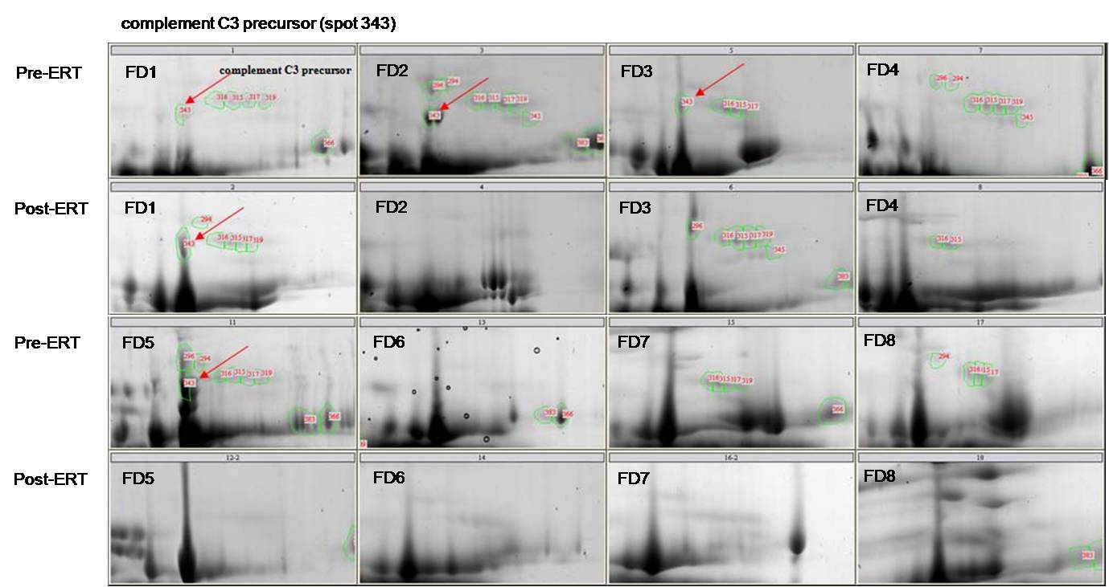
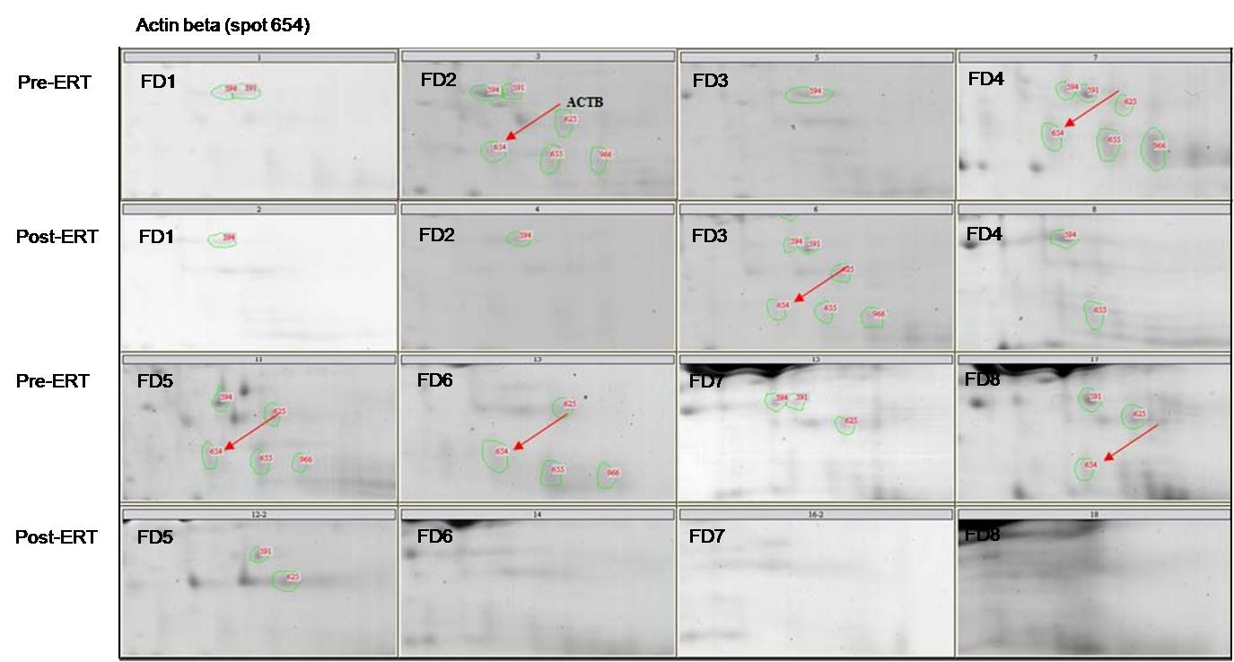
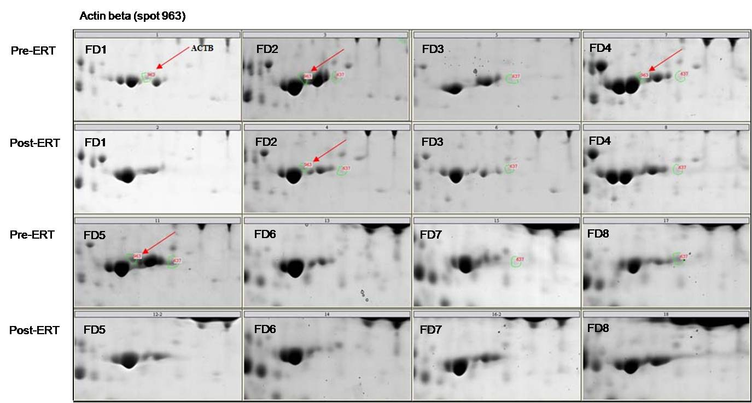

Figure S2. Sequential measurements of the expression levels of ACTB, PFN1, C4B, iC3b, and C1QC throughout the course of ERT in the eight FD males. Expression levels were normalized to those of the housekeeping protein GAPDH. Gray bar represents the global shortage of Fabrazyme (Dec 2009 to Oct 2011).
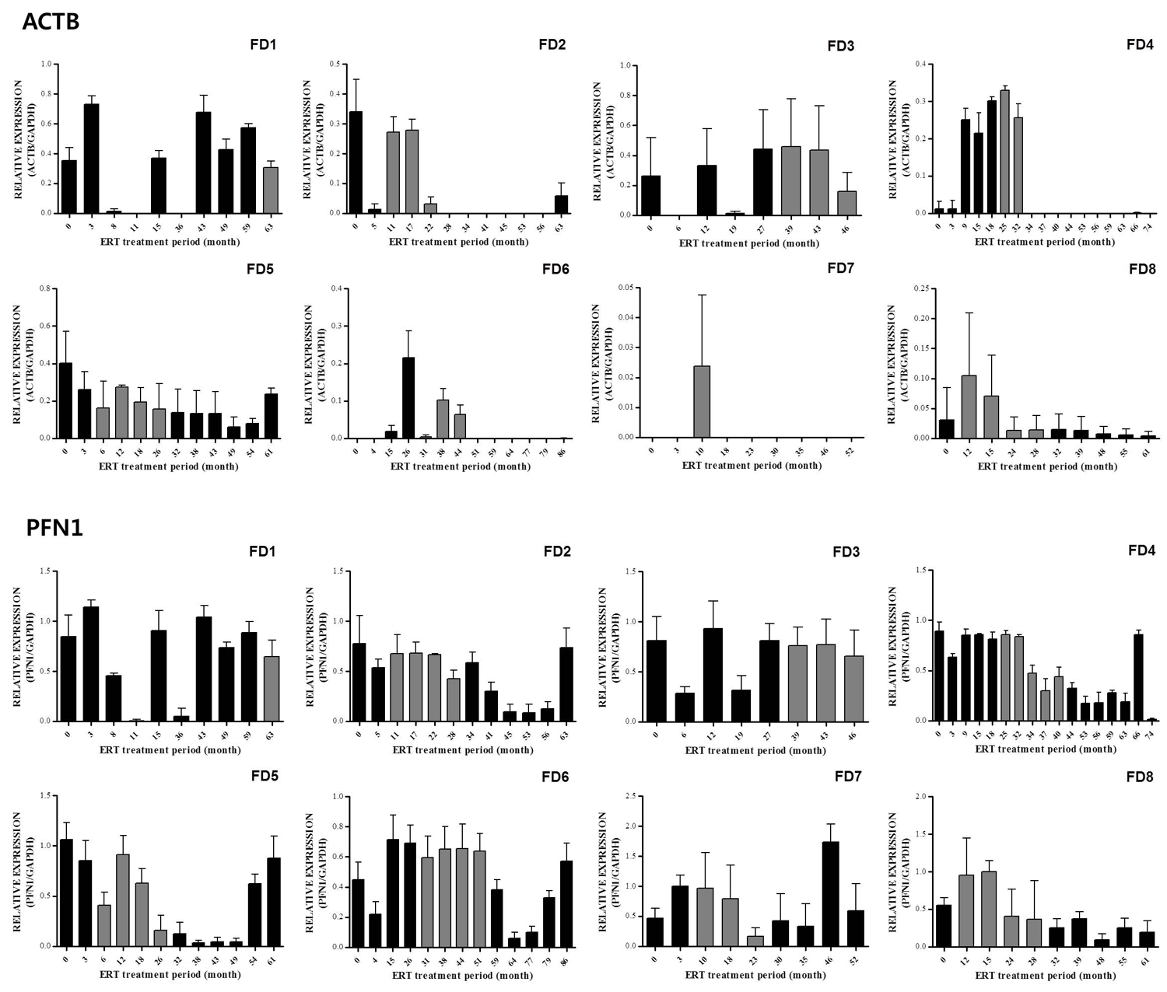
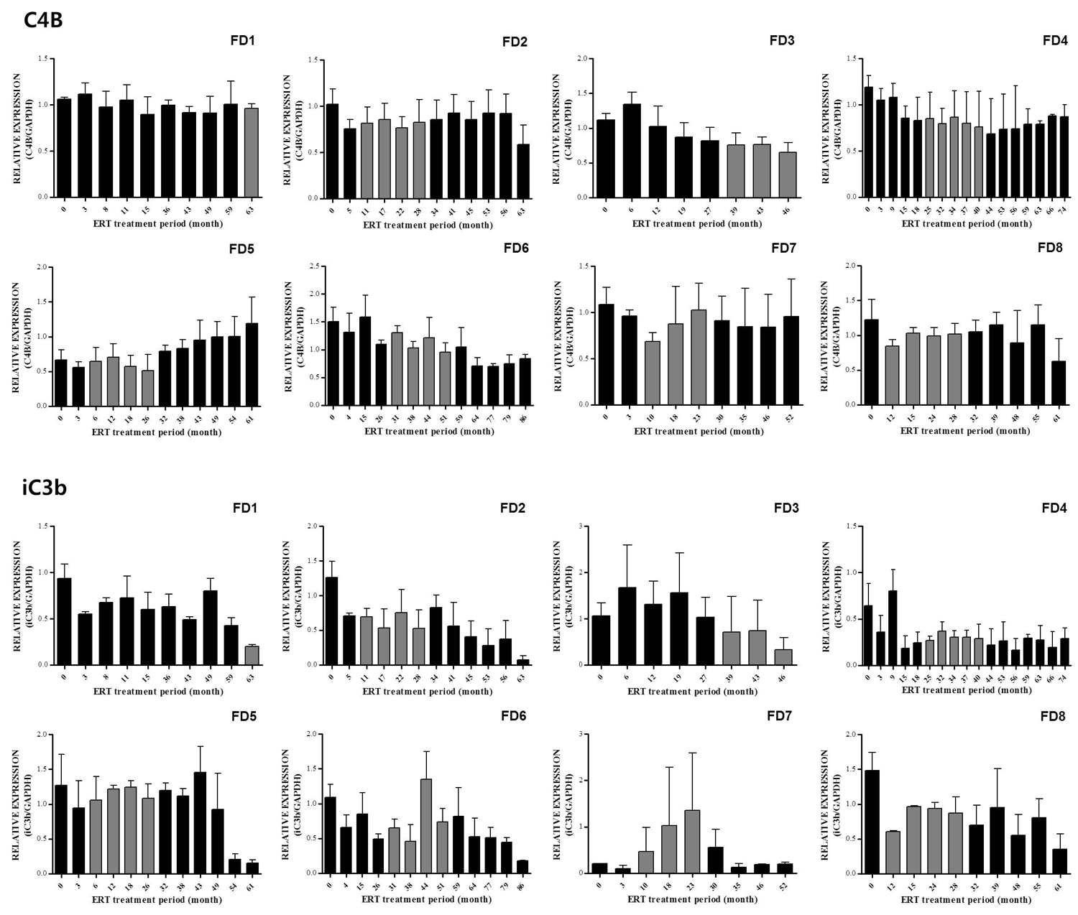
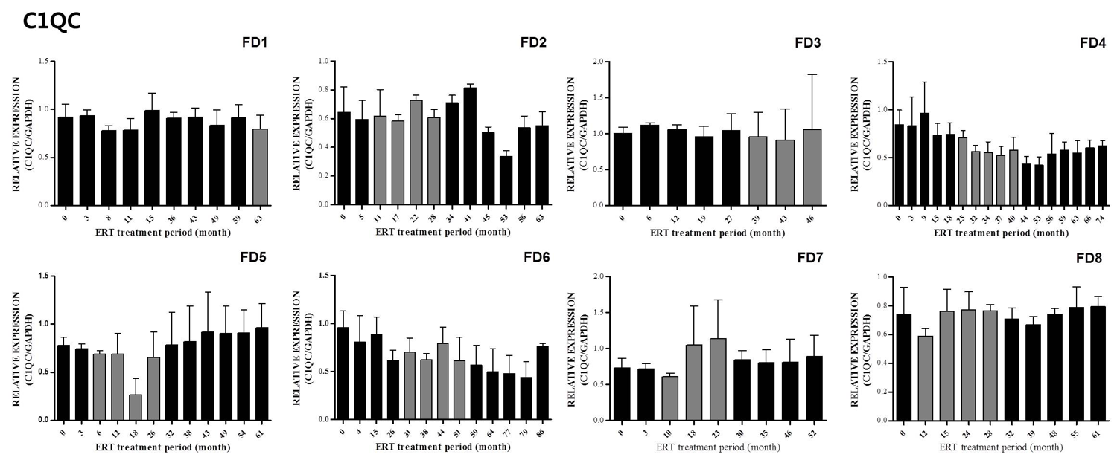

Figure S3. Mouse FD Plasma iC3b/GAPDH ratios. Plasma iC3b/GAPDH ratios were measured in FD male mice at 10 weeks of age (n=4) and in their age and sex- matched control mice (n=3). *P=0.006 for the comparison (Student t test).

Table S1. Partial list of proteins found to be differentially expressed in the plasmas of eight FD males after ERT.
Differential expression after ERT | Spot No. | Protein name (gray p>0.05) MS | Protein name (gray p>0.05) MS/MS
Increased | 179 | 64 for gi|24415404, midasin | 11 for gi|29499, beta-spectrin
 | 394 | 122 for gi|51476390, hypothetical protein | 53 for gi|28590, unnamed protein product
 | 556 | 67 for gi|55960096, dystonin | 15 for gi|17974508, MAGED4 protein
 | 572 | 46 for gi|6331377, KIAA1285 protein | 18 for gi|337467, transmembrane receptor
 | 756 | 65 for gi|57014047, lamin A/C transcript variant 1 | 27 for gi|125625322, ralBP1-associated Eps domain-containing protein 2 isoform 2
 | 763 | 68 for gi|7546520, Chain A, Molecular Recognition Of Fatty Acids By Peroxisome Proliferator-Activated Receptors | 31 for gi|125625322, ralBP1-associated Eps domain-containing protein 2 isoform 2
 | 805 | 66 for gi|55960762, caspase 7, apoptosis-related cysteine peptidase | 35 for gi|36609, unnamed protein product
 | 832 | 94 for gi|435476, cytokeratin 9 | 12 for gi|9966827, PEST proteolytic signal containing nuclear protein
 | 841 | 47 for gi|47077137, unnamed protein product | 62 for gi|1181996, hair type II basic keratin
 | 980 | 32 for gi|54304014, cyclin-dependent kinase inhibitor 2A | 59 for gi|34073, cytokeratin 4 (408 AA)
Decreased | 187 | 106 for gi|31542984, inter-alpha-trypsin inhibitor family heavy chain H4 isoform 1 precursor (ITIH4) | 35 for gi|1483187, inter-alpha-trypsin inhibitor family heavy chain H4 isoform 1 precursor (ITIH4)
 | 204 | 116 for gi|24657579, Vinculin | 36 for gi|24657579, Vinculin
 | 219 | 87 for gi|435476, cytokeratin 9 | 41 for gi|435476, cytokeratin 9
 | 224 | 97 for gi|28334, unnamed protein product | 19 for gi|28334, unnamed protein product
 | 233 | 46 for gi|40737468, C4A | 47 for gi|40737468, complement component C4A
 | 234 | 71 for gi|11935049, keratin 1 | 189 for gi|7331218, keratin 1
 | 236 | 233 for Mixture 1, gi|21961605, (Keratin 10) + gi|55956899, (keratin, type I cytoskeletal 9) + gi|11935049, (keratin 1) | 34 for gi|179674, complement component C4A
 | 237 | 76 for gi|76496497, protein artemis isoform a | 26 for gi|187655, MHC factor B precursor peptide
 | 315 | 65 for gi|189617, protein PP4-X | 44 for gi|125184, RecName: Full=Plasma kallikrein
 | 316 | 69 for gi|3126878, M4 protein deletion mutant | 32 for gi|544492, lymphoid-restricted membrane protein
 | 317 | 65 for gi|11935049, keratin 1 | 52 for gi|11935049, keratin 1
 | 319 | 101 for gi|11935049, keratin 1 | 84 for gi|11935049, keratin 1
 | 343 | 180 for gi|115298678, complement C3 precursor | 202 for gi|115298678, complement C3 precursor
 | 366 | 88 for gi|1314244, complement component C4B precursor | 220 for gi|1314244, complement component C4B precursor
 | 370 | 88 for gi|11935049, keratin 1 | 195 for gi|11935049, keratin 1
 | 409 | 95 for gi|13591823, fibrinogen alpha chain preproprotein, isoform alpha | 77 for gi|13591823, fibrinogen alpha chain preproprotein, isoform alpha
 | 464 | 79 for gi|306891, 90kDa heat shock protein | 79 for gi|306891, 90kDa heat shock protein
 | 500 | 67 for gi|37955184, HSD13 | 42 for gi|28592, serum albumin
 | 553 | 57 for gi|11935049, keratin 1 | 37 for gi|7331218, keratin 1
 | 562 | 50 for gi|42542403, methyltransferase-like protein 13 isoform 1 | 36 for gi|544492, lymphoid-restricted membrane protein
 | 591 | 64 for gi|51094925, activator of S phase kinase | 36 for gi|28592, serum albumin
 | 594 | 63 for gi|4503011, carboxypeptidase N catalytic chain precursor | 30 for gi|4503011, carboxypeptidase N catalytic chain precursor
 | 625 | 76 for gi|4503571, alpha-enolase | 60 for gi|4503571, alpha-enolase
 | 637 | 65 for gi|11935049, keratin 1 | 157 for gi|11935049, keratin 1
 | 654 | 85 for gi|14250401, actin, beta | 124 for gi|14250401, actin, beta
 | 655 | 161 for gi|11935049, keratin 1 | 198 for gi|11935049, keratin 1
 | 716 | 91 for gi|999892, Chain A, Crystal Structure Of Recombinant Human Triosephosphate Isomerase At 2.8 Angstroms Resoluti | 44 for gi|30313, cytokeratin 8 (279 AA)
 | 720 | 101 for gi|13786847, Chain A, Human Heart L-Lactate Dehydrogenase H Chain, Ternary Complex With Nadh And Oxamate | 19 for gi|30268367, hypothetical protein
 | 726 | 65 for gi|31873336, hypothetical protein | 28 for gi|179674, complement component C4A
 | 759 | 74 for gi|435476, cytokeratin 9 | 19 for gi|36609, unnamed protein product
 | 772 | 64 for gi|3694922, upstream regulatory element binding protein 1 | 29 for gi|544492, lymphoid-restricted membrane protein
 | 774 | 82 for gi|453155, keratin 9 | 16 for gi|1616766, cationic trypsinogen
 | 807 | 64 for gi|11935049, keratin 1 | 87 for gi|11935049, keratin 1
 | 810 | 65 for gi|4758638, peroxiredoxin-6 | 40 for gi|4758638, peroxiredoxin-6
 | 821 | 72 for gi|34328014, KIAA0465 protein | 59 for gi|16553735, unnamed protein product
 | 822 | 64 for gi|56786155, complement C1q subcomponent subunit C precursor | 76 for gi|56786155, complement C1q subcomponent subunit C precursor
 | 833 | 346 for Mixture 1, gi|435476, (cytokeratin 9) + gi|7331218, (keratin 1) | 155 for gi|435476, cytokeratin 9
 | 835 | 64 for gi|73909121, ANKLE2 protein | 31 for gi|544492, lymphoid-restricted membrane protein
 | 840 | 53 for gi|1046221, melanoma ubiquitous mutated protein | 166 for gi|29577, unnamed protein product
 | 857 | 64 for gi|5360689, norepinephrine transporter isoform 1 | 59 for gi|6650826, PRO2044
 | 867 | 229 for Mixture 1, gi|435476, (cytokeratin 9) + gi|11935049, (keratin 1) | 32 for gi|544492, lymphoid-restricted membrane protein
 | 871 | 67 for gi|10835095, serum amyloid A-4 protein precursor | 34 for gi|544492, lymphoid-restricted membrane protein
 | 879 | 87 for gi|4826898, profiling 1 | 77 for gi|4826898, profilin 1
 | 891 | 97 for gi|3212456, Chain A, Crystal Structure Of Human Serum Albumin | 44 for gi|28592, serum albumin
 | 897 | 47 for gi|225986, amyloid related serum protein SAA | 73 for gi|225986, amyloid related serum protein SAA
 | 901 | 65 for gi|119120897, partitioning defective 3 homolog B isoform b | 23 for gi|20302038, hypothetical protein LOC116254 precursor
 | 963 | 141 for gi|14250401, actin, beta | 250 for gi|14250401, actin, beta
 | 964 | 50 for gi|57162131, 5'-nucleotidase, cytosolic II | 23 for gi|1616766, cationic trypsinogen
 | 965 | 64 for gi|5689750, Annexin A10 protein | 28 for gi|520450, sorbitol dehydrogenase
 |  | Ions scores are presented as -10*Log(P), where P is the probability that an observed match is a random event. | Ion scores are presented as -10*Log(P), where P is the probability that an observed match is a random event.
 |  | Protein scores > 63 are significant (p<0.05). | Individual ions scores > 33 indicate either identity or extensive homology (p<0.05).
 |  | Database: NCBInr_100326 (10,635,453 sequences; 3,627,481,469 residues) | Database: NCBInr_100326 (10,635,453 sequences; 3,627,481,469 residues)
 |  | Taxonomy: Homo sapiens (human; 115,456 sequences) | Taxonomy: Homo sapiens (human; 115,456 sequences)

