Family | Variant | Gene | AA change | dbSNP | Allele frequency in Gnomad | OMIM No.
1 | chr2:97164934 G>C | NEURL3 | NM_001285486:exon5:c.C190G, p.P64A | - | - | 617206
1 | Chr2:109411047 G>A | CCDC138 | NM_144978:exon5:c.G446A, p.S149N | - | - | -
1 | chr10:128810594 T>C | DOCK10 | NM_001380:exon12:c.T1094C, p.I365T | - | - | 611518
1 | chr1:89225946 T>G | PKN2 | NM_006256:exon3:c.T391G, p.C131G | rs755666862 | 6.271e-5 | 602549
1 | chr1:120284468 C>T | PHGDH | NM_006623:exon10:c.C1157T, p.A386V | rs768396645 | 1.804e-5 | 606879
1 | chr2:128396897 G>A | LIMS2 | NM_001256542:exon7:c.C529T, p.R177C | rs528266998 | 2.438e-5 | 607908
1 | chr13:110437908 C>T | IRS2 | NM_003749:exon1:c.G493A, p.A165T | - | - | 600797
1 | chr22:42076296 C>T | NHP2L1 | NM_005008:exon3:c.G76A, p.V26I | - | - | 601304
3 | Chr2: 54856890 C>A | SPTBN1 | NM_003128.2: c.2619C>A, p.Asn873Lys | - | - | 182790
3 | Chr10: 76780901 G>A | KAT6B | NM_001256468.1: c.2330G>A, Arg777Gln | - | 0,0000082 | 605880
3 | Chr13: 24465620 T>C | C1QTNF9B | XM_005266372.1: c.296A>G, p.Glu99Gly | - | 0,0000083 | 614148
3 | ChrX: 56591294 G>T | UBQLN2 | NM_013444.3: c.988G>T, p.Ala330Ser | - | 0,0000056 | 300264
Table S1: Homozygous rare variants identified after filtering whole exome sequencing data of the index patients from family 1.

Gene | Disease and related phenotype |  | Mode of Inheritance | OMIM No.
MAB21L2 | Microphthalmia/coloboma and skeletal dysplasia syndrome |  | AR, AD | 604357
SMAD4 | Myhre syndrome |  | AD | 139210
BMP2 | Craniofacial, Skeletal, and  Cardiac Features |  | AD | ----
PAX6 | Aniridia, Cataract with late-onset corneal dystrophy |  | AD | 607108
HOXA13 | hand-foot-genital syndrome |  | AD | 140000
LMX1B | Nail-patella syndrome |  | AD | 161200
MEIS2 | Cleft palate, cardiac defects, and mental retardation |  | AD | 600987
PBX1 | Congenital anomalies of kidney and urinary tract syndrome with or without hearing loss, abnormal ears, or developmental delay |  | AD | 617641
RUNX2 | Cleidocranial dysplasia, forme fruste, with brachydactyly |  | AD | 119600
Table S2. Identified human mutations in interaction- partners of MAB21L1 and resulting human phenotypes

A
Chr.13: 37,227,227- 37,247,380
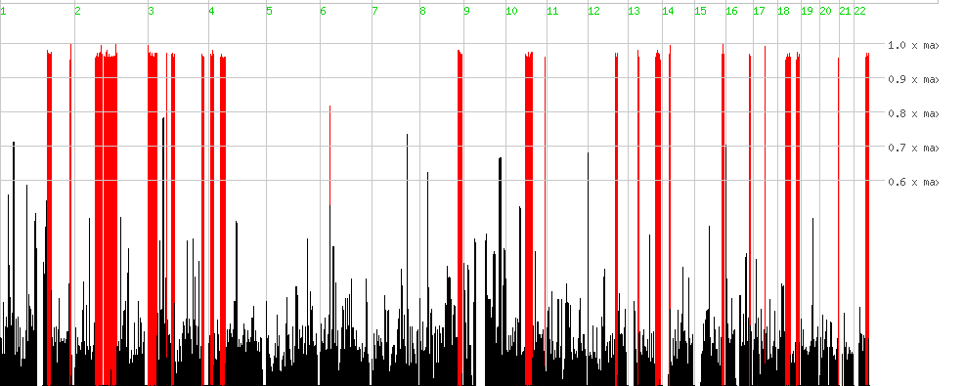
Figure S1.

B
1. chr1: 65,368,561-88,605,099
2. chr.4: 37,156,452-63,243,416
3. chr.6: 184,718-11,236,644
4. chr.7: 29,198,773-83,173,734
5. chr.9: 30,064,498-40,087,758
6. chr.9: 71,013,799-82,975,578
7. chr.11: 8,017,223-22,696,112
8. chr.11: 46,556,751-51,563,636
9. chr.13: 24,737,091-43,447,499
10. chr. 17: 18,900-6,027,060

Figure S1. Homozygous areas identified by SNP chip analysis. (A) Homozygous intervals identified in family 1 (homozygosity mapper). The MAB21L1 variant lies within a homozygous interval on chr13: 37,227,227- 37,247,380. (B) Homozygous intervals identified in family 2 (homozygpsity mapper). The MAB21L1 varaint lies within a homozygous interval in chromosome 13: 24,737,091-43,447,499 .

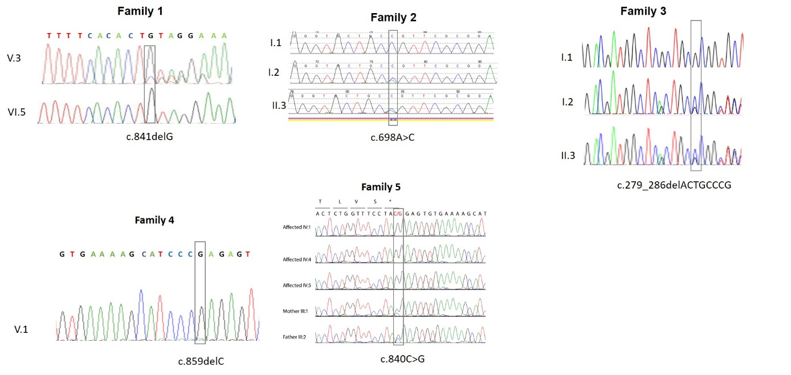
Figure S2: Sanger sequencing chromatograms of identified MAB21L1 disease causing alleles.

A

B
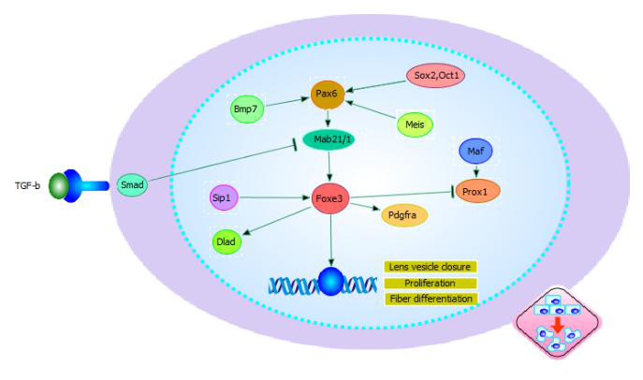

Figure S3: Crosstalk visualization for MAB21L1 and related proteins. (A) MAB21L1 experimentally confirmed protein-protein interactions (String network analysis). Analysis setup was chosen so that only experimentally confirmed interactions partners are displayed. Confidence levels were High (>0.70) for all MAB21L1 interaction proteins displayed. (B) Schematic of MAB21L1 putative downstream effects regulating ocular (lens) development

