Supplementary files
Table S1 : Parental origin showing the paternal origin of the deletion and duplication regions
a) Highly polymorphic Sequence Tagged Sites (STSs) were selected using the STS Markers track on the UCSC Genome Browser, Human Feb. 2009 (GRCh37/hg19) Assembly. Asterisks (*) indicate duplicated alleles.
Locus | Position (hg19) | Proband | Father | Mother | Status
D22S284 | 40316896 | 84*/100 | 84/96 | 94/100 | Dup(Pat)
D22S423 | 40382186 | 217*/219 | 217/232 | 219/230 | Dup(Pat)
D22S1160 | 46429162 | 210 | 186/200 | 186/210 | Del(Pat)

b) Informative SNPs obtained by the use of 180K CGH+SNP array platform (G4890A, Agilent Technologies)

SNP ID | Chr | SNP Position | Proband | Mother | Father | Interpretation
rs2267423 | chr22 | 40.364.415 | AGG | AA | AG | Dup(Pat)
rs130388 | chr22 | 43.082.826 | G | GG | TT | Del(Pat)
rs2092212 | chr22 | 43.318.948 | G | CG | CC | Del(Pat)
rs738386 | chr22 | 43.328.419 | G | AG | AA | Del(Pat)
rs5751458 | chr22 | 43.655.526 | G | GG | AA | Del(Pat)
rs10453447 | chr22 | 46.334.133 | T | TT | GG | Del(Pat)
rs5769162 | chr22 | 47.195.274 | C | CC | TT | Del(Pat)
rs139581 | chr22 | 47.209.900 | T | TT | CC | Del(Pat)
rs9626954 | chr22 | 47.560.432 | C | CC | GG | Del(Pat)
rs5767669 | chr22 | 47.707.793 | C | GC | GG | Del(Pat)
rs732493 | chr22 | 47.729.347 | T | TA | AA | Del(Pat)
rs6008558 | chr22 | 48.516.695 | A | AG | GG | Del(Pat)
rs6007867 | chr22 | 48.889.170 | G | TG | TT | Del(Pat)
rs9616484 | chr22 | 49.580.069 | C | CT | TT | Del(Pat)
rs134465 | chr22 | 49.913.238 | T | TT | CC | Del(Pat)
rs137887 | chr22 | 50.464.439 | C | CC | GG | Del(Pat)

Figure S1: WGS data showing the 1kb invertion event between duplicated and deleted segments on chromosome 22 of proband.

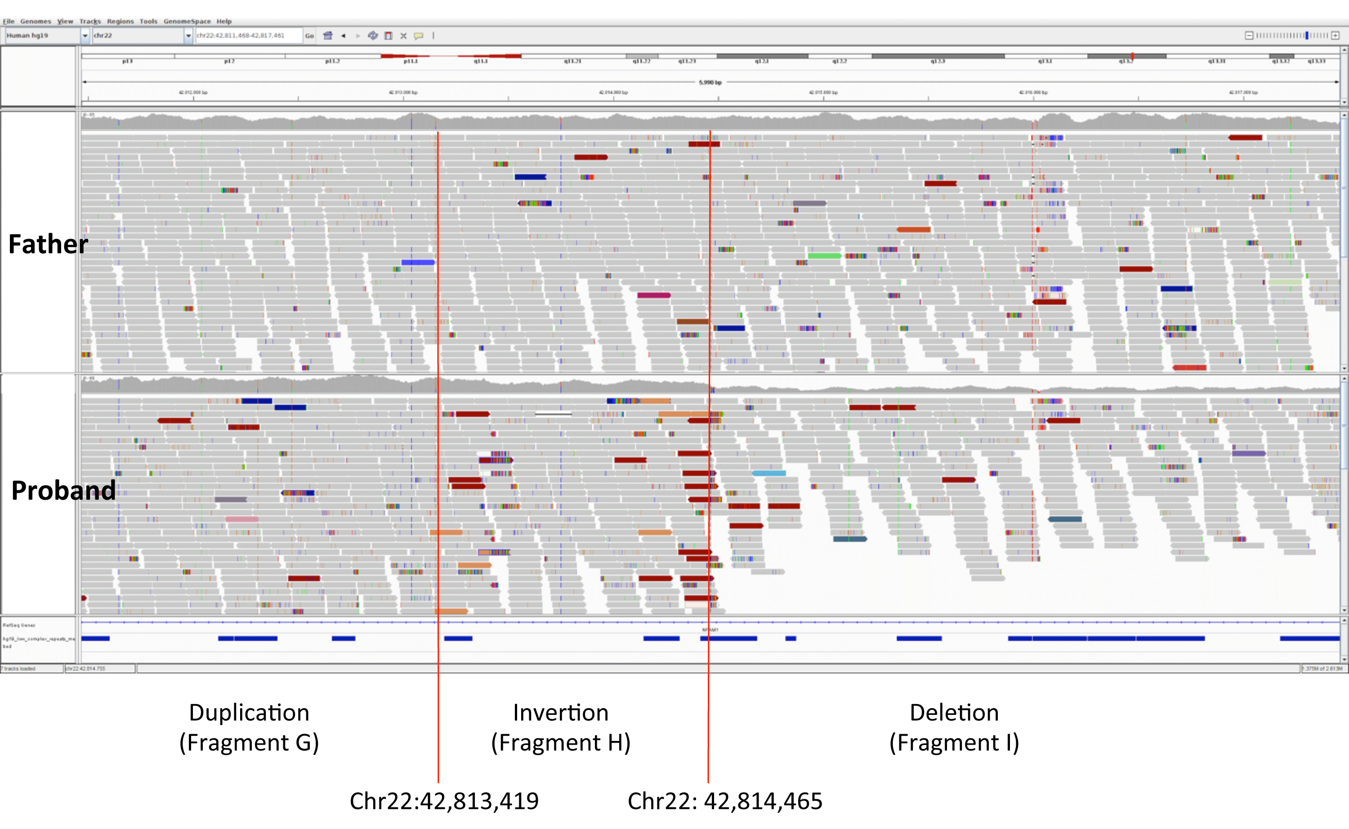

Figure S2: PCR confirmation of fusion junctions on proband; fragment G-inverted fragment H (GHinv) and inverted fragment G-fragment D. (P: proband; F: father; M: mother; L: ladder)

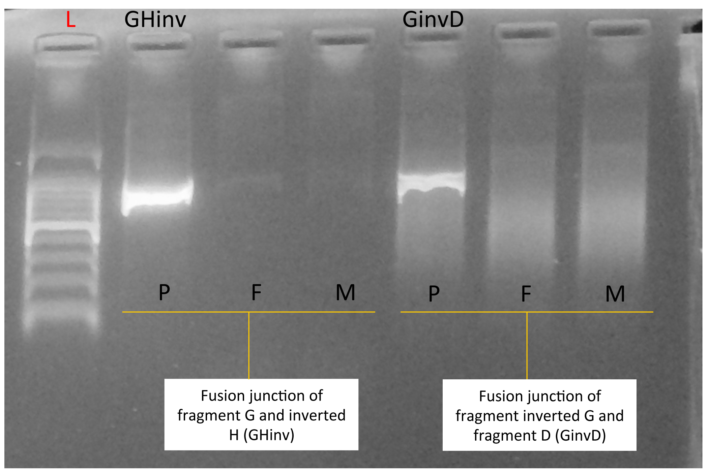

Table S2: Primers used for Sanger Sequencing Confirmation of Breakpoints
Primer ID | Direction | Sequence | Product Size (bp) | Ta
BP_GHinv_F | Forward | GGGGAACCACTTCAGCTTTA | 708 | 62
BP_GHinv_R | Reverse | TGGATCCCTGCTTAGTCTGC
BP_GinvD _F | Forward | TGGTGTTGAAGATGCAGGAG | 832 | 62
BP_GinvD _R | Reverse | GTTAGCCAGGATGGTCTCCA

Figure S3: AluSq sequence of chromosome 14 represented by the UCSC RepeatMasker track (https://genome.ucsc.edu/)

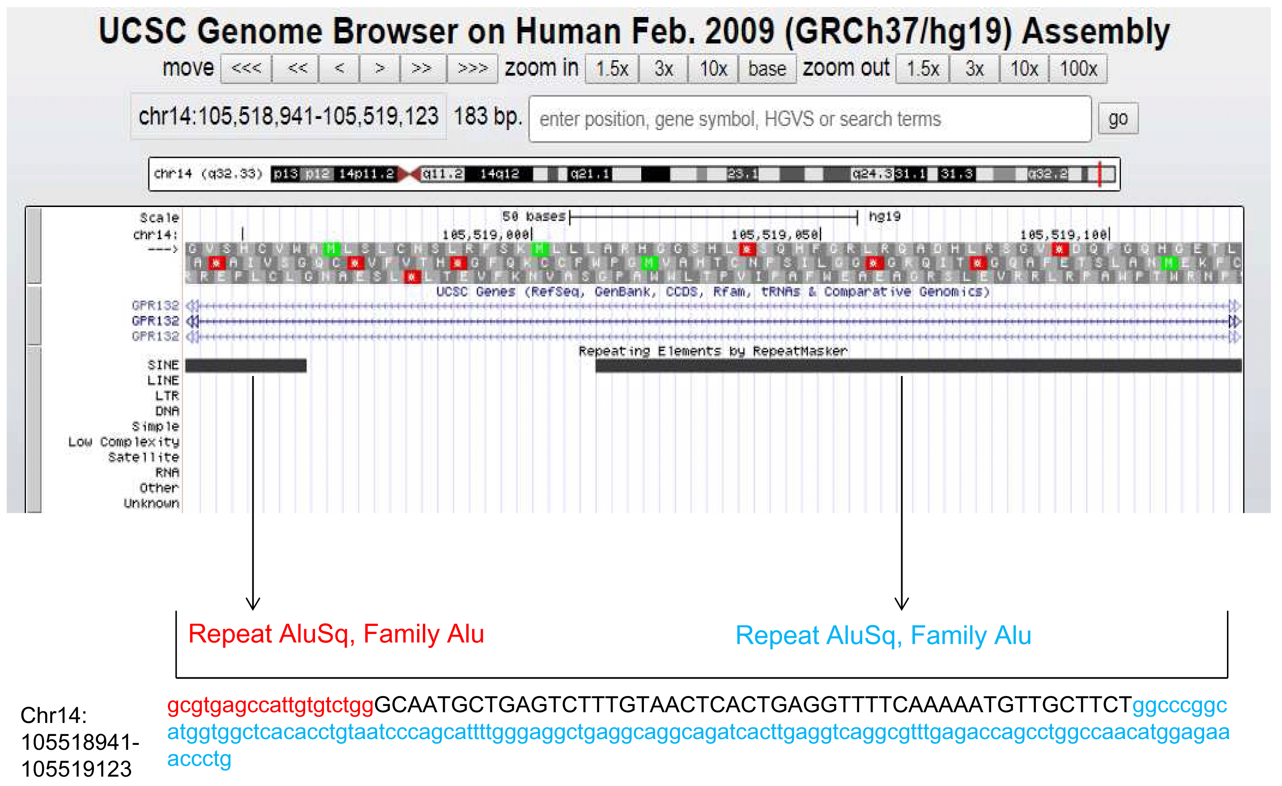

Figure S4 : Breakpoint Junction G-chr14(inv)-H(inv)
Sanger Sequencing result of fusion junction between,: (upper) Fragment G (red) and inverted sequence of chromosome 14 (green), (bottom) inverted sequence of chromosome 14 and Fragment H. Microhomology at the breakpoints is underlined.

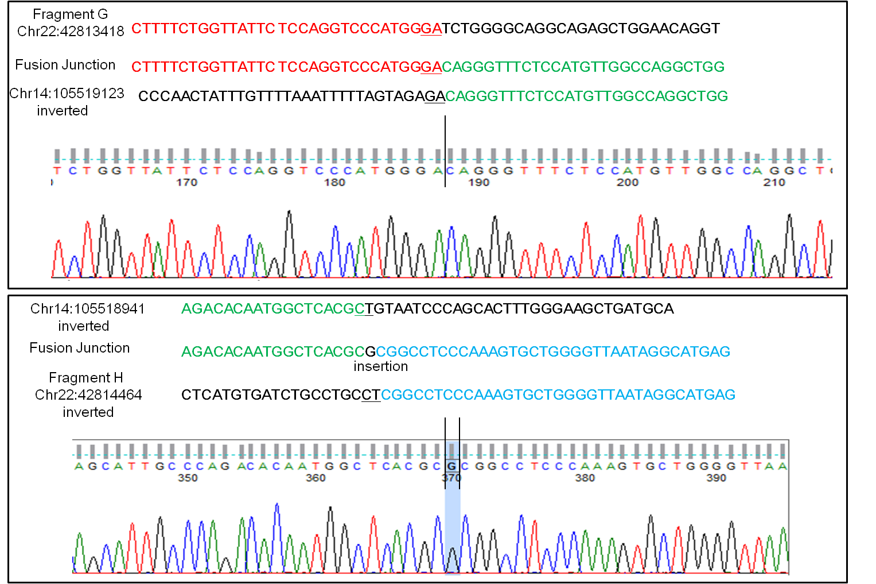

Figure S5: AluSx3 sequence (underlined in the text) at the H-I breakpoint junction represented by the UCSC RepeatMasker track (https://genome.ucsc.edu/). Breakpoint between fragment H (blue) and fragment I is shown with a dashed line.

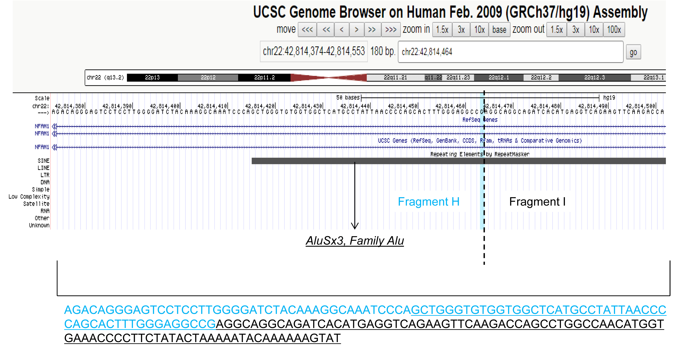

Figure S6: Breakpoint Junction G(inv)-D
Sanger confirmation of breakpoint junction between inverted fragment G and fragment D

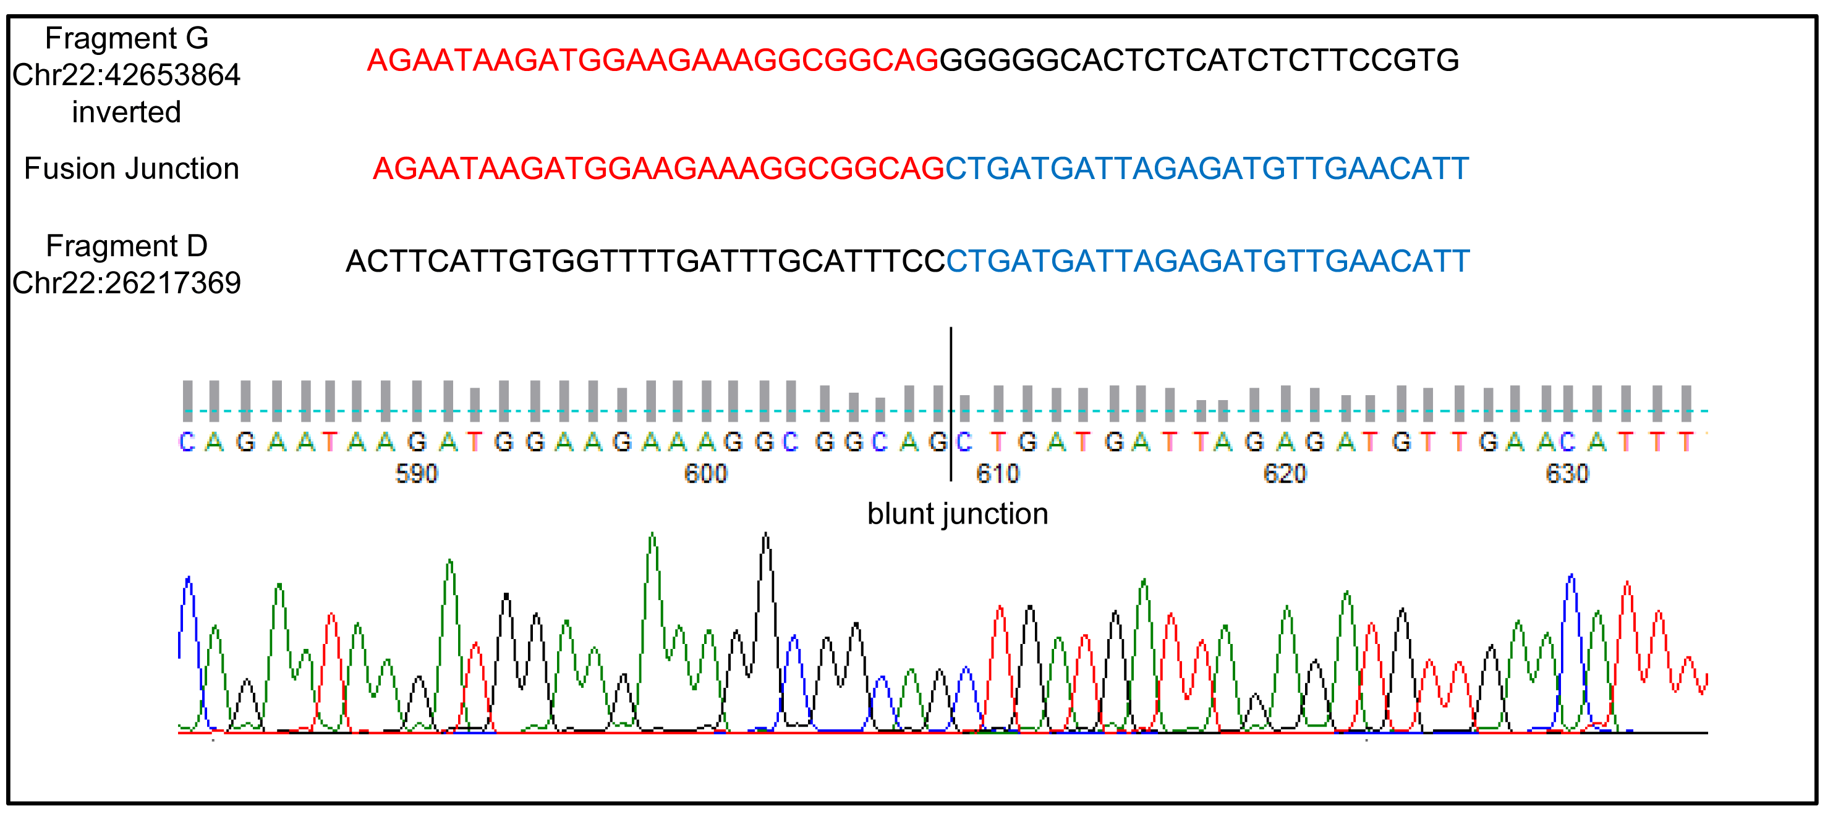

Figure S7: WGS data showing breakpoint on Fragment E (chr22:41,503,612) mapped with unknown region (reads mapped with unknown region represented with cyanine blue).

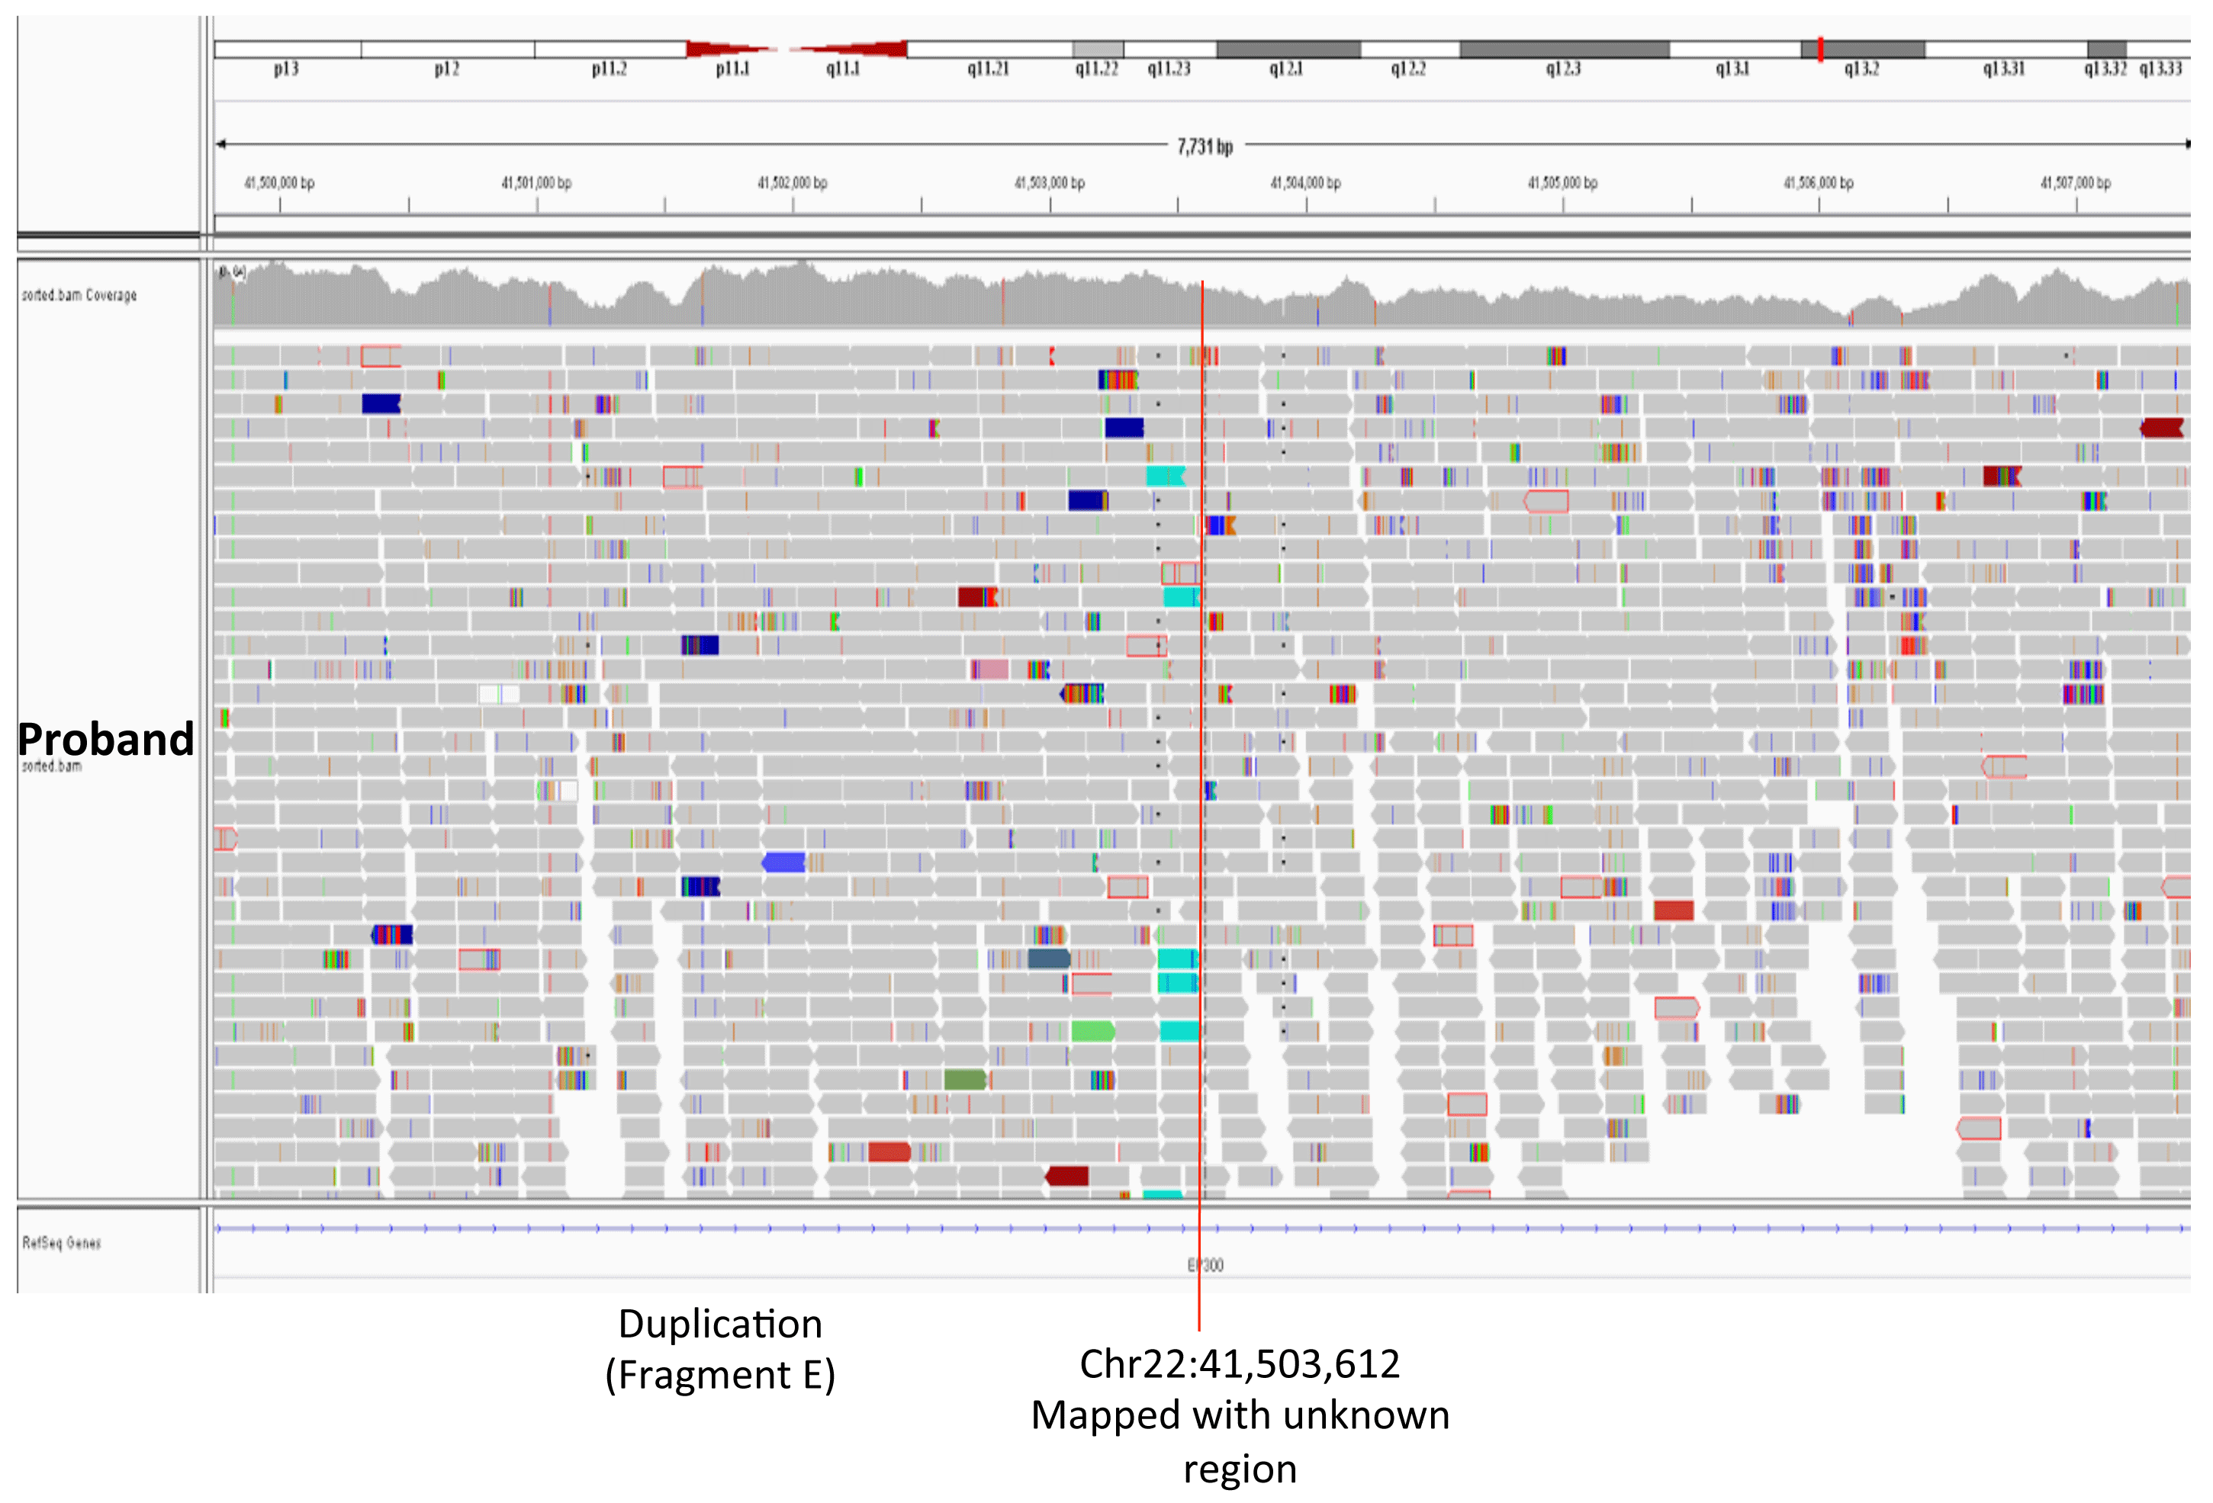

Figure S8: FISH analysis using pan-telomeric peptide nucleic acid (PNA) probe (PNA FISH kit/Cy3, Dako Denmark A/S, red signals). Ring chromosome 22 (arrowhead) showed the absence of the consensus sequence (TTAGGG)n of human telomeres

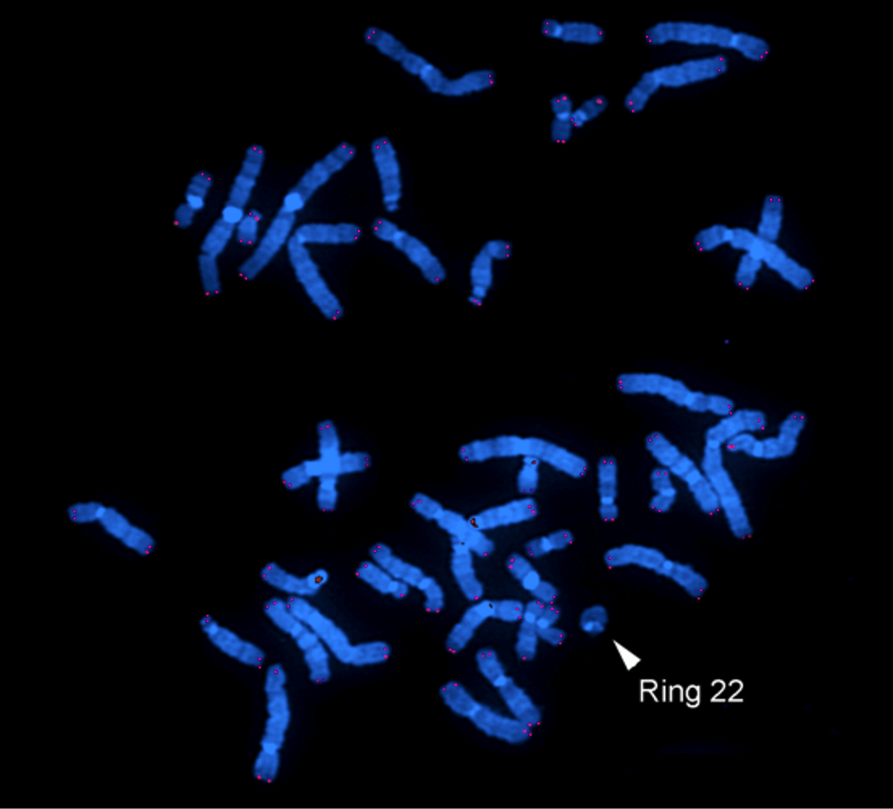

Figure S9: Three-generation family pedigree showing the segregation for SRPX2 variant and X-inactivation pattern.

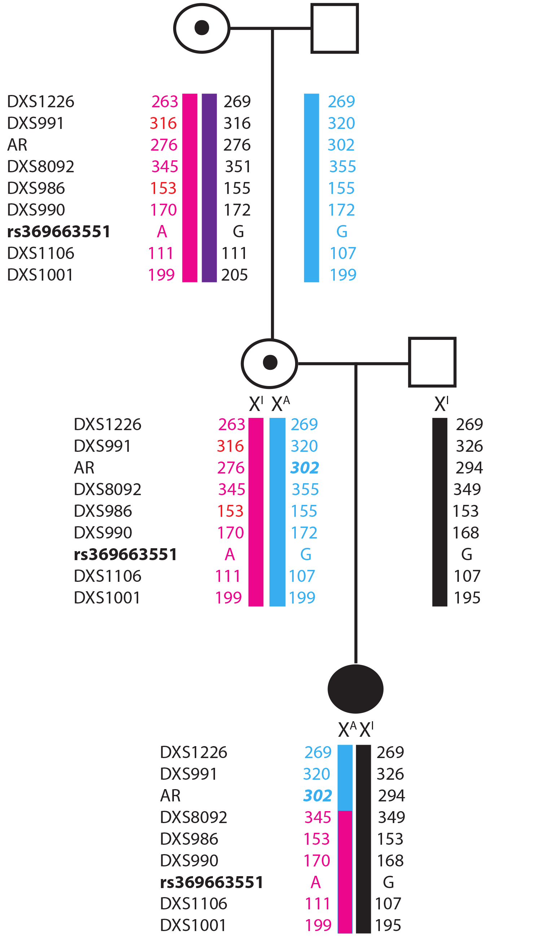
Chromosome X inactivation analysis was performed as described (Allen et al. 1992) on a highly polymorphic microsatellite repeat of the androgen receptor (AR) gene.
The analysis showed complete (>98%) inactivation of the paternal X chromosome in the proband. Her mother had >80% inactivation of her maternally-inherited X chromosome, containing the SRPX2 variant, but she did not pass on to her daughter the AR allele she had inherited from the maternal grandmother. In fact, microsatellite analysis demonstrated a meiotic crossover between AR (chrX: 66765056) and DXS8092 (chrX: 74122919) on the X chromosome transmitted to the patient from her mother (Supplementary Figure S10). Therefore the SRPX2 variant is located on the active X chromosome in the proband and on the inactive one in her mother. The maternal grandmother was homozygous for AR and therefore not informative.

REFERENCES Allen RC, Zoghbi HY, Moseley AB, Rosenblatt HM, Belmont JW. Methylation of HpaII and HhaI sites near the polymorphic CAG repeat in the human androgen-receptor gene correlates with X chromosome inactivation. Am J Hum Genet 1992;51:1229-1239.

