Role of germline aberrations affecting CTNNA1, MAP3K6 and MYD88 in gastric cancer susceptibility

Robbert D.A. Weren^{1,*}, Rachel S. van der Post^{2,*}, Ingrid P. Vogelaar¹, J. Han J.M. van Krieken², Liesbeth Spruijt¹, Jan Lubinski³, Anna Jakubowska³, Urszula Teodorczyk³, Cora M. Aalfs⁴, Liselotte P. van Hest⁵, Carla Oliveira^{6,7,8}, Eveline J. Kamping¹, Hans K. Schackert⁹, Guglielmina N. Ranzani¹⁰, Encarna B. Gómez García¹¹, Frederik J. Hes¹², Elke Holinski-Feder¹³, Maurizio Genuardi¹⁴, Margreet G.E.M. Ausems¹⁵, Rolf H. Sijmons¹⁶, Anja Wagner¹⁷, Lizet E. van der Kolk¹⁸, Annemieke Cats¹⁹, Inga Bjørnevoll²⁰, Nicoline Hoogerbrugge¹ and Marjolijn J.L. Ligtenberg^{1,2}

¹ Department of Human Genetics, Radboud university medical center, Nijmegen, the Netherlands
² Department of Pathology, Radboud university medical center, Nijmegen, the Netherlands
³ Department of Genetics and Pathology, Pomeranian Medical University, Szczecin, Poland
⁴ Department of Clinical Genetics, Academic Medical Centre, Amsterdam, the Netherlands
⁵ Department of Clinical Genetics, VU University Medical Center, Amsterdam, the Netherlands
⁶ Expression Regulation in Cancer Group, Instituto de Investigação e Inovação em Saúde, Porto, Portugal (i3S)
⁷ Institute of Molecular Pathology and Immunology of the University of Porto (IPATIMUP), Porto, Portugal
⁸ Department of Pathology and Oncology, Faculty of Medicine, University of Porto, Al. Prof. Hernâni Monteiro, 4200-319 Porto, Portugal.
⁹ Department of Surgical Research, Universitätsklinikum Carl Gustav Carus, Technische Universität Dresden, Dresden, Germany
¹⁰ Department of Biology and Biotechnology, University of Pavia, Pavia, Italy
¹¹ Department of Clinical Genetics, Maastricht University Medical Center, Maastricht, the Netherlands
¹² Department of Clinical Genetics, Leiden University Medical Center, Leiden, the Netherlands
¹³ Medizinische Klinik und Poliklinik IV, Campus Innenstadt, Klinikum der Universität München, Germany
¹⁴ Institute of Genomic Medicine, Catholic University of the Sacred Heart, Rome, Italy
¹⁵ Department of Genetics, University Medical Center Utrecht, the Netherlands
¹⁶ Department of Genetics, University Medical Center Groningen, University of Groningen, the Netherlands
¹⁷ Department of Clinical Genetics, Erasmus University Medical Center, Rotterdam, the Netherlands
¹⁸ Family Cancer Clinic, The Netherlands Cancer Institute, Amsterdam, the Netherlands
¹⁹ Department of Gastrointestinal Oncology, The Netherlands Cancer Institute/ Antoni van Leeuwenhoek, Amsterdam, the Netherlands
²⁰ Department of Medical Genetics, St. Olavs Hospital, Trondheim University Hospital
*These authors contributed equally

Online Supporting Information | Page
Supplementary 1. Clinical criteria of included gastric cancer patients (n=299) | 2
Supplementary 2. Materials and Methods | 3
Supplementary 3. Average coverage of the open reading frame of CDH1, CTNNA1, MAP3K6 and MYD88 using smMIP-based targeted sequencing | 4
Supplementary 4. Overview of known CTNNA1 mutation-positive GC families | 5

Supplementary 1. Clinical criteria of included gastric cancer patients for which germline testing was successful (n=283)
Category | Criteria* | Number | Age (SD; Range) | Sex
HDGC | HDGC Criteria 2015:  One DGC <40 years (n=50)  Two or more GC, one DGC<50 (n=53)  Three or more DGC at any age (n=9)  1 DGC & 1 LBC, 1<50 (n=2)  New criterion HDGC guidelines 2015, 2 GC at least 1 DGC, not fulfilling one of the criteria above (n=33) | 147 | 44 (15; 17-80) | M: 49  F: 98
FIGC | Criteria:  One IGC <40 years (n=11)  Two or more GC, one IGC<50 (n=12)  Three or more IGC at any age (n=3) | 26 | 41 (11; 21-66) | M: 17  F: 9
FGC/EOGC | Familial GC or early-onset GC <40 years with mixed histology or (partly) unknown (not from all relatives were histology reports available):  Index with DGC (n=4)  Index with MGC (n=6)  Index with IGC (n=30)  Histology unknown (n=36) | 76 | 52 (15; 28-87) | M: 42  F: 34
Other | One GC between age 40 – 50:  Index with DGC (n=22)  Index with MGC (N=2)  Index with IGC (n=4)  Index with GC, histology unknown (n=6) | 34 | 42 (3; 40-49) | M: 14  F: 20
*Included are first/second degree relatives affected by gastric cancer; Abbreviations: DGC= diffuse gastric cancer; IGC= intestinal gastric cancer; MGC= mixed gastric cancer; GC= gastric cancer; LBC= lobular breast cancer; SD= standard deviation; M= male; F= female

Supplementary 2. Materials and Methods
smMIP-based targeted sequencing
To determine the germline status of CDH1, CTNNA1, MAP3K6 and MYD88 in GC patients, we applied smMIP-based targeted sequencing on blood derived DNA of these patients (according to previously published methods[13-16]). Briefly, 81 smMIPs were designed to target both DNA strands of the protein encoding genomic regions of CDH1 independently (i.e., double tiling). These smMIPs contained a stretch of eight random nucleotides to enable molecular tagging (smMIP sequences are available upon request). To sequence the open reading frame of CTNNA1, MAP3K6 and MYD88, a total of 63, 78 and 16 smMIPs were designed, respectively (smMIP sequences are available upon request). In contrast to the CDH1 smMIPs, these smMIPs contained a stretch of five random nucleotides for molecular barcoding and most genomic regions were only targeted by one smMIP. Following smMIP capture and endonuclease treatment (final volume 27µl), 20µl of the mixture was distributed equally across four PCR reactions. A unique barcoded reverse primer was used per sample to enable subsequent equimolar pooling of multiple libraries. Sequencing of these pooled libraries was performed using the Illumina NextSeq 500 system.

Data analysis
Prior to data analysis, fastq files were separated using the sample specific barcodes. Next, these fastq files were analyzed using the SeqNext software package version 4.3.0; JSI medical systems GmbH). Consensus reads were generated using the eight (CDH1) or five (CTNNA1, MAP3K6, MYD88) basepair molecular tags and variants were called if the corresponding variant was observed in ≥3 unique reads, ≥5% of all unique reads and ≥10 unique reads were observed at the corresponding genomic position. After manual exclusion of mapping artefacts and low confident variant calls (percentage variant reads ≤10), all non-synonymous variants in the protein coding regions and variants affecting the canonical splice sites were selected. The ExAC database, containing whole-exome sequencing data derived from 60,706 individuals, was used as a control dataset to establish the variant allele frequency of germline variants in CDH1, CTNNA1, MAP3K6 and MYD88 in the general population (Exome Aggregation Consortium (ExAC), Cambridge, MA (http://exac.broadinstitute.org) [01/04/2017 accessed]. [17] To predict the pathogenicity of encountered germline variants, in silico analyses were performed using the Alamut software package (Alamut Visual version 2.9 (Interactive Biosoftware, Rouen, France)). All reported germline variants in CTNNA1, MAP3K6, MYD88 (Table 1) were validated using Sanger sequencing (primers available upon request).

Statistics
A two-tailed Chi-square test with Yates' correction was performed to determine the potential enrichment of germline variants affecting CTNNA1, MAP3K6 and MYD88 in GC patients compared to the general population (i.e., ExAC database). Patient 270A, who is a family member of a previously published CTNNA1 family [9], was excluded from the statistical analysis which was applied to determine if strong loss-of-function germline variants in CTNNA1 were enriched in our GC cohort compared to the general population (reducing the number of CTNNA1 alleles in our cohort from 566 to 564).

Immunohistochemistry for α-E-catenin
To assess α-E-catenin protein expression, immunohistochemical staining was performed on 4-μm-thick formalin-fixed paraffin-embedded slides of gastric carcinomas. Tissue sections were deparaffinised in xylene and rehydrated with alcohol. Antigen retrieval was done by boiling in EDTA at 96°C for 30 min. Endogenous peroxidase activitity was blocked by 10 minutes incubation in 3% H₂O₂ in methanol. The rabbit monoclonal antibody against α-E-catenin (EP1793Y from Abcam) was diluted to 1:200 in normal antibody diluent (ImmunoLogic, Duiven, The Netherlands). Slides were labeled with primary anti- α-E-catenin antibody by 1 hour incubation at room temperature. Next, sections were incubated in Power Vision 1:2 plus poly-horseradisch peroxidase (HRP)-anti-mouse/rabbit/rat solution (ImmunoLogic, Duiven, The Netherlands) for 30 minutes. Visualization was done with DAB for 5 min. Nuclei were counterstained with hematoxylin. Slides were dehydrated, cleared in xylene, and mounted with micromount. Tissue samples of the gastric cancer specimen from patient 432A with CTNNA1 variant p.Arg330fs were stained for α-E-catenin protein, as well as 105 anonymous control gastric adenocarcinomas (core biopsies on tissue microarrays, see also the study R.S. van der Post et al Virchows Arch (2014) 464:673-679).
Supplementary 3. Average coverage of the open reading frame of CDH1, CTNNA1, MAP3K6 and MYD88 using smMIP-based targeted sequencing
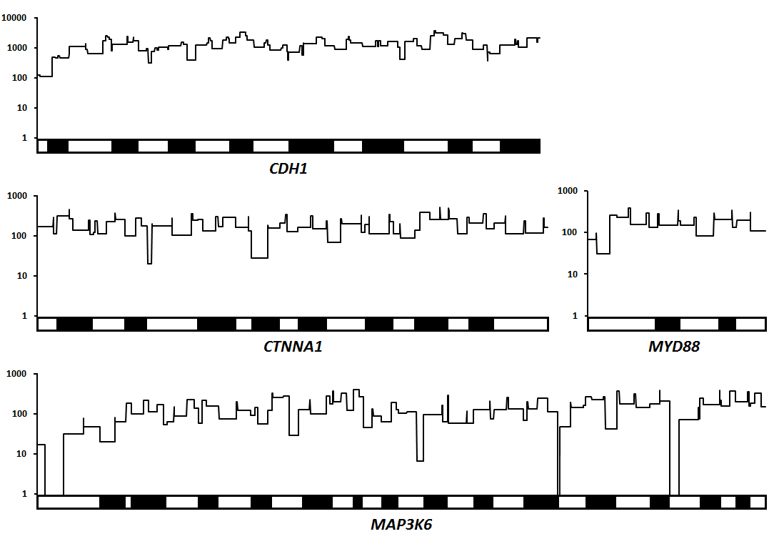
Black and white boxes represent alternating exons, including the canonical splice sites of the respective genes. Coverage of the open reading frame was determined based on the average number of reads obtained per smMIP in 107 (CDH1) and 283 (CTNNA1, MAP3K6 and MYD88) germline DNA samples of gastric cancer patients, respectively. X-axis: alternating exons. Y-axis: average number of unique reads mapping to the corresponding genomic position.

Supplementary 4. Overview of known CTNNA1 mutation-positive GC families

Family | Amino acid change | Nucleotide change | Proband | Family history (at counseling)# | Other malignancies | Family origin | Signet-ring cell differentiation |  | Original criteria by Caldas et al |  | HDGC criteria 2010 |  | HDGC criteria 2015 |  | Remarks/ comments |  | Reference paper(s)
1 | p.Arg27fs | c.80_81del | DGC (62) mut* | 1DGC (63) mut*; 1GC (54); 1GC (71); 4x2GC (45, 51, 57, 72) | Brain tumor | Dutch |  | Yes |  | No |  | No |  | Yes |  | Ten carriers (6 tested and 4 inferred). Endoscopic surveillance revealed invasive diffuse gastric cancer (pT1a signet ring cell mucosal foci) in four relatives at age 40, 41, 42 and 75. Three patients underwent gastrectomy and multiple mucosal SRCC foci were found, no typical in situ or pagetoid SRCC were reported. | [1, 2]
2 | p.Asn71fs | c.211A>AT | DGC (22) mut* | 1DGC (59) mut*, 2BC (50) | NR | White/ Canadian | Yes with pools of mucin |  | Yes |  | Yes |  | Yes |  |  |  | [3]
3 | p.Arg129* | c.385C>T | DGC (72) mut* | 1DGC (52) | NR | Italian | Unknown |  | No |  | No |  | Yes |  |  |  | [3]
4 | p. Arg330fs | c.964_988dup | DGC (40) mut* | 2GC (56) | NR | Dutch | Yes |  | Yes |  | Yes |  | Yes |  |  |  | Current paper
5 | p.Asn443fs | c.1328dup | GC (30) mut* | 1GC (48) | NR | Polish | Unknown |  | No |  | No |  | No |  |  |  | Current paper

#number before ‘GC’ refers to the degree of family member (i.e. first- or second degree relative), number in brackets refers to age. Reference papers: [1] Majewski IJ, Kluijt I, Cats A, Scerri TS, de Jong D, Kluin RJ, Hansford S, Hogervorst FB, Bosma AJ, Hofland I, Winter M, Huntsman D, Jonkers J, Bahlo M, Bernards R. An alpha-E-catenin (CTNNA1) mutation in hereditary diffuse gastric cancer. J Pathol 2013;229(4):621-9. [2] van der Post RS, van Dieren J, Grelack A, Hoogerbrugge N, van der Kolk LE, Snaebjornsson P, Lansdorp-Vogelaar I, van Krieken JH, Bisseling TM, Cats A. Outcomes of screening gastroscopy in first-degree relatives of patients fulfilling hereditary diffuse gastric cancer criteria. Gastrointest Endosc 2017. [3] Hansford S, Kaurah P, Li-Chang H, Woo M, Senz J, Pinheiro H, Schrader KA, Schaeffer DF, Shumansky K, Zogopoulos G, Almeida Santos T, Claro I, Carvalho J, Nielsen C, Padilla S, Lum A, Talhouk A, Baker-Lange K, Richardson S, Lewis I, Lindor NM, Pennell E, MacMillan A, Fernandez B, Keller G, Lynch H, Shah SP, Guilford P, Gallinger S, Corso G, Roviello F, Caldas C, Oliveria C, Pharoah PDP, Huntsman DG. Hereditary Diffuse Gastric Cancer Syndrome: CDH1 Mutations and Beyond. JAMA Oncol 2015;1(1):23-32.

Supplementary 5. A-E-catenin protein expression in gastric cancer controls

Immunohistochemistry for α-E-catenin of 105 anonymous control gastric adenocarcinomas showed strong membranous staining in 101 cases (96%). Sixty-two cases were of the intestinal-type of which 60 showed strong positive membranous staining (see example A-B, magnification 200x) and two showed no staining (one nuclear and one total negative, see example C-D, magnification 400x). Forty-two cases were of the diffuse-type of which 40 showed positive membranous staining (see example E-F, magnification 400x) and two showed no membranous staining: one showed nuclear staining (see example G-H, magnification 400x) and one showed no staining.

